**AlgoExpert Documents**

**What is the Problem solving technique?**

First analyze the problem by writing down one input case. Find out couple of theoretical solutions in paper. I love it. Start with worst solution and slowly go to the best solution. Write pseudo code of them and find O costs. Choose the best solution and if everybody agreed then start writing code.

**Can you make any better?**

That means there is space to make it better. It is normally storing recalculating stubs in memory and reuse from there so that we don’t need to calculate again and again same things. Another technique is to store visited nodes using Boolean array or hash map would make stub lot easier.

**Problem Solving Techniques**:

1. How to solve a problem:
   1. First write down an example of a problem
   2. Describe step by step very details
   3. Later pick one or more extreme example to find corner cases
   4. Figure out the problem restrictions defined in the problem or you will see by analyzing couple of example input output
   5. Figure out the problem goals
   6. Write theorem if you found any
   7. Write Pseudo code
   8. Then start coding, then it will be easy to implement
2. Multi pointer approach (left + right pointer for array using **while** loop)
3. Check if **sorting** gives you any benefit, something after sorting manipulate by **while** loop and **two pointer** helps
4. Efficient use of **HashMap** with Boolean, Boolean/ Boolean, Integer/ Integer, Class Type to make it faster
5. Using **Hashmap** **duplicate** elimination, you have to put element as key and index as value
6. **Memorize** operation by two dimensional arrays: Boolean/ Integer / String / Or any Class type to **duplicate** elimination.
7. Using DFS (**Stack**), BFS (**Queue**) to manage connections or adjacent nodes
8. Using **iterative** way (while or for loop) or **recursion** (call stack: hard to debug, not memory efficient) to do similar step again and again.
9. When input is layer by layer and we need to do the same job again and again, it is perfect time to use **recursion**. When it is needed to provide half of the array from left side and get the result, also we need to provide half of the array from right side and get the result, and reuse them over and over, it is then perfect time to use recursive algorithm. It is possible to do these operations **recursively** without deleting any array indexes. For example, **Merge sort, Min Height BST**
10. **Duplication** elimination by considering only previous elements (from current element) from array. And in forward side do other operation to meet any condition. For example, four number sums, three number sums.
11. Many dynamic problems can be solved by **reverse calculation from the current element**. For example, move to one more elements to right sight and consider all left elements again. For example: in min number of jumps.
12. Use **Linked** list where you have to manage **4 pointers** to manage connection with previous and next node. You have to keep the chain always stable no matter what operation you do. Linked list is better when you want to insert or remove items, but for searching items this is not much faster.
13. Efficient **lambda** Stream to do many operation in Java including sorting, searching items
14. Use **Tree** which has similar data structure like linked list (can be managed by left and right pointer). Insert and delete is easy because you can deal it from leaf node. But remove is the hardest one because you have to keep structure filled (huge rearrange) for the change, when you remove something from middle or top
15. Use **Trie** to quick pattern search in a fixed text which is time efficient to search but n^2 cost to build
16. Solved many problem using **Math.max**, **Math.min**
17. To find a particular logical match in string, one approach is **stay center** and **compare left and right** by two pointers**.** For example, LongestPalindromeSubstring, we need to find the center of a palindrome from long string.
18. When one approach cannot solve more than two or three aspects/situation of the problem, then it is a signal that this approach is not effective enough. Handling these situations separately would make the code big mess. When code looks messy, or it takes long time, this is also a symbol that the approach was not the right one. Ideal approach should solve a problem without or with at most one to two corner cases.

**Why Tree?**

One reason to use trees might be because you want to store information that naturally forms a hierarchy. For example, the file system on a computer: file system

1. Store hierarchical data, like folder structure, organization structure, XML/HTML data.
2. Binary Search Tree is a tree that allows fast search, insert, delete on a sorted data. It also allows finding closest item
3. Heap is a tree data structure which is implemented using arrays and used to implement priority queues.
4. B-Tree and B+ Tree: They are used to implement indexing in databases.
5. Syntax Tree: Used in Compilers.
6. K-D Tree: A space partitioning tree used to organize points in K dimensional space.
7. Trie: Used to implement dictionaries with prefix lookup.
8. Suffix Trie: For quick pattern searching in a fixed text.
9. Spanning Trees and shortest path trees are used in routers and bridges respectively in computer networks

**Use case of Linked list**

1. Implementation of stacks and queues
2. Implementation of graphs: Adjacency list representation of graphs is most popular which uses linked list to store adjacent vertices is.
3. *Image viewer* – Previous and next images are linked, hence can be accessed by next and previous button.
4. *Previous and next page in web browser* – We can access previous and next url searched in web browser by pressing back and next button since, they are linked as linked list.
5. *Music Player* – Songs in music player are linked to previous and next song. you can play songs either from starting or ending of the list.

**Sorting**

**Bubble Sorting**

The **bubble sort** gets its name because elements tend to move up into the correct order like **bubbles** rising to the surface. Every time it compares with next one element, if left one is bigger, then it swaps. Every round it leaves one item from right side as a sorted part.

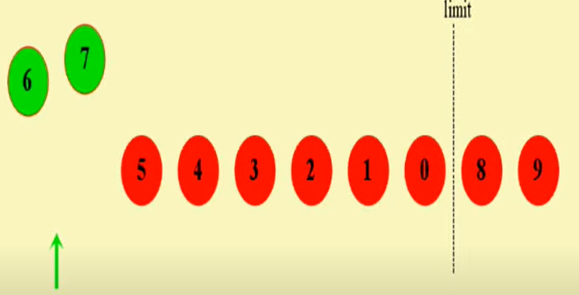

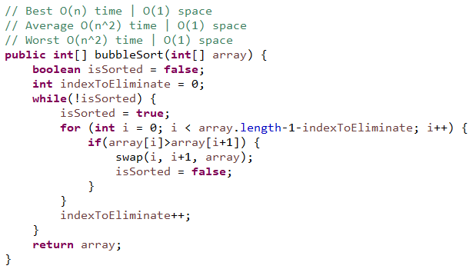

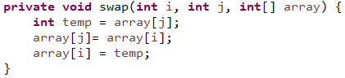

**Insertion Sorting**

This **sort** works on the principle of inserting an element at a particular position, hence the name **Insertion Sort**. First time, it considers first element is sorted element. Then every first item from non sorted part is considered reversed order to see if it is smaller than swap it to left.

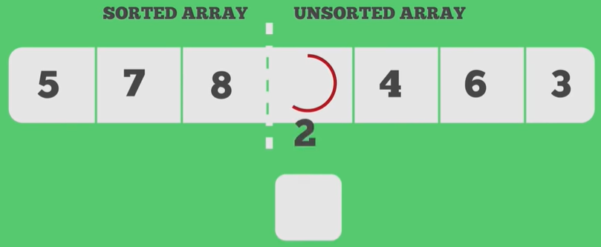 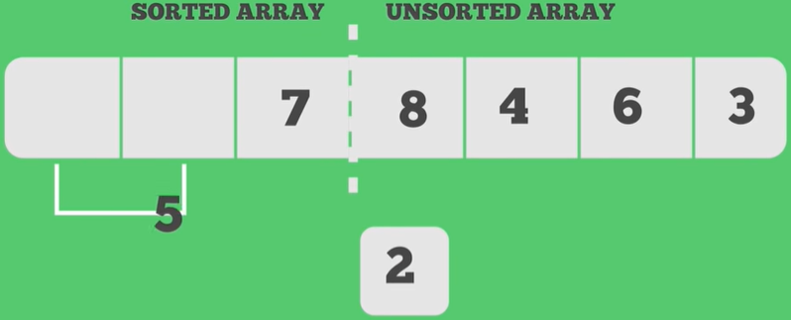

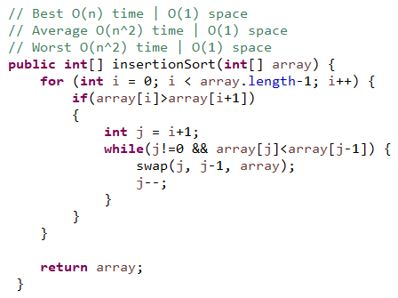

**Selection Sort**

Selection sort is called selection sort because it always select **lowest** number and swap with first positioned number, and the select second lowest number and swap with the second positioned number, select third lowest number and swap with the third positioned number, and so on.

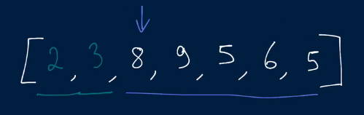

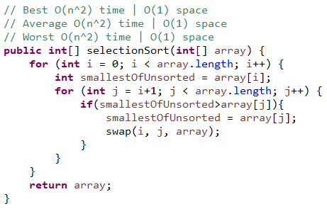

**QuickSort**

**Quick Sort** provides a fast and methodical way to sort lists of entities. It chooses an element known a **pivot** and ensures that it gets placed at its right position in the list (move smaller than pivot to left sight and bigger than pivot to right side).

The reason is that even though it may be asymptotically slow, it works very fast in most practical cases. There is even a version which claims O (nlog(n)) average case complexity. It doesn't need much extra memory.

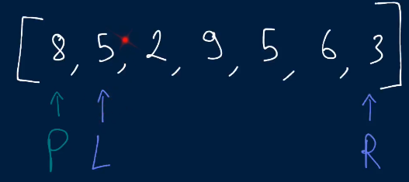 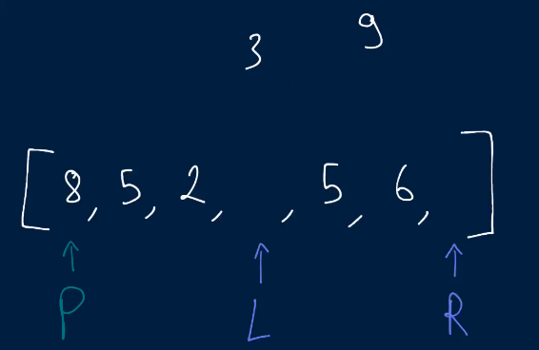

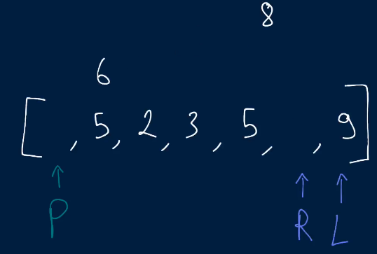 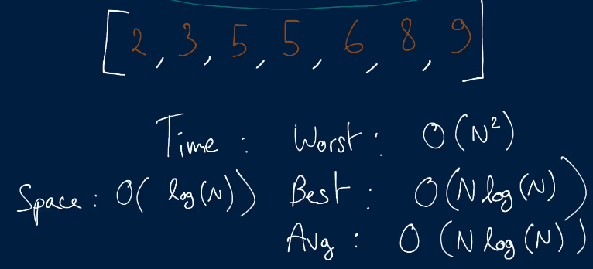

Our job is to select a pivot and keep numbers bigger than pivot to right side and keep number smaller than pivot to left side of the pivot. Notice the number on pivot is getting its final place at every iteration. Then provide left part of the pivot as a source of input for the recursive method and provide right part also afterwards. It does all the operation by providing the same array but by only providing pointers of the different numbers (start and end part). And it also swaps on the same array. This is quite interesting idea. The recursive method is essential here.

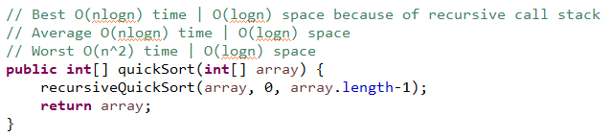

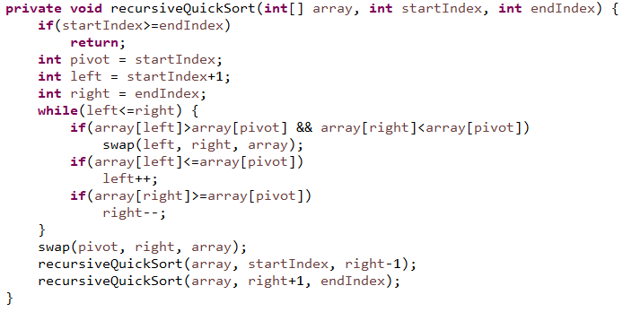

**Merge Sort**

Merge sort is a divide and conquer algorithm where the idea behind is a combination of three things: dividing, sorting and merging.

**Solution 1**

This is a beauty of recursion. For me, it was still hard to imagine using two different part recursively and calling another method at the same time by using them. Let’s think about it. For the recursive method, first of all you have to think about its exit point. It is very similar like while loop. Then you can take part of your data and with that you can do recursive call to do the same operation again. The question is what you want to do with output of that recursive call. To use the result or do further process, you can put your recursive call inside another method’s parameter. You can call that using multiple parts of these data too. To write logic on that method, you can just think about what logic you would do with first time collected data.

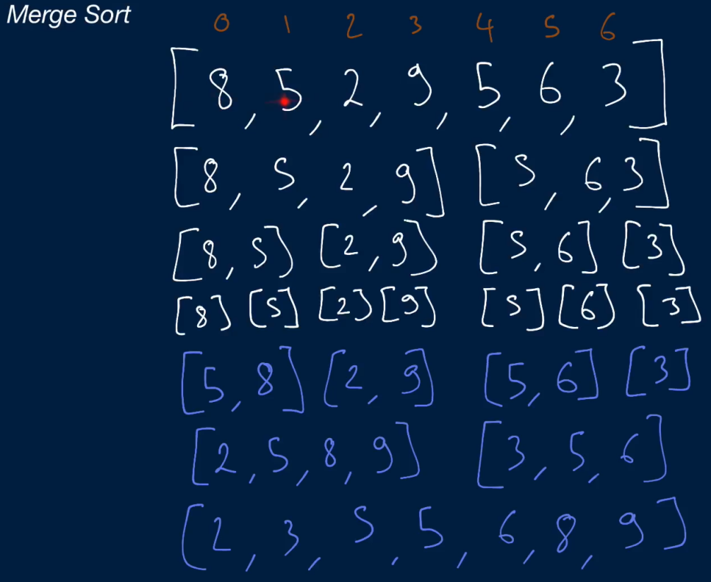 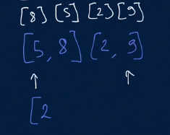

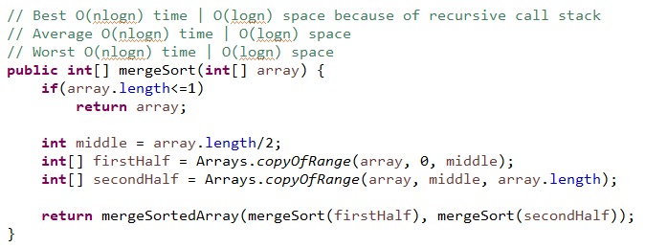

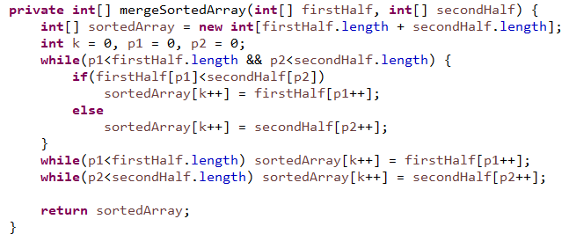

**Solution 2**

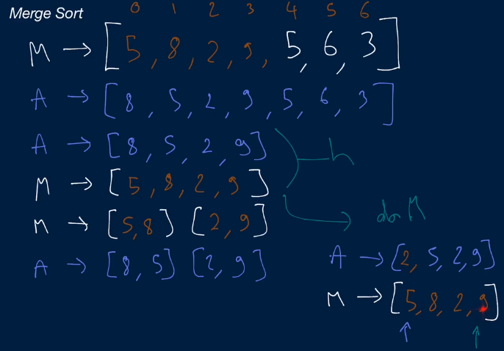

I have not done it yet.

**Recursion**

**Nth Fibonacci**

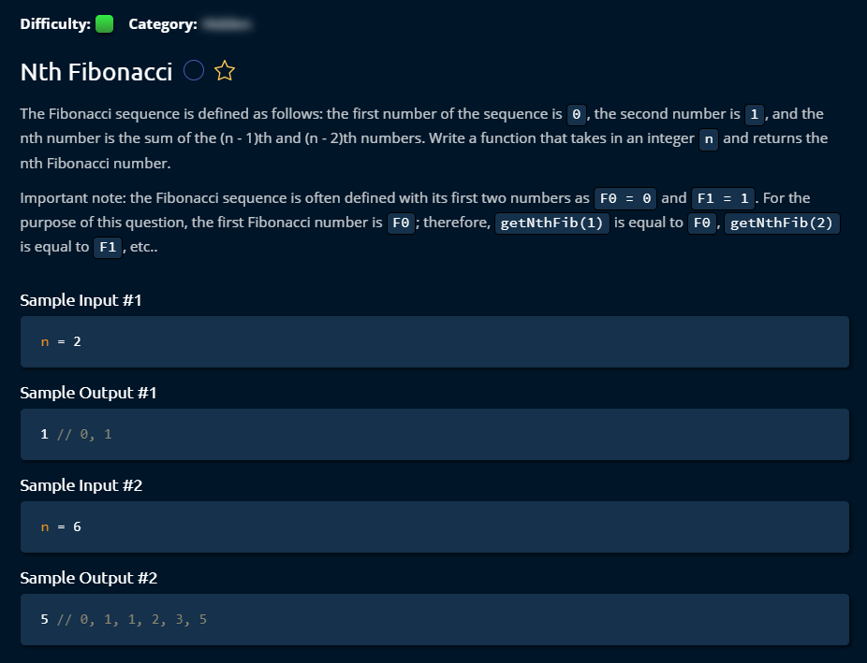

**Solution 1**

By making a recursive method call, it can do the job.

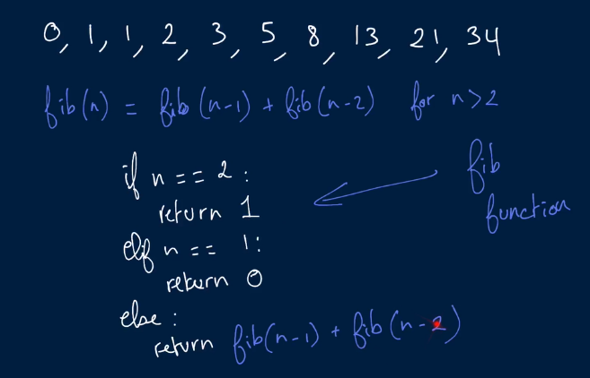

It would cost Time: O (2n) and Space: O (n). We are just making recursive call. It seems like we are not storing anything, then why it would cost space O (n)? But in recursive call, we use function call stack which uses memory. When we call Fib (6), it will generate an entry on very bottom of call stack. It realizes that it has lot of pending work. It will wait there and will generate two recursive calls Fib (5) and Fib (4) which will come on top. They are just hanging in the memory. It has to remember the state that we are on. This goes on until our base case Fib (2).

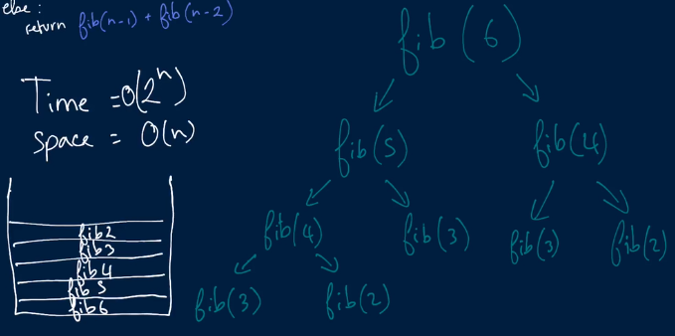

Then it will erase Fib (2) at the beginning when it is done. This is done even twice over because Fib (4), it will call first Fib (3) and then Fib (2). It will remove as LIFO order. Because we have at most n frames in that call stack, it will use O (n) space complexity.

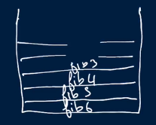 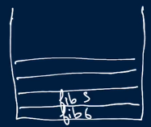

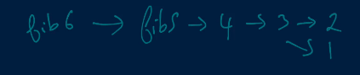

In the recursive method call, it generates call stack and the return is going to place from where (inside that method) it was called. It will back track the result which means one wait for another result.

**Recursion** can be slower **than iteration** because, in addition to processing the loop content, it has to deal with the **recursive** call stack frame, which will mean more code is run, which means it will be slower and comparatively more memory use.

Solution 1 (Java Code)

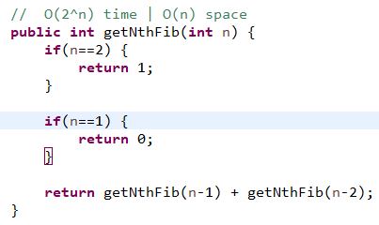

**Solution 2**

Instead of computing Fib (n), for n = 3…..n many times (same data), we will computed one in store (in Hashmap) each of the Fib (n) when a unknown Fib (n) comes. It will reduce computing complexity.

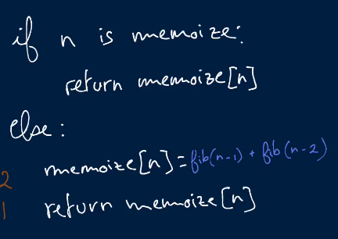 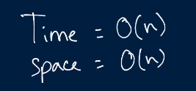

Time complexity will reduce to O (n) but Space complexity will remain same as O (n) because we still use same call stack for recursive. Additionally we introduce a new Hashtable variable. But it will not increase space complexity.

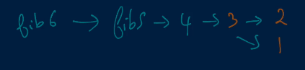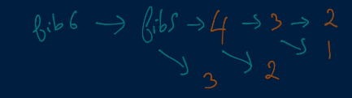

Solution 2 (Java Code)

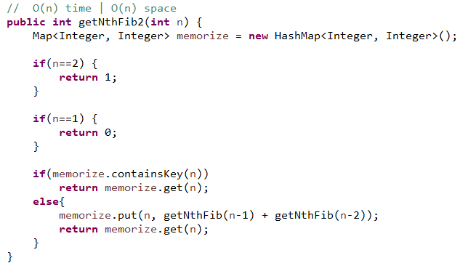

**Solution 3**

This one is the best solution for this problem because it uses only a two dimensional array to solve the problem which is almost nothing. It is just shifting the next value from right to left and the right side array is interchanged by the result of adding current two values. This is an amazing solution which costs O (n) time and O (1) space complexity.

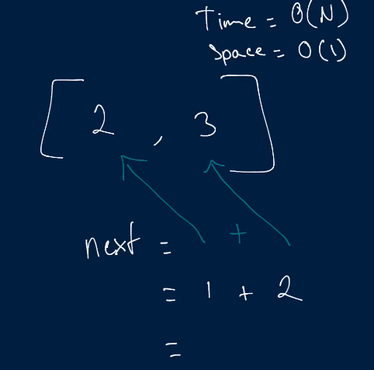 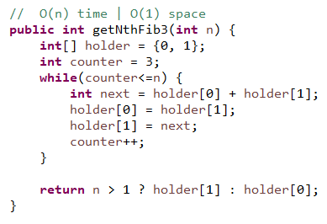

**Product Sum**

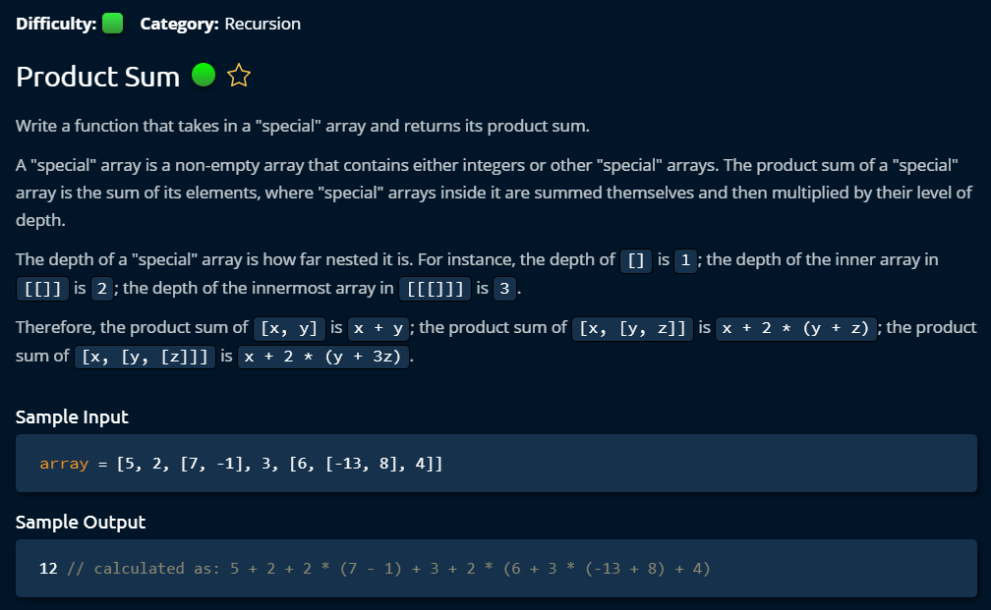

**Solution**

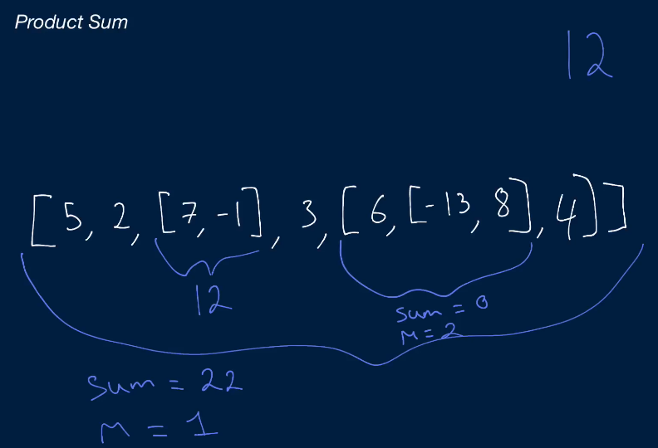

The input is like an onion where it contains list with layer by layer. So by using two variable sum and multiplier, we can use recursion. Notice that the inner layer must be multiplied by more number (+1) than current layer. That is why we pass multiplier as a method variable. And when we get a new inner list, we increase the multiplier by +1 and send the inner list to the recursive method. From this problem I learned, how to compare if an Object is ArrayList type and how to convert from Object item to ArrayList<Object>.

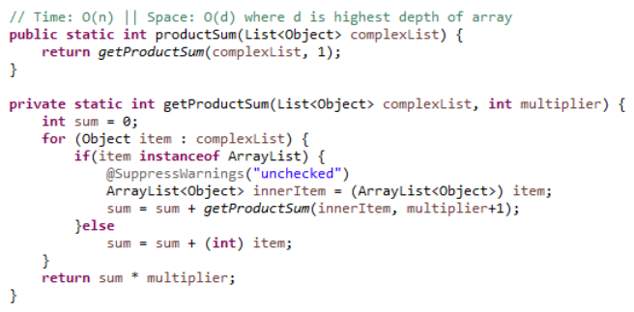

**Binary Tree**

**Invert Binary Tree**

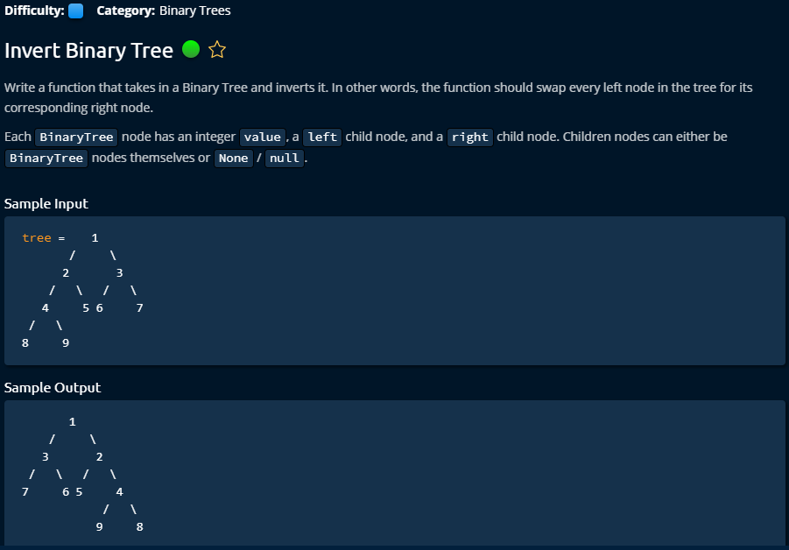

**Solution 1 (Iterative Solution)**

This is an elegant work with iterative solution and I like it because it works with queue and FIFO. It picks a node and handles its Childs. It is very easy to understand solution. But the recursive solution has a bit better space complexity.

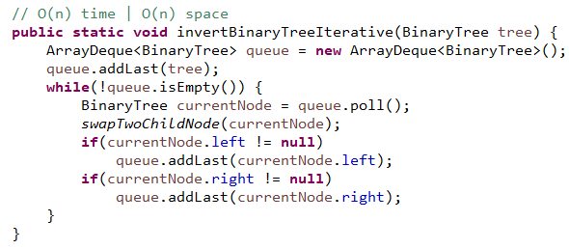

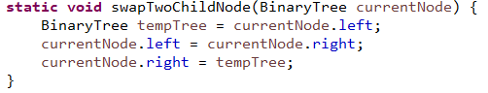 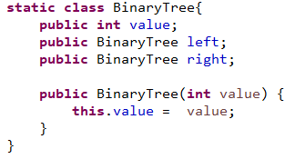

**Solution 2 (Recursive Solution)**

This recursive solution has a bit advantages over other iterative solution. Due to the nature (DFS like) of recursive call, it needs to store call stack but it will always go the depth of tree to the left side first and next right. So, we don’t need extra queue to keep track of data but the call stack has to be remembered. And the call stack has to remember until depth and it will go from depth to next right side, so it will make the call stack free from left side as it completing the operation from left depth. So, the space complexity we need until depth which means logn.

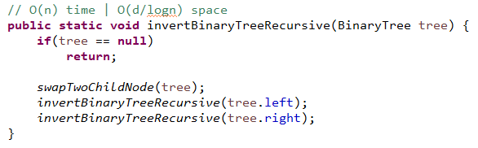

** **

**Branch Sums**

This is a recursive solution which execution style is similar like DFS algorithm. It deals with call stack. Due to the nature (DFS like) of recursive call, it needs to store call stack but it will always go the depth of tree to the left side first and next right. So, we don’t need extra queue to keep track of data but the call stack has to be remembered. And the call stack has to remember until depth and it will go from depth to next right side, so it will make the call stack free from left side as it completing the operation from left depth. So, the space complexity we need until depth which means logn. But we need to remember the summation result of each node hierarchically which also need memory, that’s why we provide a **list by method parameter** to keep track of summation result and it will only add the result to the list once it find the leaf of a side (by checking if there is no child in either left or right).

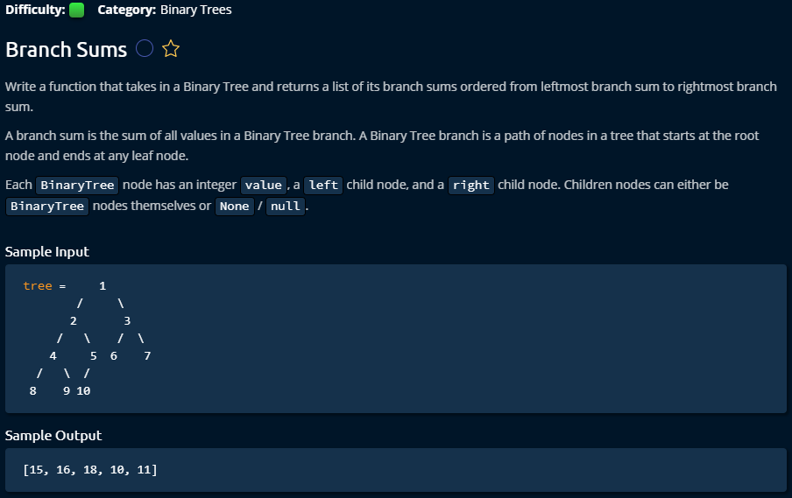

It comes to the node with remembering previous nodes upper hierarchy’s summation and sum with current nodes values.

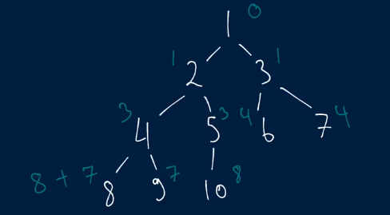 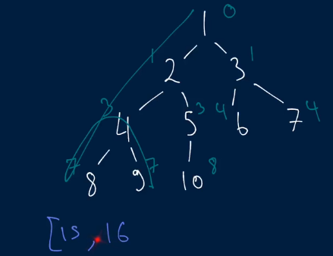

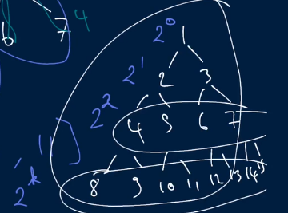 Normally it contains 2n nodes in each row of trees.

**Solution**

It has a recursive technique to find its each leaf. This is elegant solution.

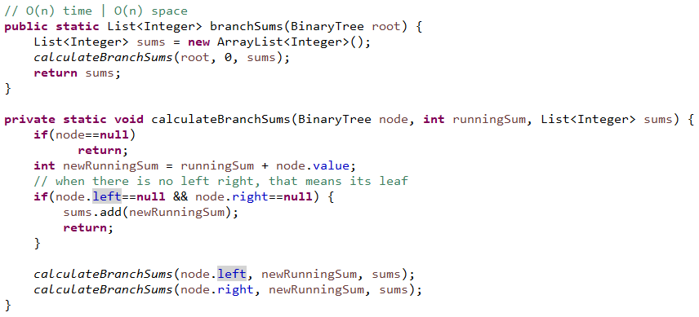

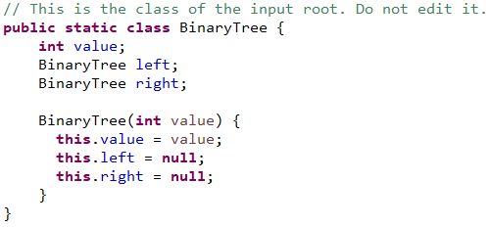

**Node Depths**

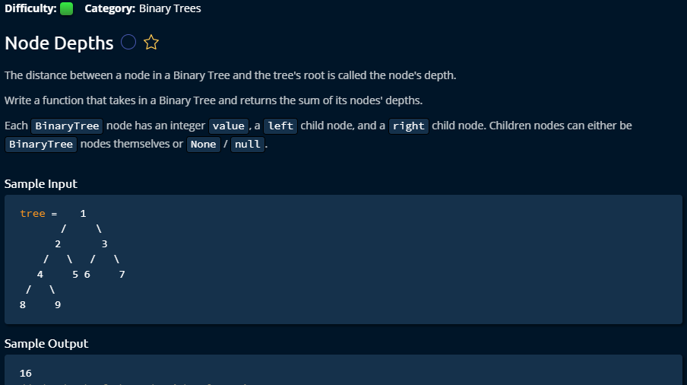

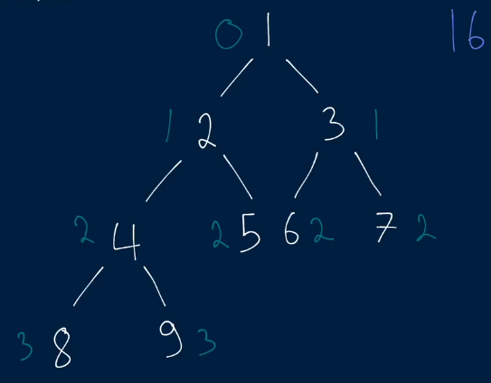 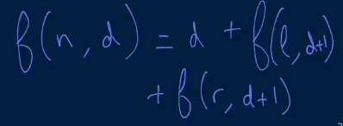

**Solution 1**

Both of these solutions have similar time and space complexity. Recursive one seems like a bit confusing to me.

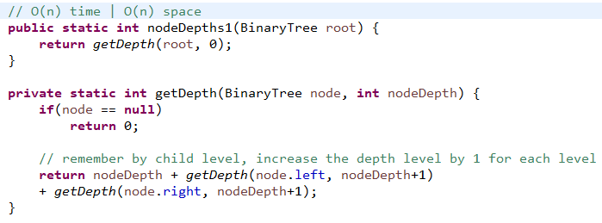 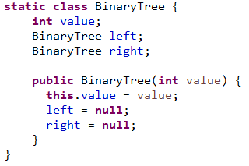

**Solution 2**

I like more this solution 2 because it works with normal queue techniques which are easy to implement and understand.

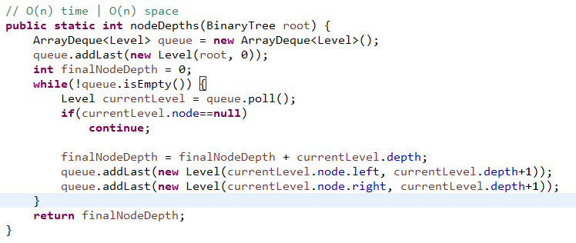 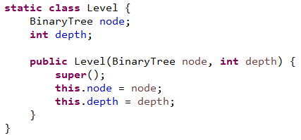

**Graphs**

**River Sizes**

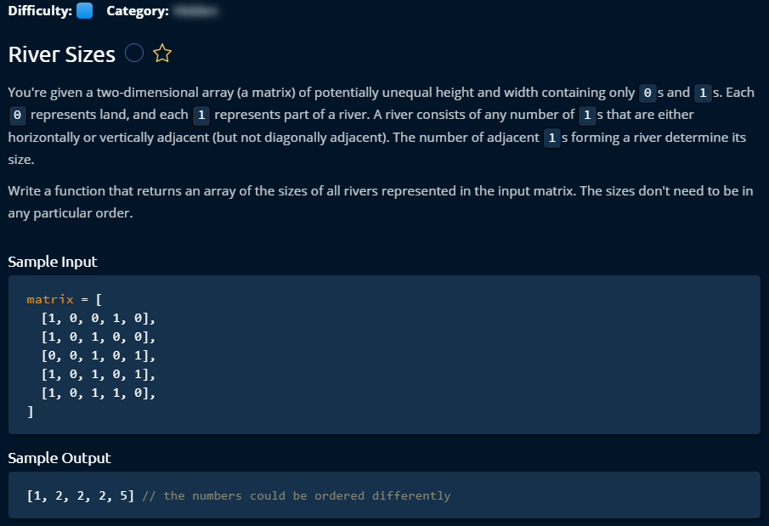

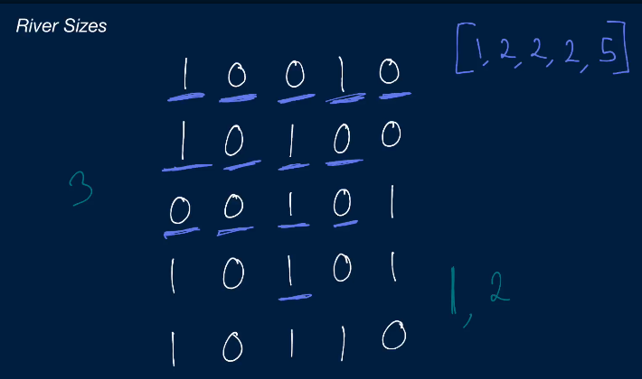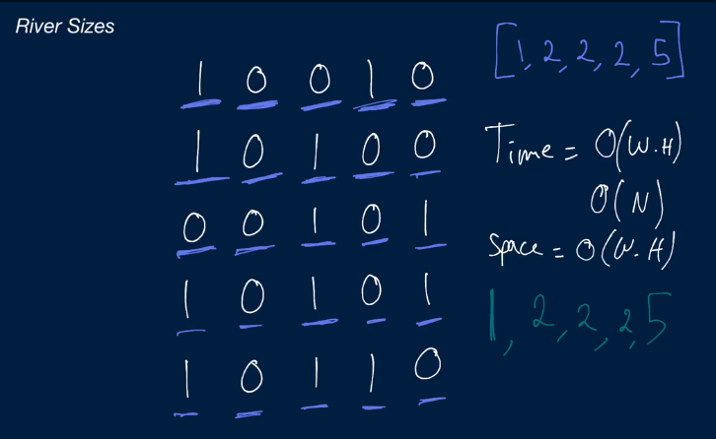

**Solution 1**

This is a very interesting problem related to graph which can be done by DFS or BFS to find all the adjacent relevant nodes. To reduce the operation times, we have to keep track of all visited nodes and make sure that we don’t visit the same node twice.

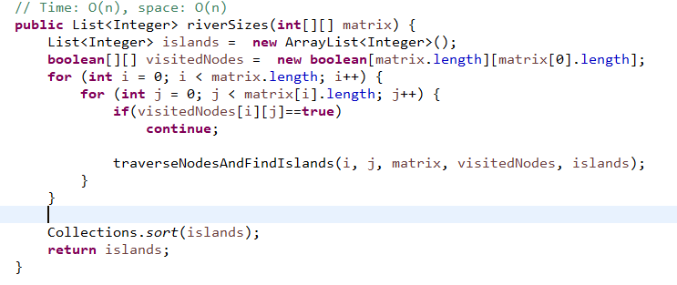

Starting with first node, we send it traverse all adjacent nodes using DFS, and store the first node inside the stack. We loop through all existing nodes in the Stack. When we found 0 then don’t consider and stop traversing that direction, but when we found adjacent node 1 then we increase the size of river and go further in that direction. The whole nodes are stored in Stack and consider one after another by push and pop operation.

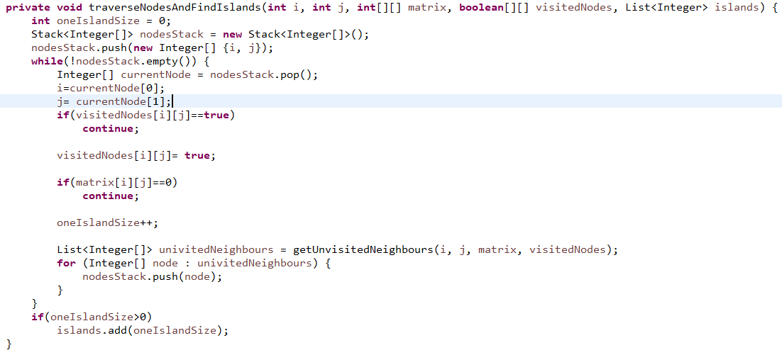

All the adjacent nodes can found by following tricks, then we add them in the Stack to consider for the next round in calculation. This way we can go until end of adjacent 1.

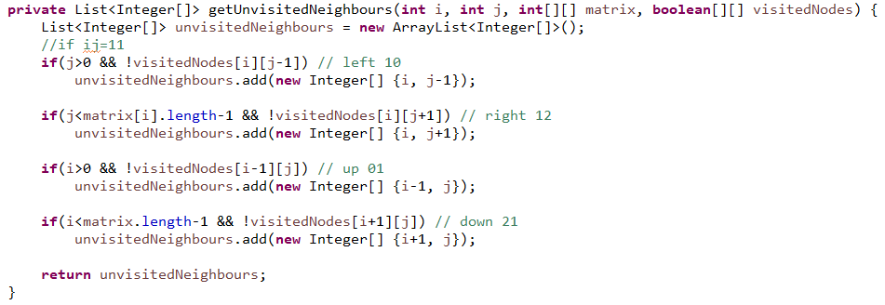

**Solution 2**

This last solution can be made a bit faster using some tricks.

From the first part, we considered all elements 0 or 1 to find if it has adjacent 1. We only had one filter which is if the node was already visited. Now, we can also avoid 0 because 0 cannot have a river. So, we will consider only 1 nodes and if it is not yet visited. It will also reduce lot of time and space complexity.

In the last technique, in the third part, we pick all the adjacent elements of 1 (all 3 sides) even if they are 0. Now, we are going only pick adjacent nodes which are 1. It will reduce lots of time and space complexity.

We also extract a new method to make our last method little bit readable.

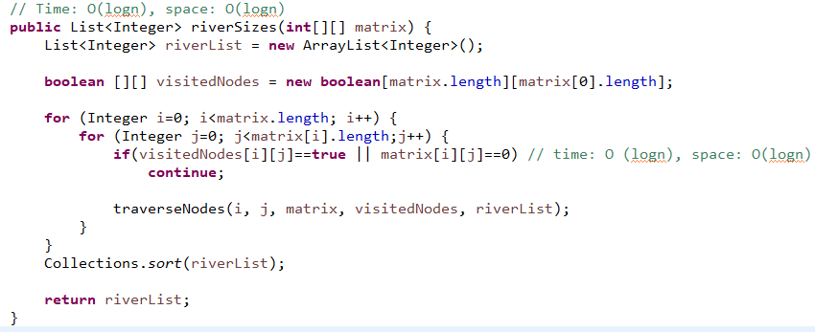

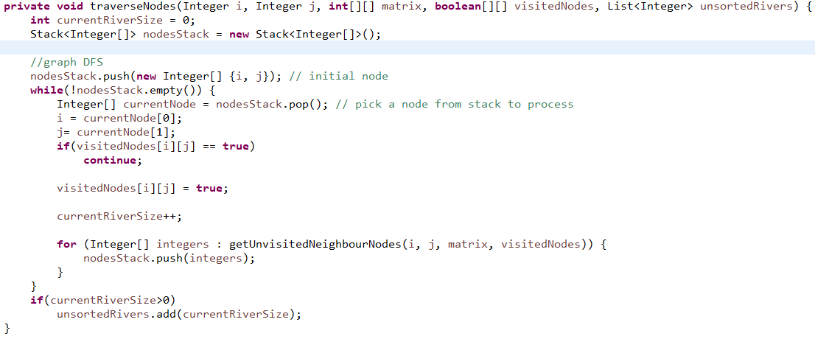

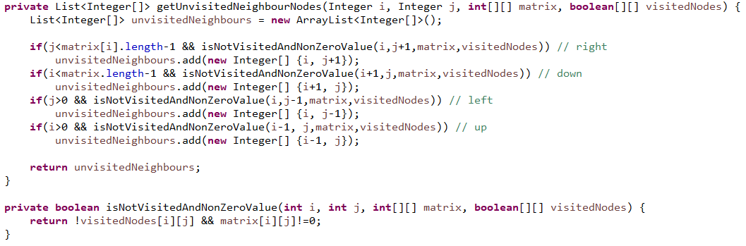

**Related problems**

463. Island Perimeter (Leetcode)

130. Surrounded Regions (Leetcode (medium))

200. Number of Islands (medium)

**Single Cycle Check**

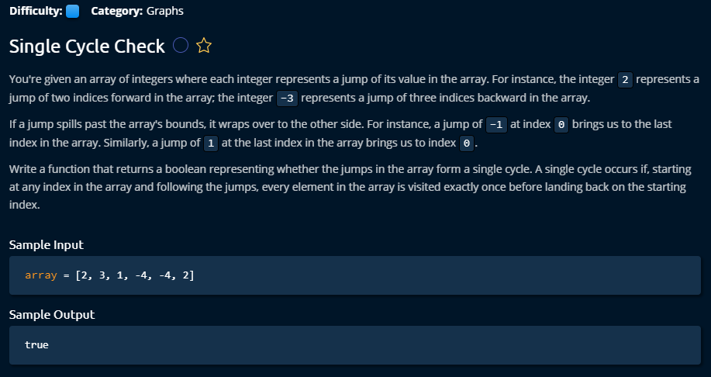

**Solution 1**

This is the solution came into my mind when I started to solve the problem. I used a Boolean array to keep track of visited nodes. As the problem was tricky and input can be wide range and the large outer bounded values had to adapt into the array, I had to do mod operation with array length. When the index was negative, then I had to make a summation with length again to keep it into the array. It costs O(n) time and O(n) space due to visited[] use. We could do the whole job even without keeping track of visited nodes which could lead to reduce the space complexity to O(1).

One thing is worth remembering that I had problem to decide the condition for while loop which should confirm that given array was considered until its length. Here is the following I also attached my first messed up copy of solution.

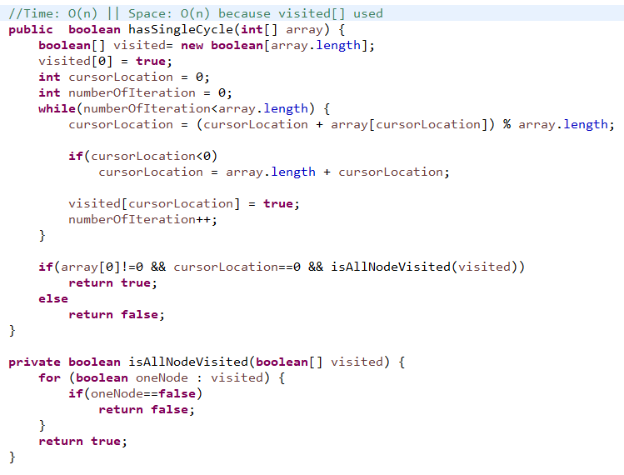

My first messed up copy of solution. I need to find a way to avoid this kind of problem.

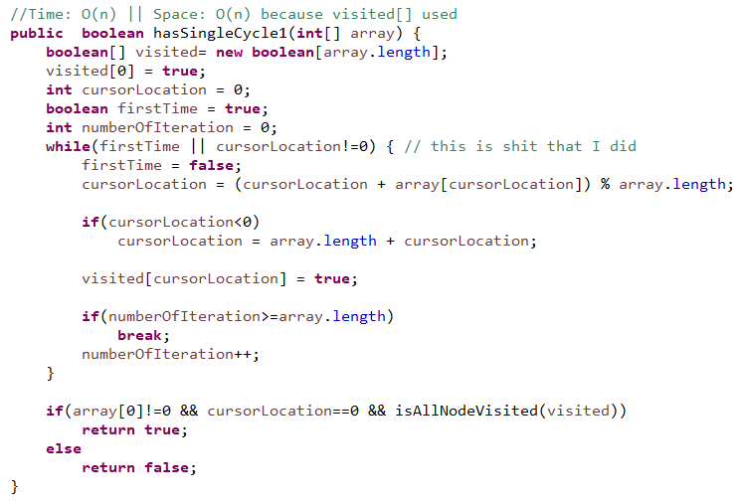

**Solution 2**

This problem could be done without remembering node visited. Only we have to care if there is any pre-matured loop, then we return false immediately. When any node is 0, that means it does not move any more. And we have to consider some corner cases.

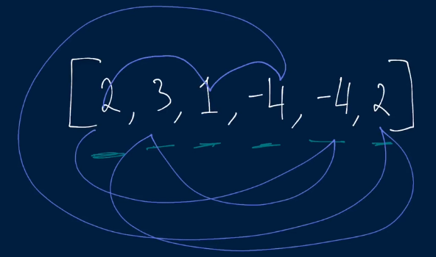 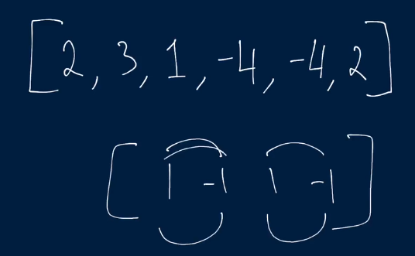

This is an elegant solution with very less complexity, as we don’t need any extra list.

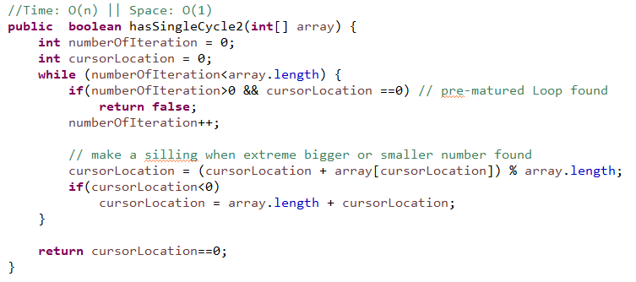

**Depth First Search**

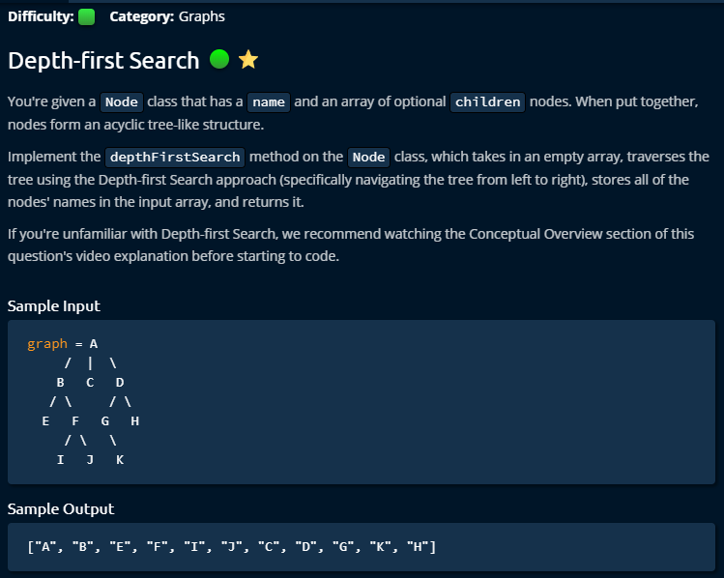

**Solution: DFS for a graph is following: (Depth first search)**

To implement DFS for graph, we have to use recursive approach so that it can go until the depth of each node from the beginning. Notice that here in graph the nodes are connected with its child by List of node, not left right pointer as in tree. **That is the difference between graph and tree: graph can be managed by graph structure class keeping name and List<Node> children, and tree should be managed by tree structure class with its value and left, right pointer.**

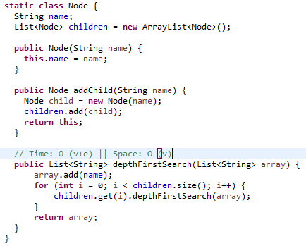 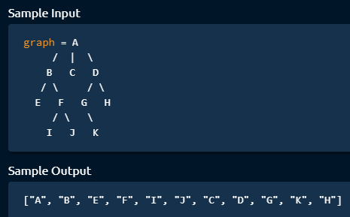

**How to generate a tree or graph by code? For the test sake, we provide the graph from given input.**

Node graph = **new** DFS.Node("A");

graph.addChild("B").addChild("C").addChild("D");

graph.children.get(0).addChild("E").addChild("F");

graph.children.get(2).addChild("G").addChild("H");

graph.children.get(0).children.get(1).addChild("I").addChild("J");

graph.children.get(2).children.get(0).addChild("K");

**Breadth First Search**

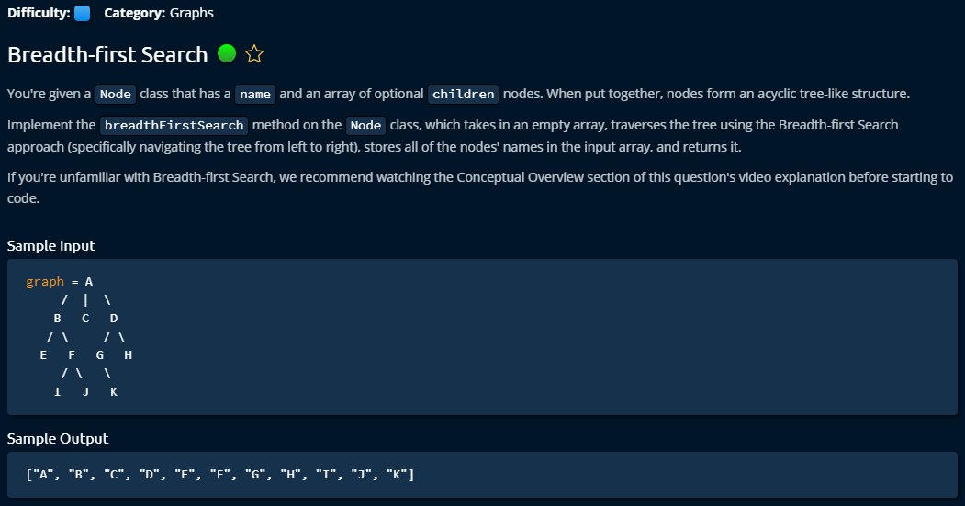

**Solution**

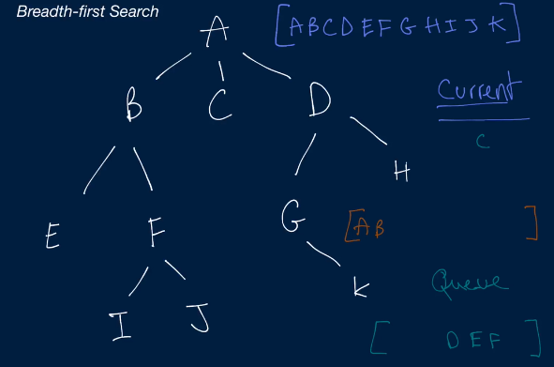

The implementation of BFS is rather easy and elegant. We just can use a build in queue in java which can efficiently manage BFS Structure. The idea in BFS is it deals with every row by row. For each node, it considers only his child and that it. And iteratively it travels to the whole tree or graph. The idea of BFS is like when we go in the supermarket and generate line to pay the bill. It’s a fist in first out (FIFO).

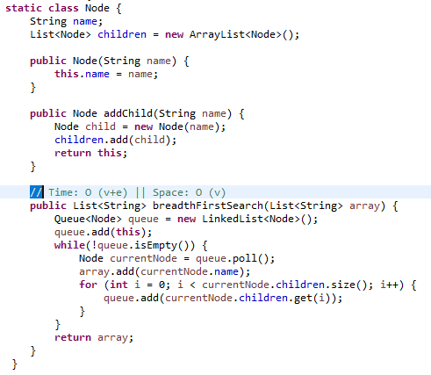

**Youngest Common Ancestor**

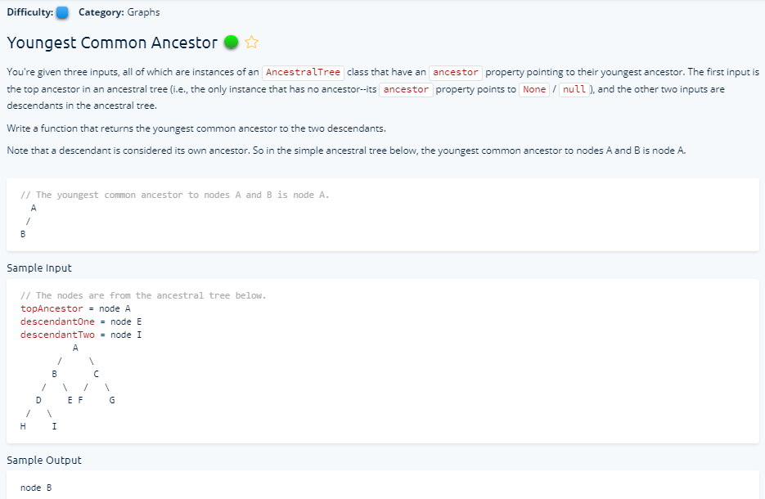

**Solution**

As the problem looks hard, actually it was solved with simple logic. I have an impression that all the different types of strange data structure that we use looks very hard, are actually easy sort than our normal data structure (e.g. Arrays, String) because of being hard to understand questions are much more easy here. In this problem, we have to find common parents of two nodes; they can be in different child level. First we find out how deep a targeted child from top ancestor, and also for second child. Then we have to bring both of these child’s ancestor (usually we need one to be in same level) to the same level in the hierarchy. When they are in same level, if we go with the ancestor up, we should be able find the common one.

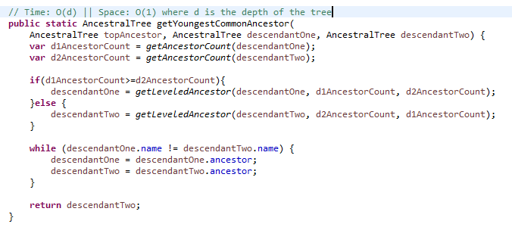

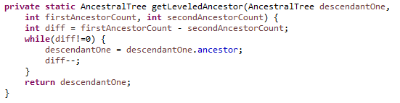

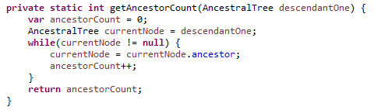

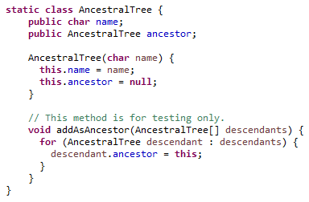

**Arrays**

**Move Element to End**

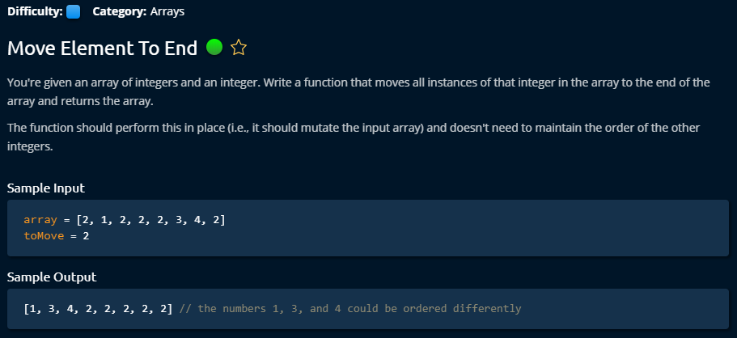

**Solution 1**

This problem is dealing with how to deal with multiple pointers. First it looks for toMove number from the array, if found then it looks for next non toMove variable. Once it found, it swaps these two numbers and move first and last pointer to the next number of first and last pointer.

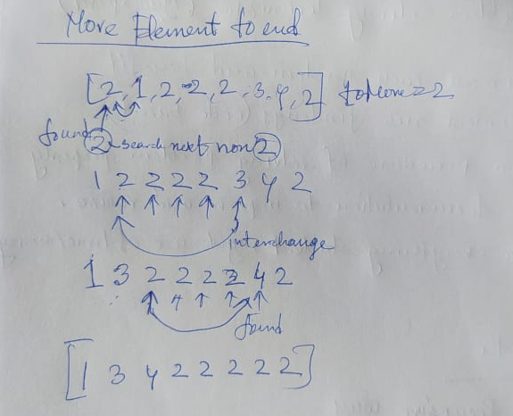

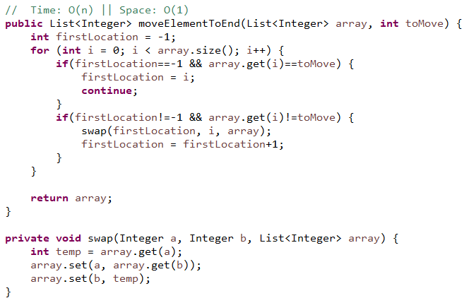

**Solution 2**

This solution is a bit elegant. It works with two sided pointers within the same loop. If left side got toMove variable, then it looks for a non toMove variable on the right side. And if it finds, then it swaps.

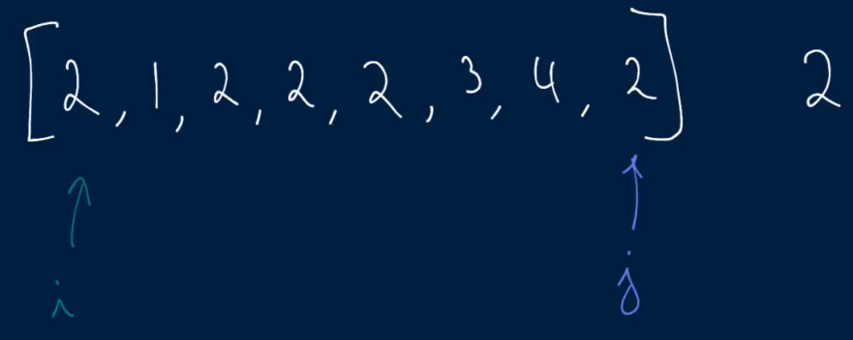 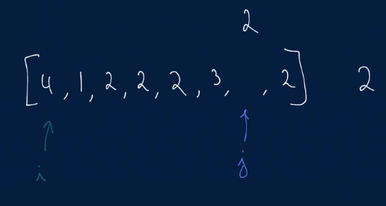

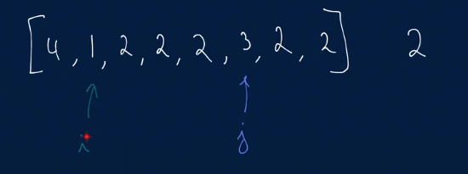

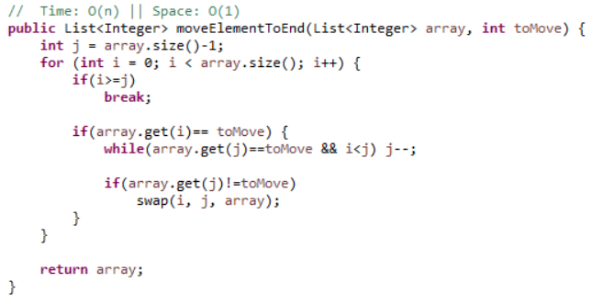

**Smallest Difference**

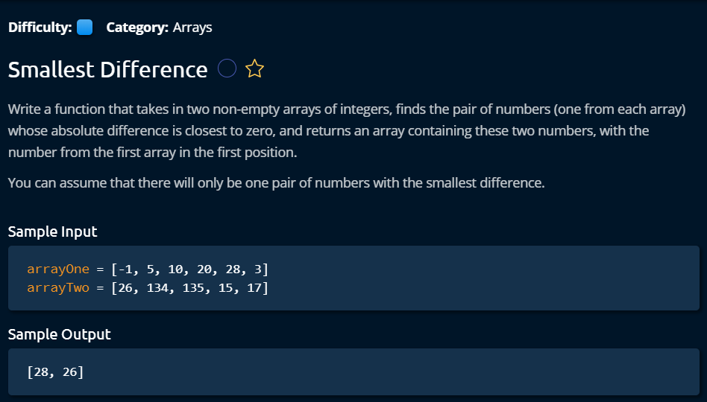

**Solution 1**

This problem is solved with two pointer management solution. It puts to pointer on two arrays and compares these two nodes value. If first value is smaller, then move that pointer to forward. If last pointer value is bigger then move it to the next pointer. We have to keep track of minimal difference of all the operation. That’s it.

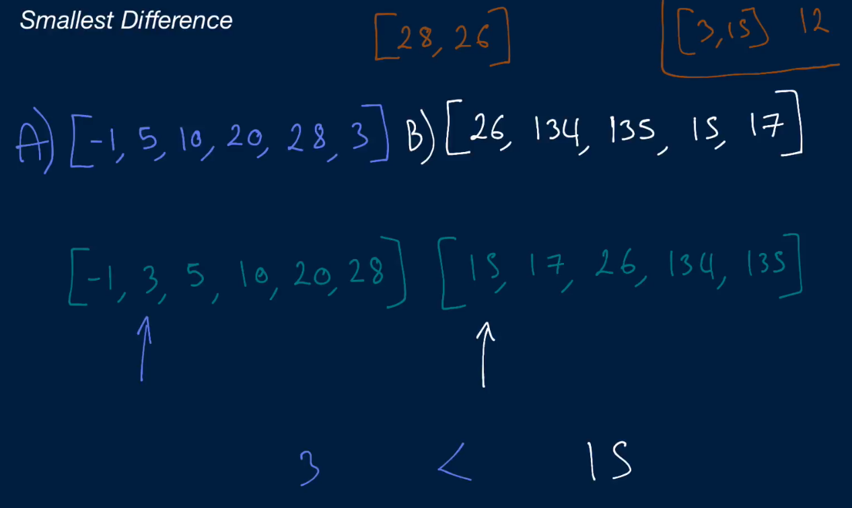

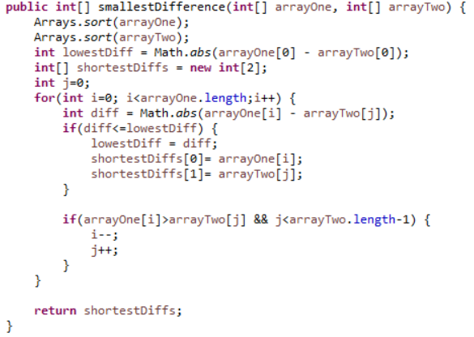

**Solution 2**

The solution is same but the development policy is a bit different. This kind of problem can be handled with a while loop in an even easy way. I need to adapt this while loop idea.

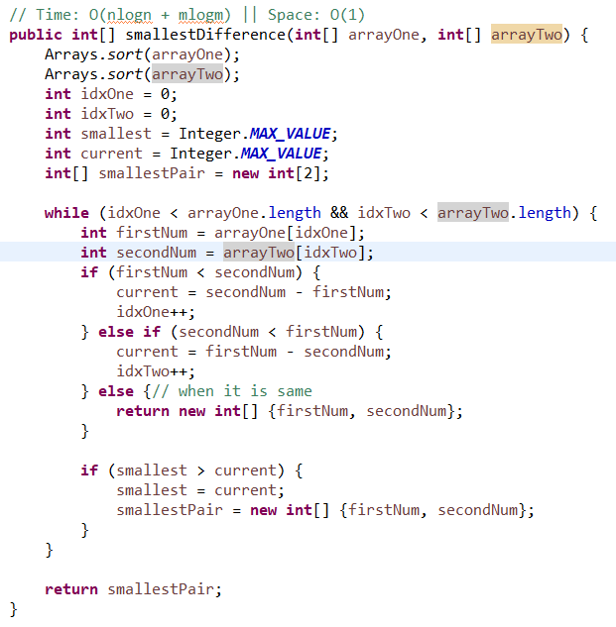

**Four Number Sum**

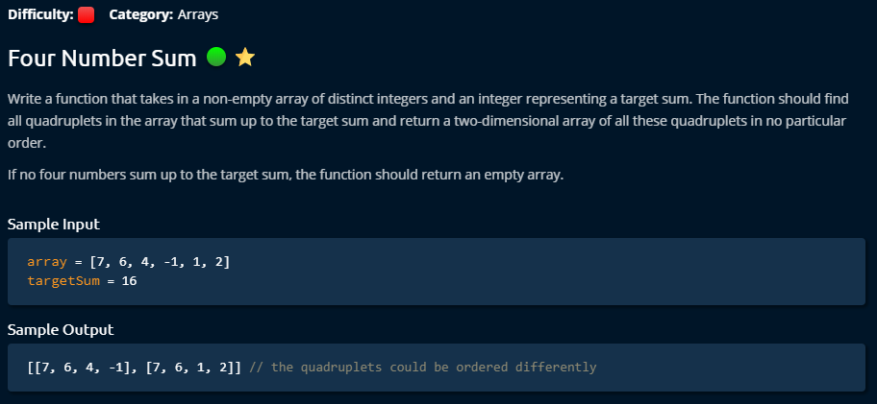

**Solution 1**

The easiest way to solve this problem by using four nested loops. The only thing is to confirm that we are not considering same index more than one places. We can do that by using i==j continue techniques. But the problem with this technique is that it takes very high time complexity (n^4) and the space complexity is good.

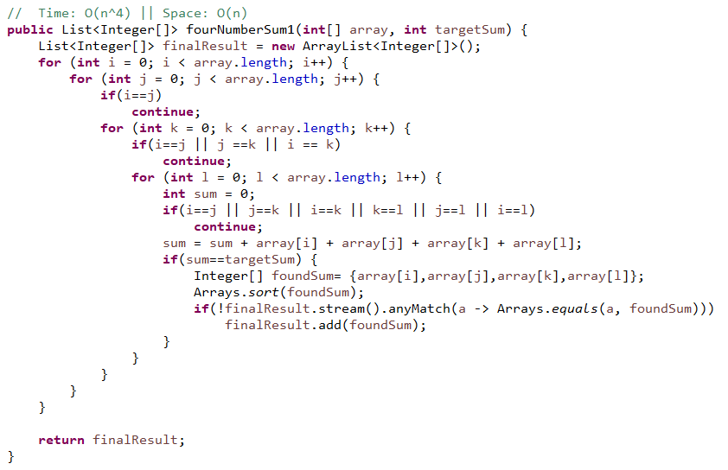

**Solution 2**

This is a bit engineered solution. This is totally new idea to me. Just by two for loop, the whole job is accomplished. To find the four numbers sum, and make the job easy, it makes a pair of two numbers and stores them on Hashmap using their sum result as a key. **Very interestingly**, to avoid duplicate data (same data with another order) in Hashmap data, it stores the key value pair into the Hashmap for the FOR loop only from the left indexes until to the current index. And the right indexes only used to find new Quadratic. It compares each pair (i, j) + Hashmaped stored pair with TargetSum, and decide found quadratic if they are same and then store it to the final list. This technique manages a surprising time complexity benefit (O (n^2)) but requires a bit more space.

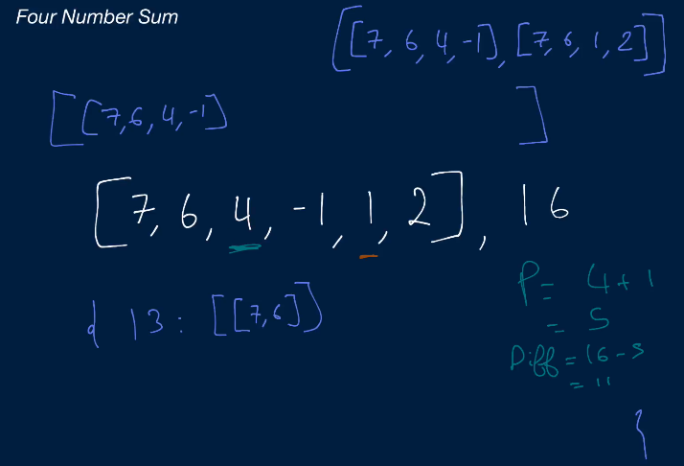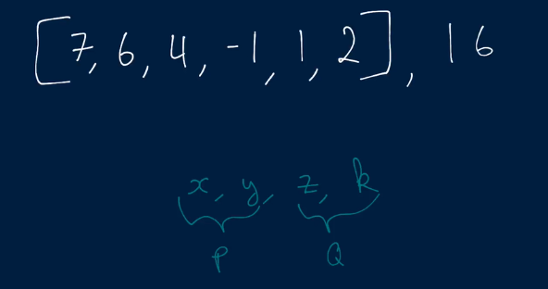

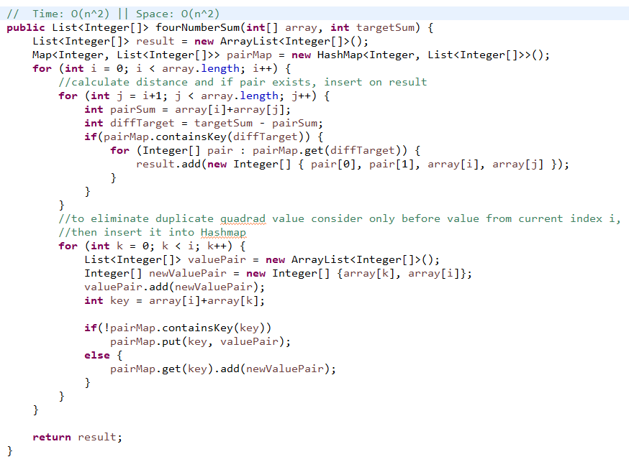

**Three Numbers Sum**

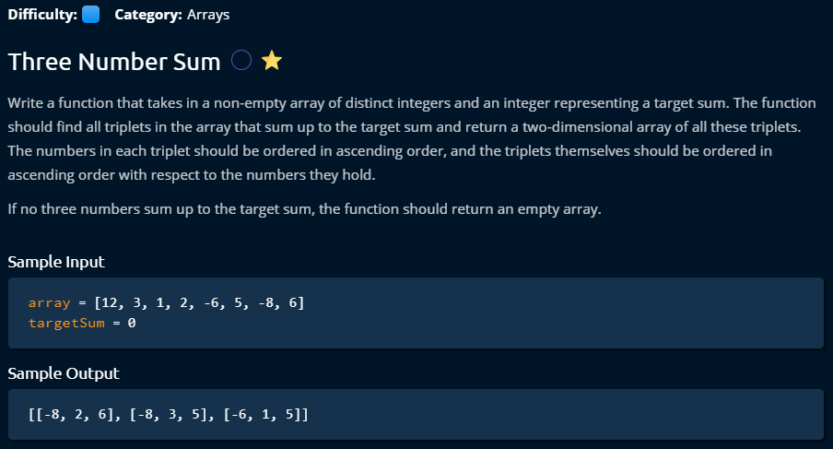

**Solution1**

This is the first solution which could someone’s mind, but it has biggest time complexity. We need to find something better to solve this problem.

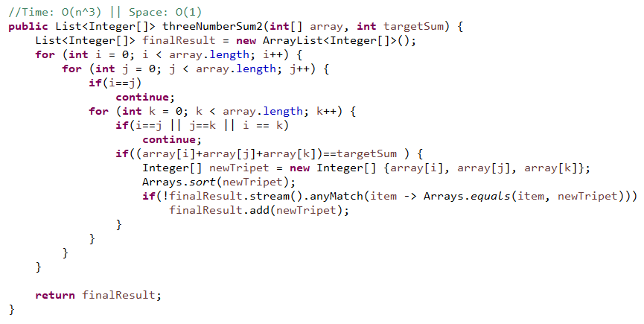

**Solution 2**

This is a good solution for this problem to solve. I have learned this technique from four numbers sum. This technique can eliminate duplicate (first half to store data and the second half to calculate if Triplet exists). It reduces the time complexity to O (n^2) but added space complexity to O (n) again. But for this problem to use this technique is too much thinking effort, because it could be solved in even easier way.

Let’s talk a bit about the technique which is used in this code to solve the problem. Here, first part is storing a pair of data in the map with the summation result as a key. If same key found, store only the value pair beside existing pair. The second part is only checking if the difference of current value and targetSum existing in the map. If yes that means current value and that pair would sum and make it targetSum. So, we got a Triplet. But the duplicate problem still exists which means same number was considered more than once. For that we need to sort the triplet before storing and compare with new one by java stream any match.

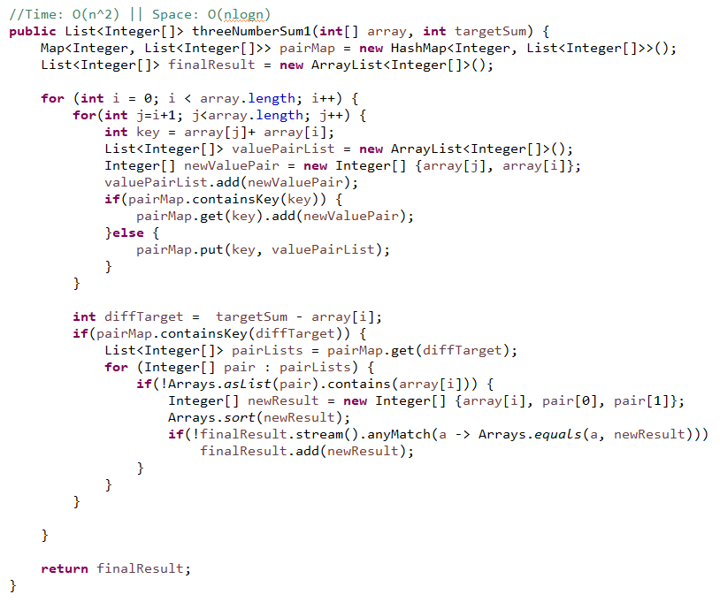

**Solution 3**

This is an elegant solution. It stores all the data into map once. Then try to find if the diff (the target and result of every two elements sum) is exists into the map. It reduces the time complexity to O (n^2) but added space complexity to O (n) again.

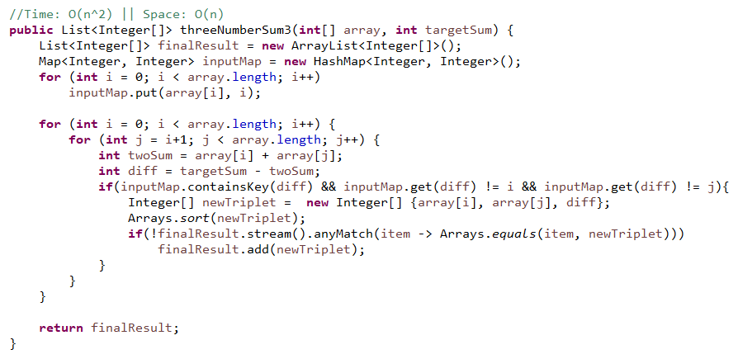

**Solution 4**

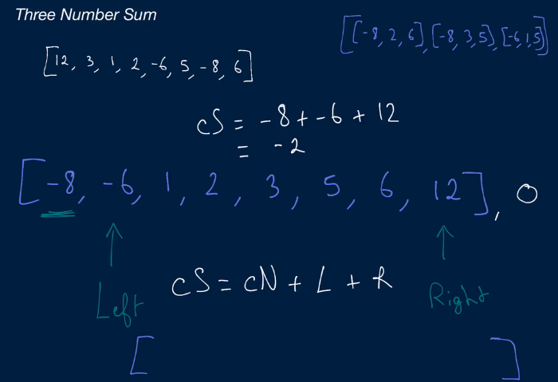

This is the best and simplest solution for this problem. This is very elegant solution which I have learned new. We just have to sort the array first. Then we get the opportunity to use two cursor policies with while loop because if you move left cursor, you get sum result increased and if you move right cursor left, you get sum result decreased. By this way you can find and optimal location to get targetSum. So, first for loop holding one element and then with while loop you can control two cursor to find optimal location to get triplets. It generates no duplicate triplets.

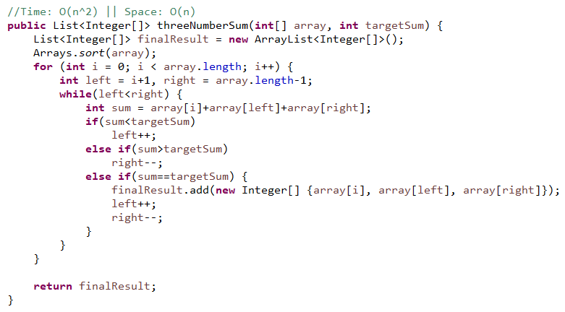

**Two Numbers Sum**

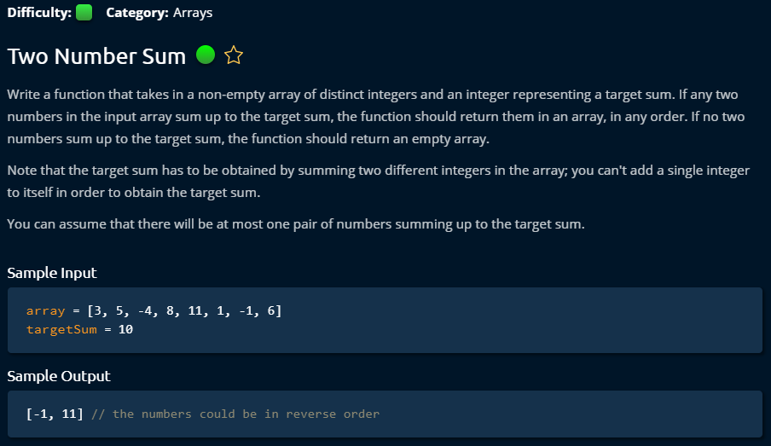

**Solution 1**

This is the general two loop solution which could come one’s mind when think about this problem. But it has O(n^2) time complexity which could be reduced if you think a bit deeper.

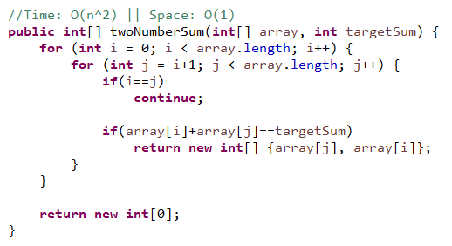

**Solution 2**

This is a two pointer solution. We need to sort it first to get this solution which is already O (nlogn) time complexity and O (n) space complexity. Even if it is an elegant and easy solution, due to complexity this is not the optimal solution for this problem.

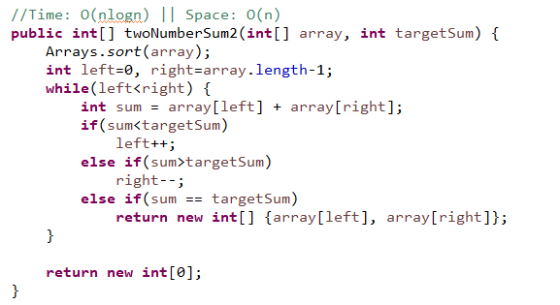

**Solution 3**

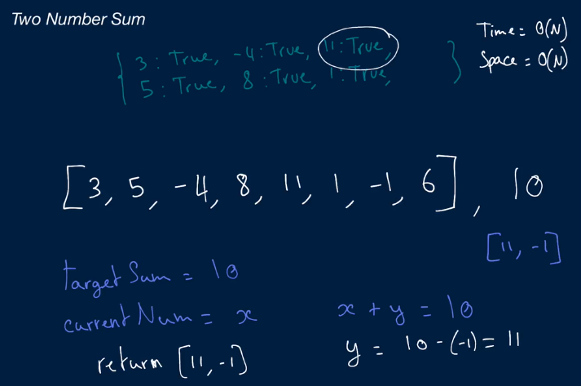

This is the most optimal solution for this problem. Using map, we have to store all elements and by just looking for the diff (targetSum and current element) into the map, we can solve the problem. This is very simple solution which time complexity is O (n) and the space complexity is also O (n) because we store all elements into the map once.

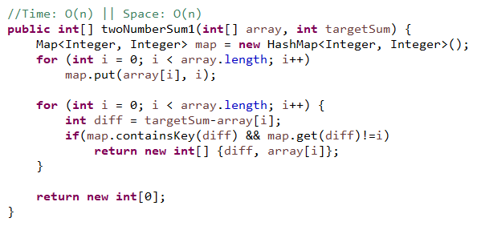

This is even more optimized. We don’t need to store the entire element of the array at first. Instead we can store only when we don’t find the diff for a data into the map. That makes thing simpler which could eliminate duplicate if same element exists **and space complexity reduced to O (logn).**

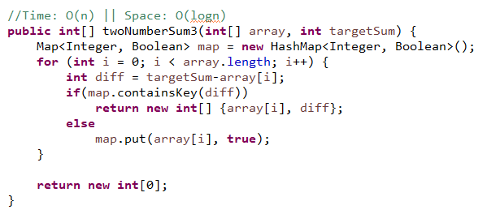

**Largest Range**

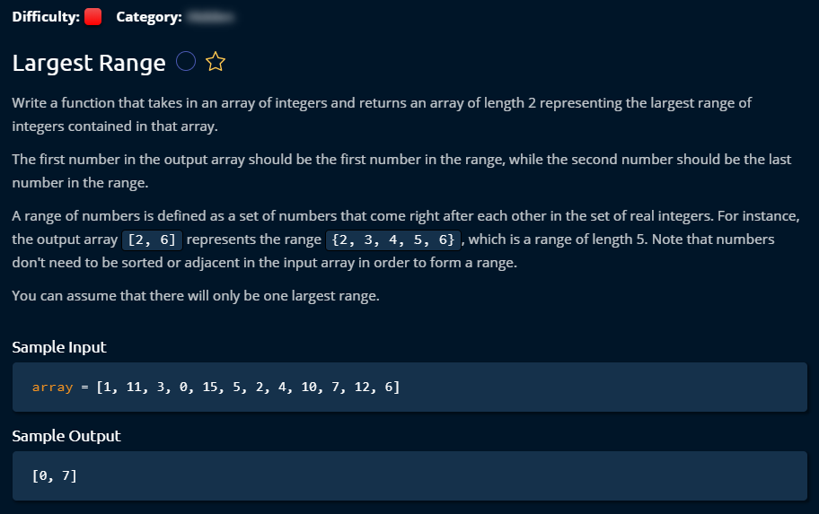

**Solution 1**

This is comparatively easy solution. But as it requires sorting, it requires O (nlogn) time and O (n) space. We can have lot more better solution by using Hashtable. We **can get O (n)** time solution.

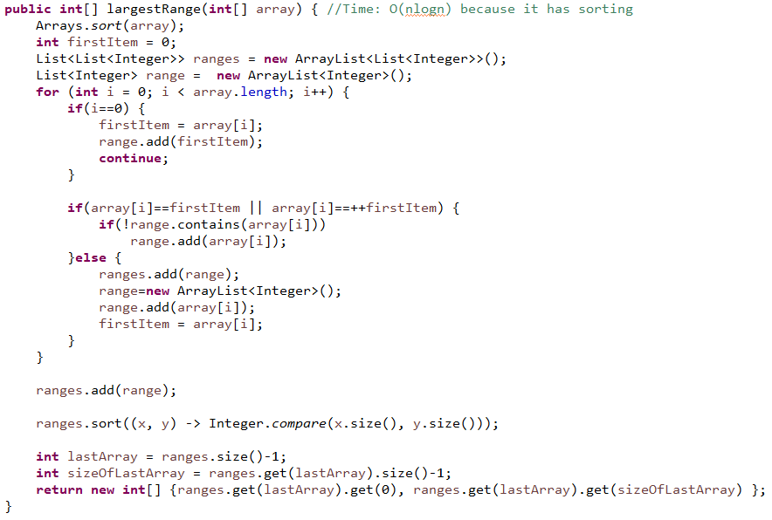

**Solution 2**

Instead of sorting, we keep these unsorted data in Hashtable where number can be a key and value can be a Boolean which can help us to keep track of if it is visited. This way we can keep it like maximum one visit of each element. Now, we have to pick one element from the input array and reduce one value and compare if exists in the hashtable. Same way increase one value and check if exists in the hashtable. We don’t have to even store the series in any array’s list. We can directly keep track of the index of biggest series and print the first and last item from them. That will reduce space uses.

Is the left number (that means -1) is in the hashtable? Is the right number (that means +1) is in the hashtable?

  

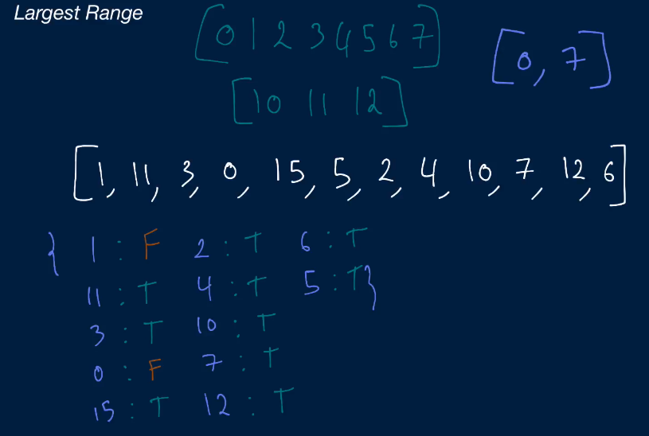

This is a genius solution with very few time complexity and space complexity. Hashmap makes it automatic sorting even we don’t use any benefit of it. One thing we have to be careful that Hashmap will remove redundant key and always use last updated key values.

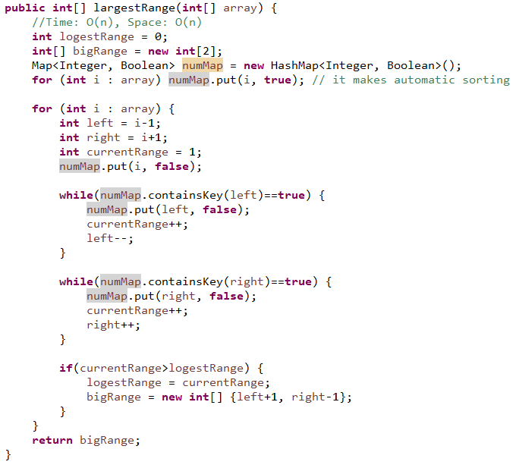

**Validate Subsequence**

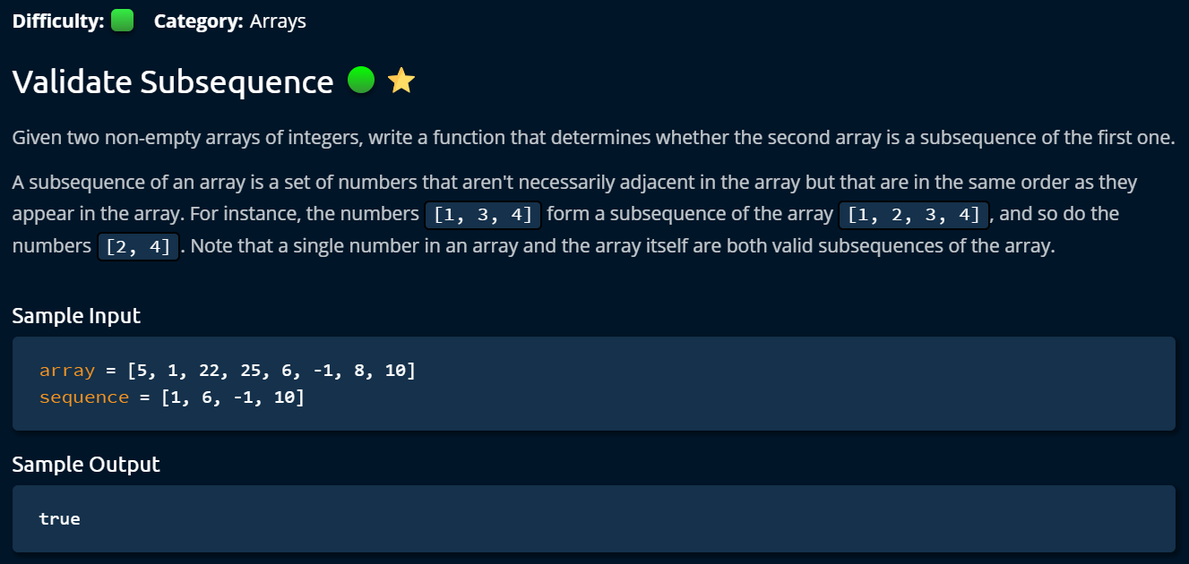

**Solution 1**

This is relatively simple problem. We used two pointer methods to solve the problem. We point the first number from sequence and compare it with each of the number from the array. When we find it we move the sequence pointer to the next number. And when we find all the sequence number, then we know that it is a valid subsequence.

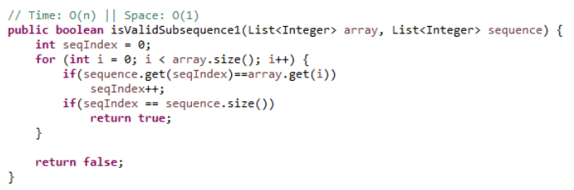

**Solution 2**

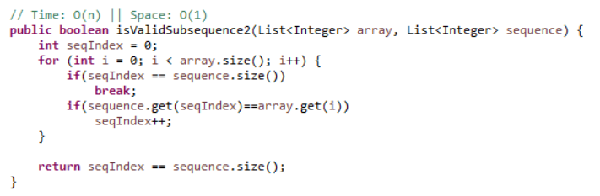

**Solution 3**

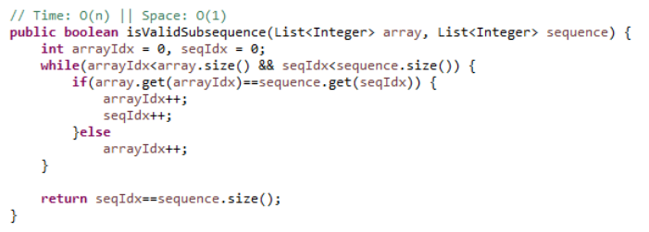

**Monotonic Array**

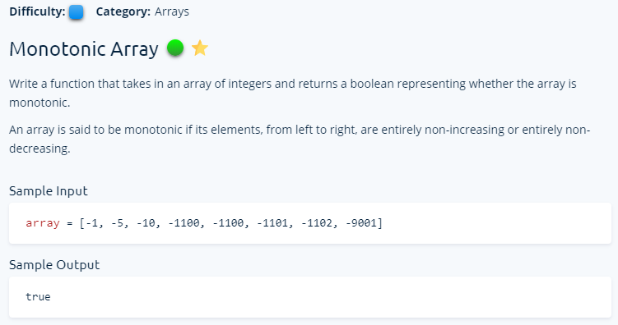

**Solution 1**

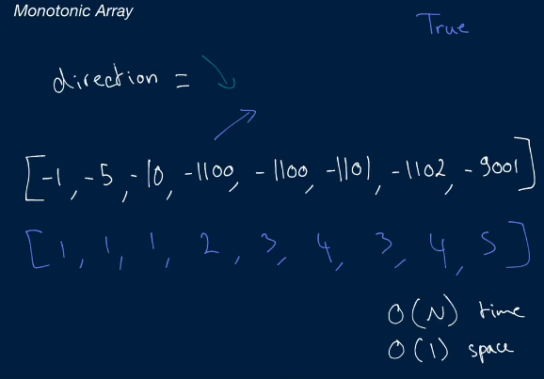

We have to find if the array is completely increasing or decreasing order. For that it is important to find out its direction first. We can either find that direction by for loop with majority count. There is one ore problem that the array could contain duplicate data which means finding trend is not easy by only single check.

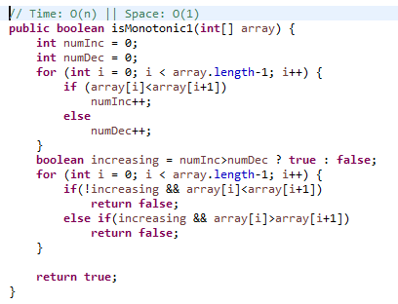

**Solution 2**

Otherwise we can manage that both job in one for loop. We just overlook when duplicate data came. Otherwise we can get the trend by first pair comparing.

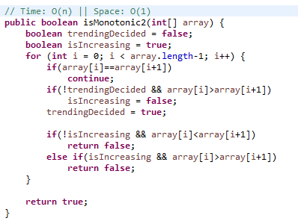

**Solution 3**

Finallythis is a elegant solution. Here by default we make both trend true. So, during the comparing of elements in array only one trend allowed to be false. If both of them false that means the array is not one trending or not monolethic. Even if the time and space complexity it does not helps, still it reduce a lot of logical hassles.

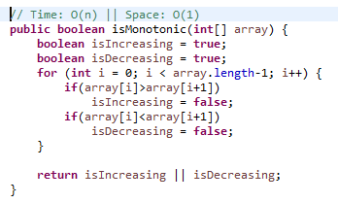

**Dynamic Programming**

**Max profit with K Transactions**

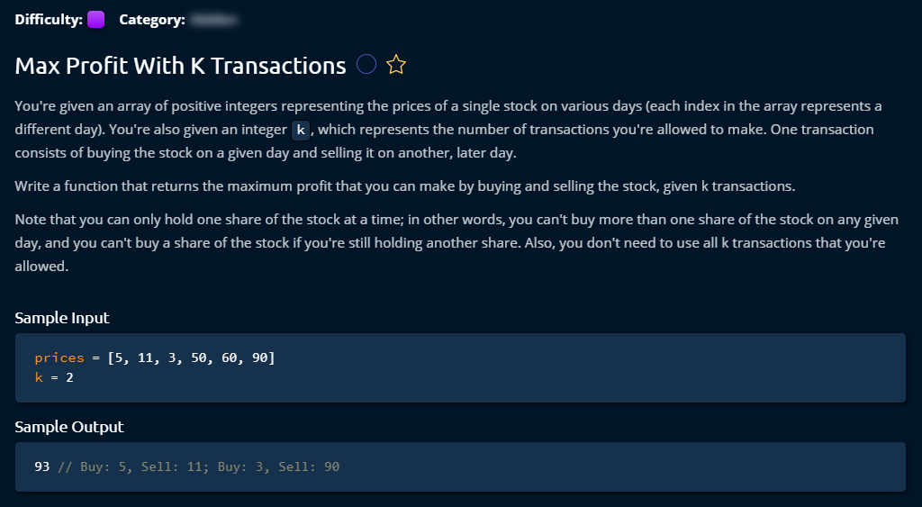

**Solution 1**

This was my solution for this problem. Probably the code implementation was lengthy. I used some of the theory from him for the calculation. This problem was a bit hard to cope up. I think I need to get back again after some more problem solving and see this one again if I feel any difference to understanding this problem.

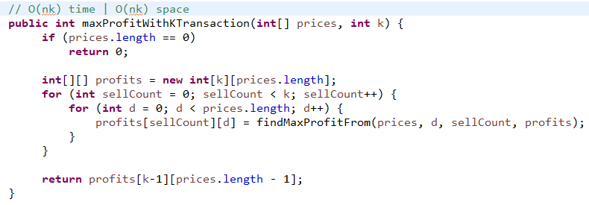

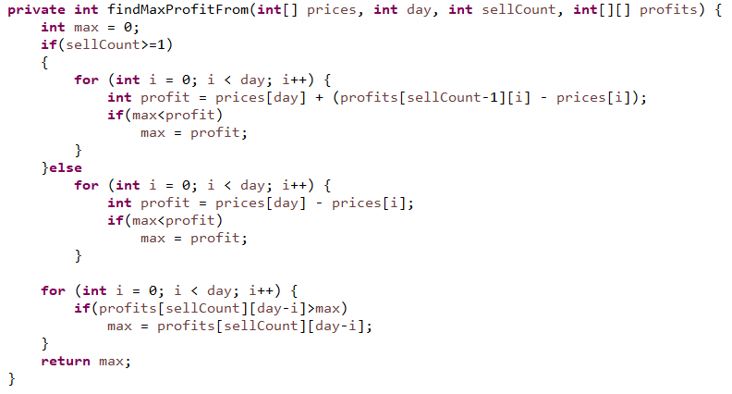

**Solution 2**

This is almost same algorithm as Solution 1. I did not properly understand how this Math.max and the discovered rules were developed. I need to come again after some day to check it.

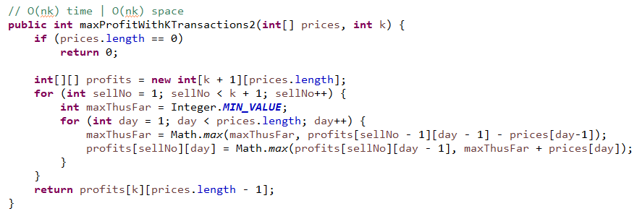

**Solution 3**

I did not properly understood how it reduced the space complexity

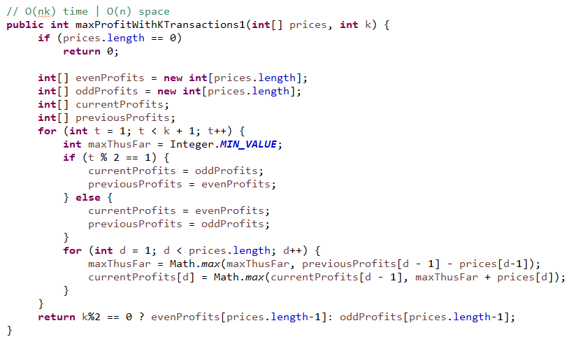

**Water Area**

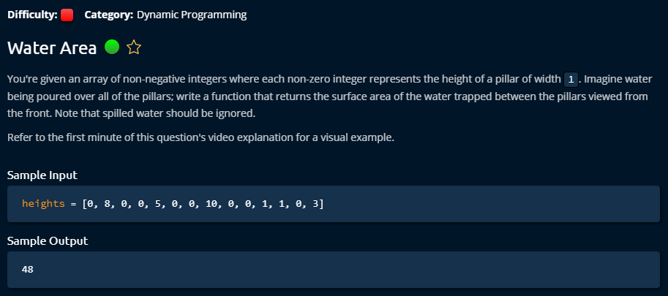

**Solution 1**

This one was my solution. I tried to generate sillingMap using complex logic. It worked but it turned out very hard to manage at the end. I had to manage four different conditions to store silling information. This turned out a nasty solution.

Too many if condition tells you that it is bad solution. When it is hard to manage you have to understand that you did not get right solution. And with pen and paper, I did not get the solution completely working, I just had feelings that it will work but still I have to figure out some part during the development. And it was hard.

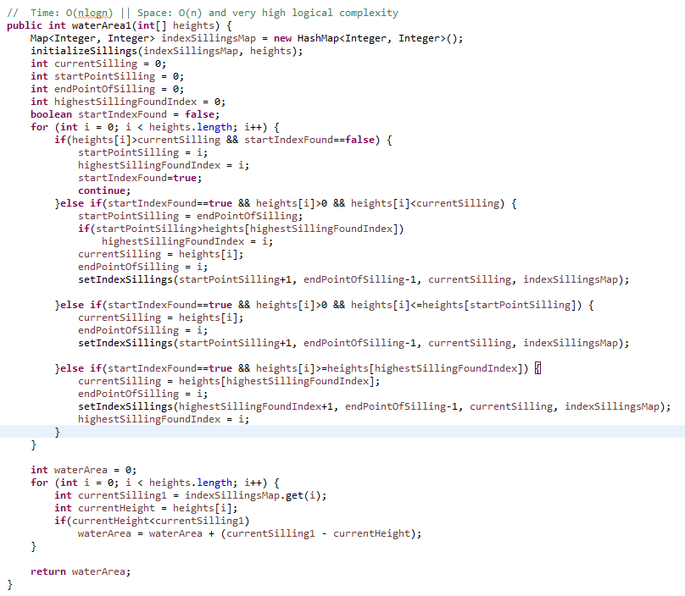

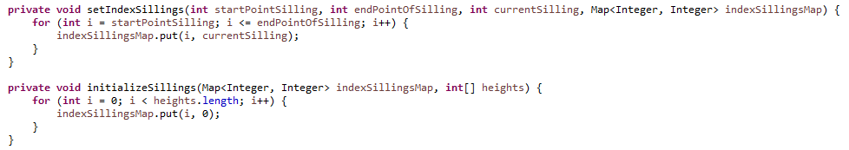

**Solution 2**

This is a decent solution. The theory was very decent which made the hard problem super easy to manage.

At the same time, it reduces some Time complexity. I had to generate two array which remembers left max and right max from current value of given array. And finally just decide the min height of each node, then subtracting, finally sum it up the results. The time complexity reduced to O (n) and gives a surprising code manage complexity.

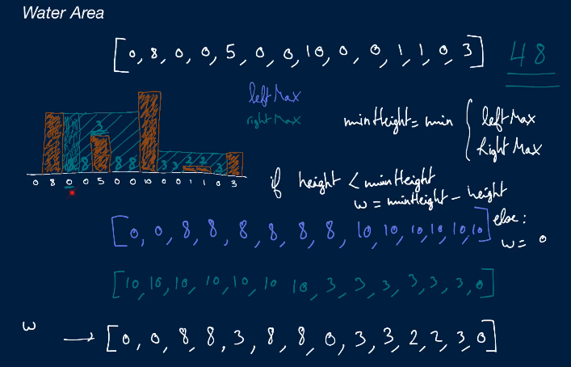

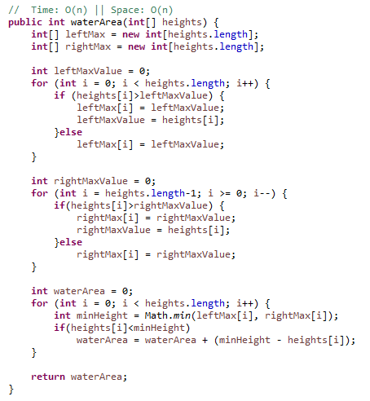

**Min Number of Jumps**

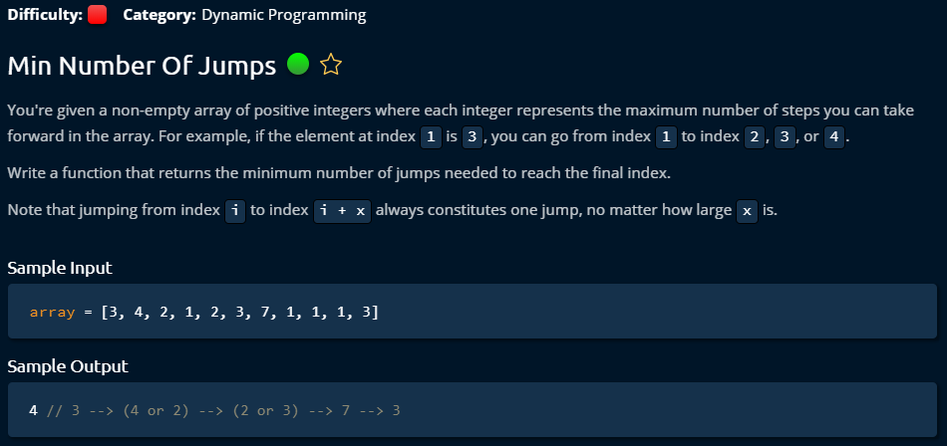

**Solution 1**

This is the first solution came to mind and very interestingly it was my first DFS based solution on any problem in life. I learned DFS few days ago properly. The idea is that it will store all the accessible nodes from current node and with that it will store number of level or number of jumps. And it stores also current location to keep track.

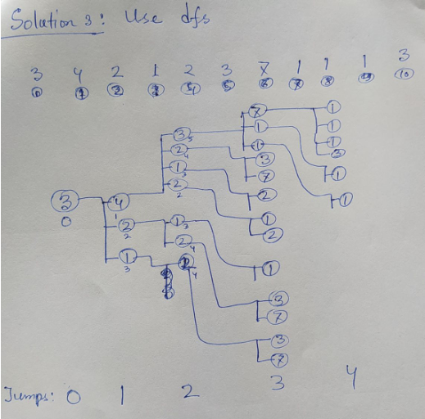

DFS deals with number of adjacent nodes and goes to first child’s deep, and come back to go the second child and go to next deep. This is suitable for this problem. In the stack, we add the all the reachable nodes on every iteration. Then we pick one element from top to see his child. If he has child we add them in the stack to find their deep. We keep track of node’s location and node’s level as curJumps. On every level, we just increase curJumps to keep track. It requires O (n^2) time and O(nlogn) space since we need to save all the child for each node.

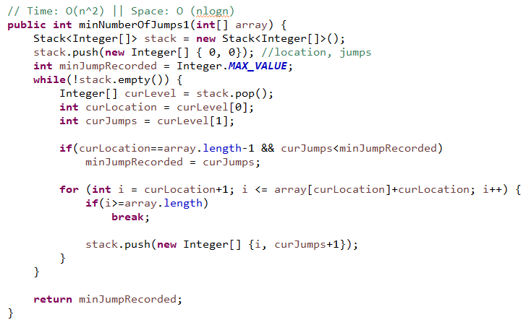

**Solution 2**

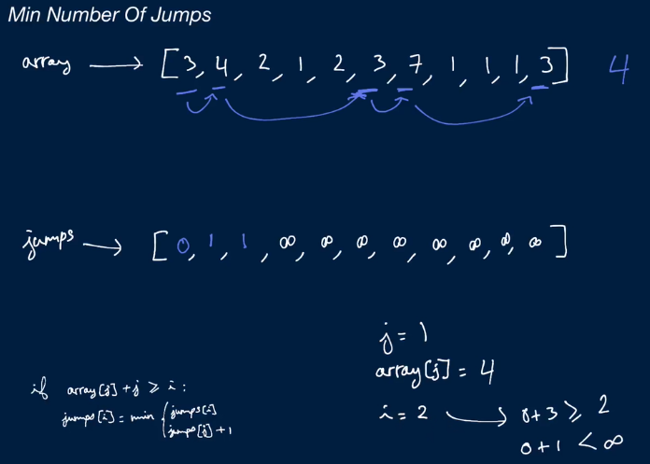

This solution works by calculating required jumps from previous node. The idea is that by double for loop, checking only left nodes if they are reachable to current node. If they are not reachable, it requires a jump. We make a jumps array. By default, we add infinity to the entire jumps array except first element. First element we set 0 since we do not need any jump to reach there. Then we check what are minimum jumps required for each particular nodes to come to current node. It requires O (n^2) time and O(n) space since jumps array is same size like given array.

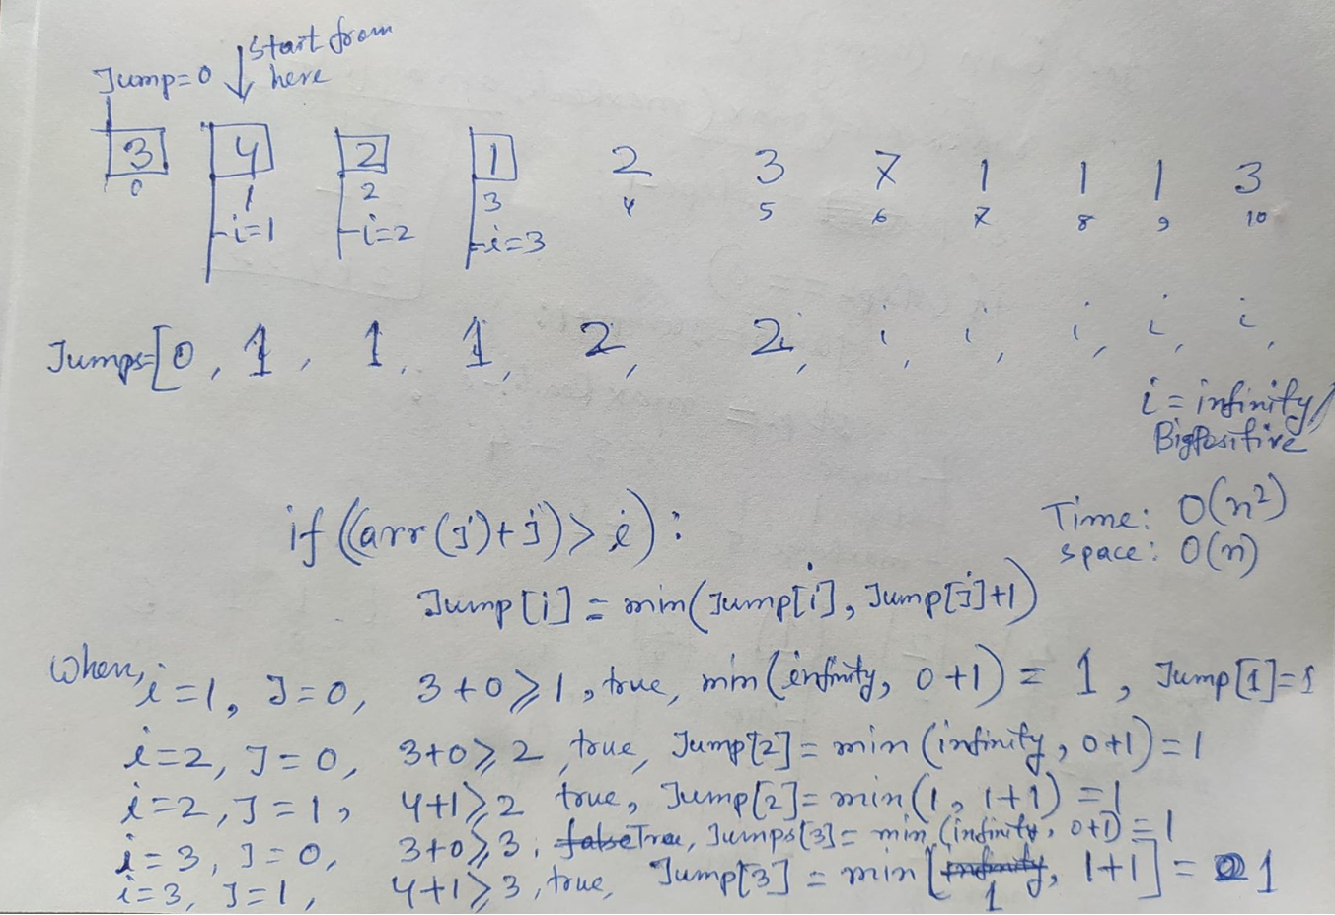

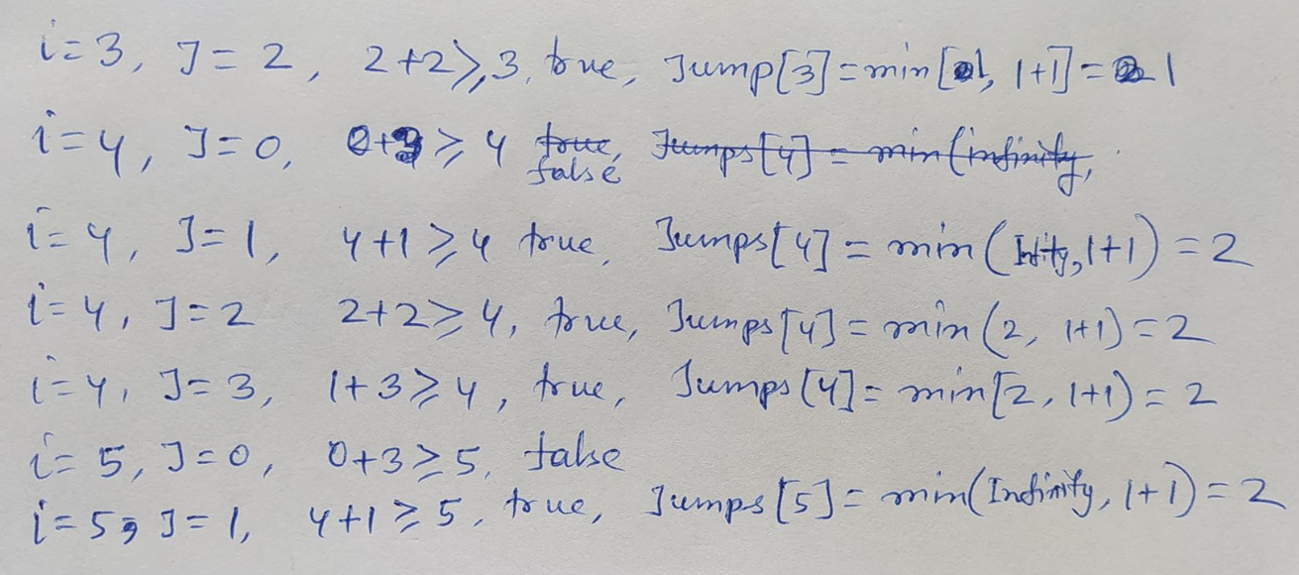

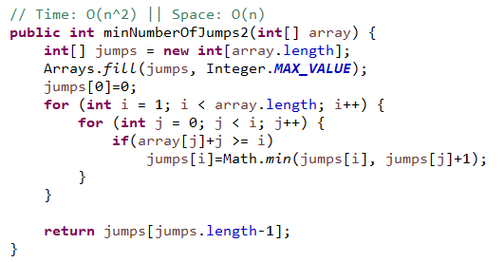

**Solution 3**

This is the best solution for this problem by Clemen. By keeping track of three variable: steps, maxReach, jumps, it calculates how many minimum jumps would be enough to go to end. Initially,steps and maxReach is 3 as first element value is 3. Moving to each next node would reduce steps to one more. When the steps is 0; that means we need to jump now. At the same time, until jumpable node to find, we consider all other nodes to find maximum reachable location from any of the node behind to forward. At the time of steps became 0 or jumps, steps become the rest of the maxReach from the current node. We just need one loop to complete all the operation. It requires O (n) time and O(1) space.

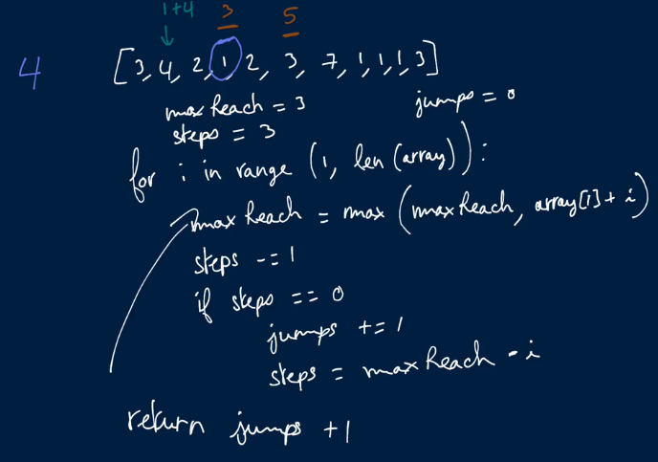

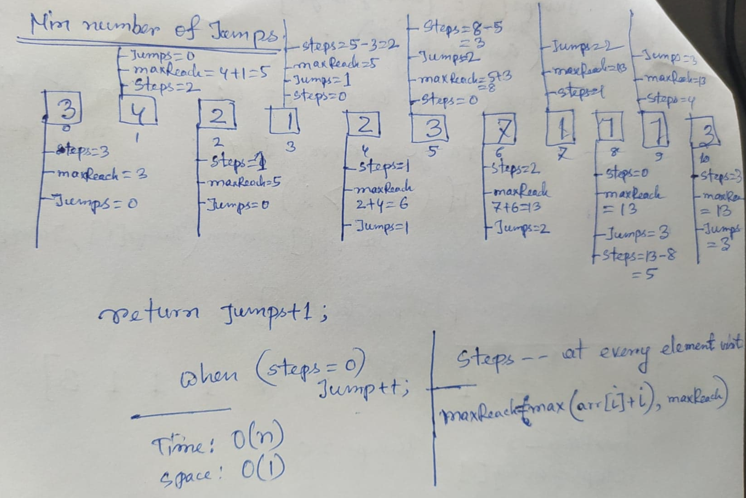

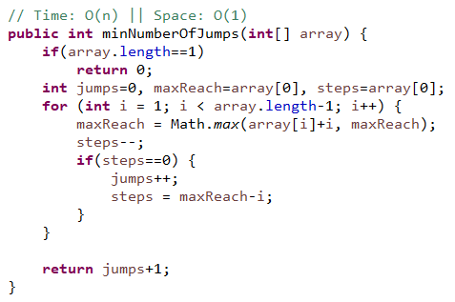

**Number of Ways To Make Change**

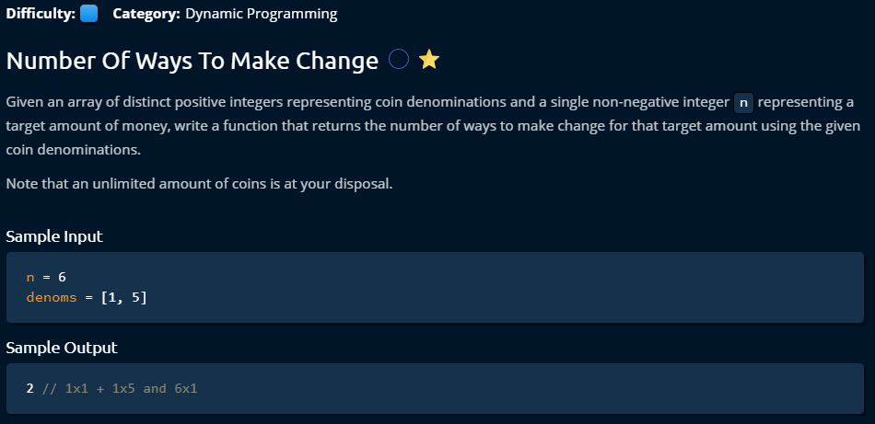

**Solution**

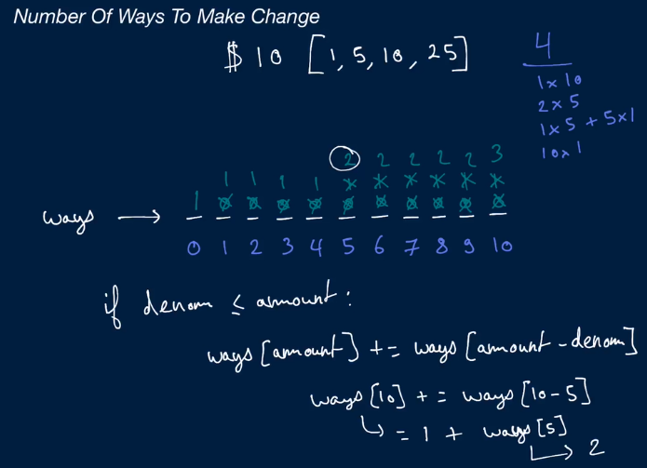

This one was pretty complex to understand. To do this dynamic problem, we have to approach completely different way. We just make a ways array for the target amount but for each of the number from 0 to target element. And we calculate them for each of the given coins. 1 dollar coins are applicable for each of the target because it could be possible to organize by 1*1 to 1*10. When it comes to 5 dollar coin, then until 5, it was not possible to get more ways. When it comes to 5 target, we can organize it by 5*1 to make 5 dollar. So, the way increases to 2. When it is 6 dollar target, we know 5 can be applied to make 5, but still 1 remains, so for 1 the number of ways must be picked from ways array again. So by both 5 and 1, it is possible to generate a way.

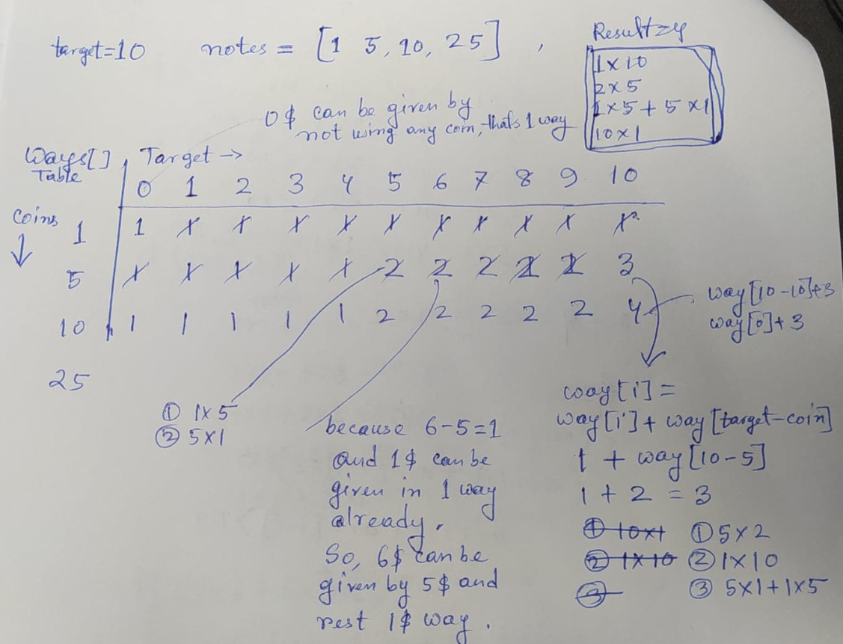

Code is pretty simple,

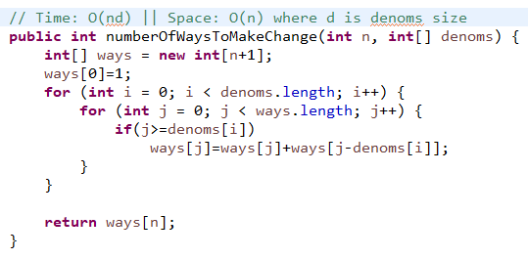

**Min Number Of Coins For Change**

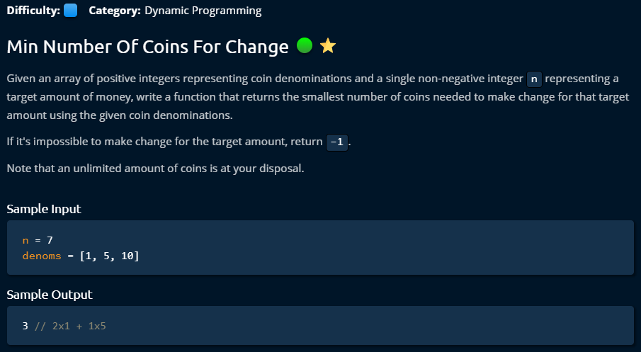

**Solution**

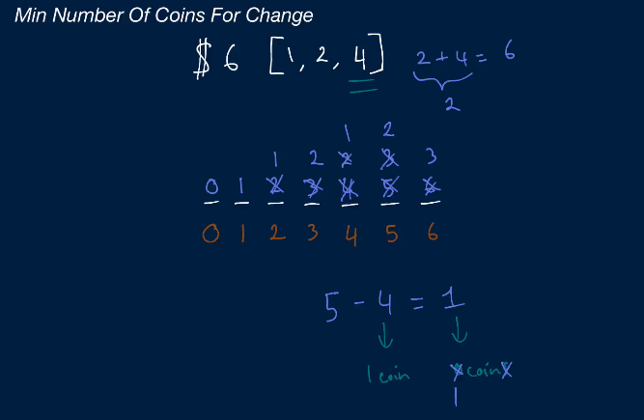

This is very similar like number of ways table. It stores only the amount of a particular coin can make a target sum. By considering new coins, it always keeps only the minimum number of coins in the m array. 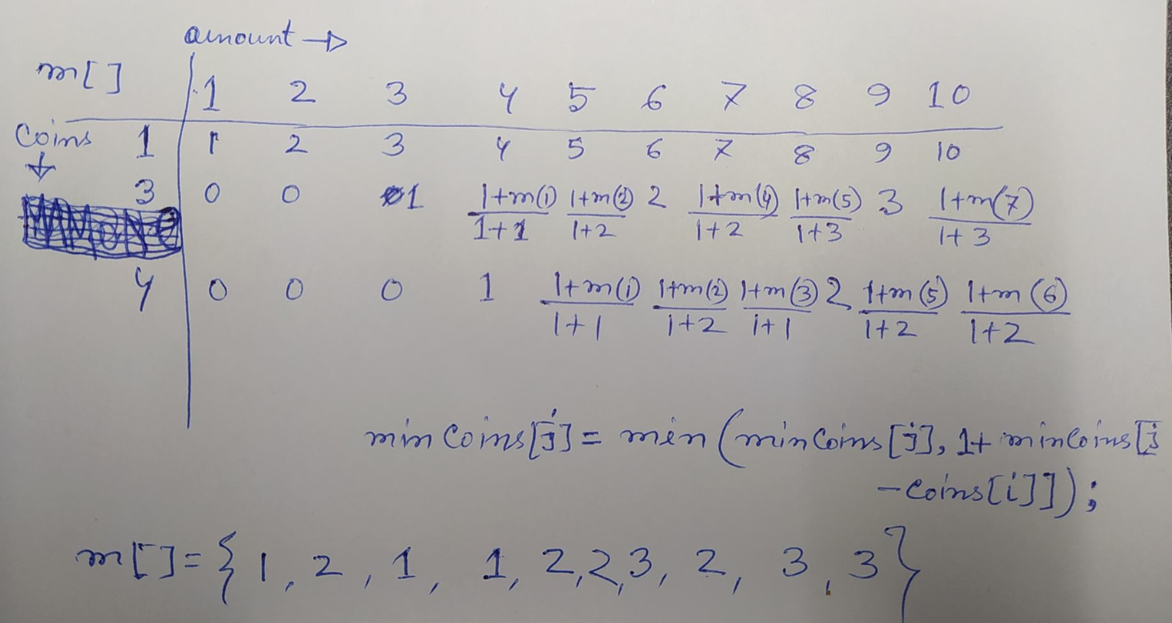

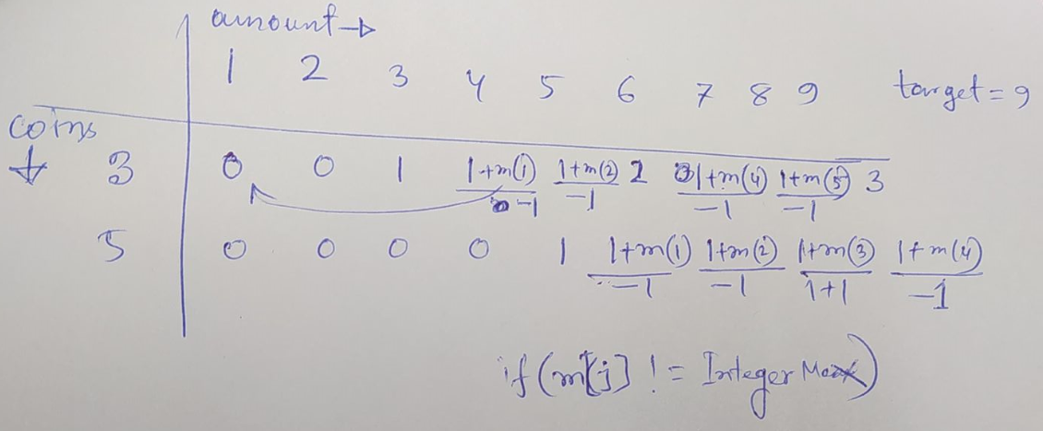

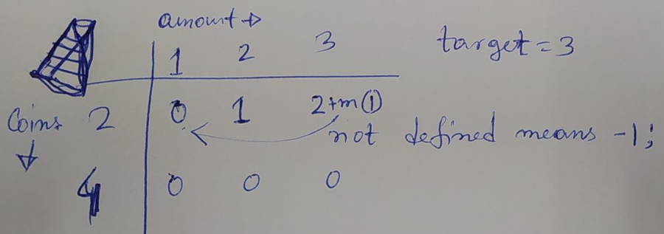

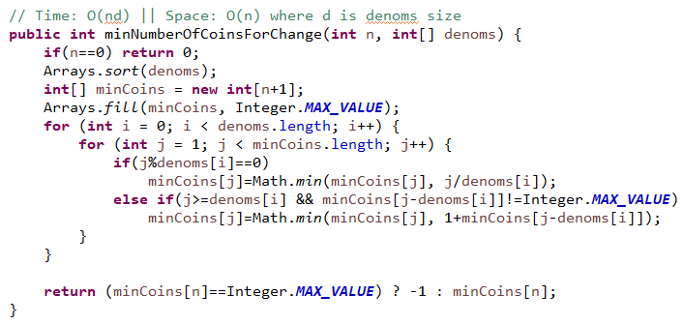

**Knapsack Problem**

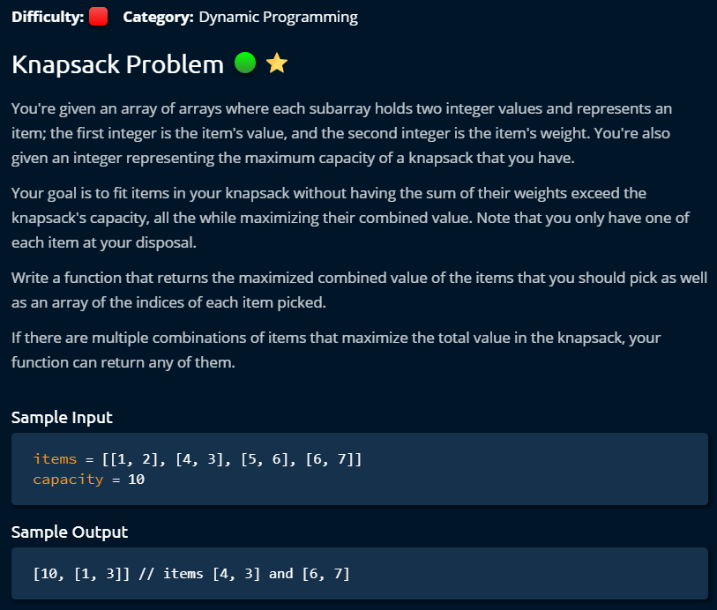

**Solution**

Managing this problem manually is very hard. So we have to deal it with dynamic programming. The idea is, we generate a table based on weight restrictions from 0 to given weight based on given items. By that for a certain value with items, we know what other item we can take in the bag. We just have to get back to that weight location by subtracting current weight location.

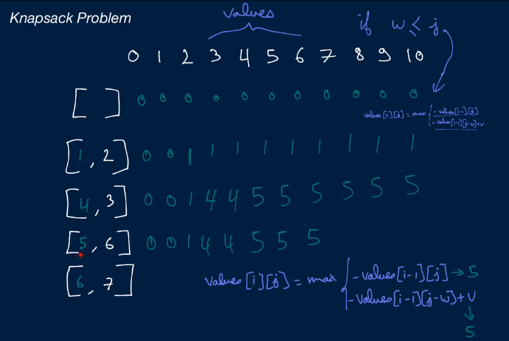

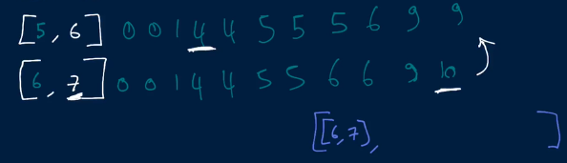

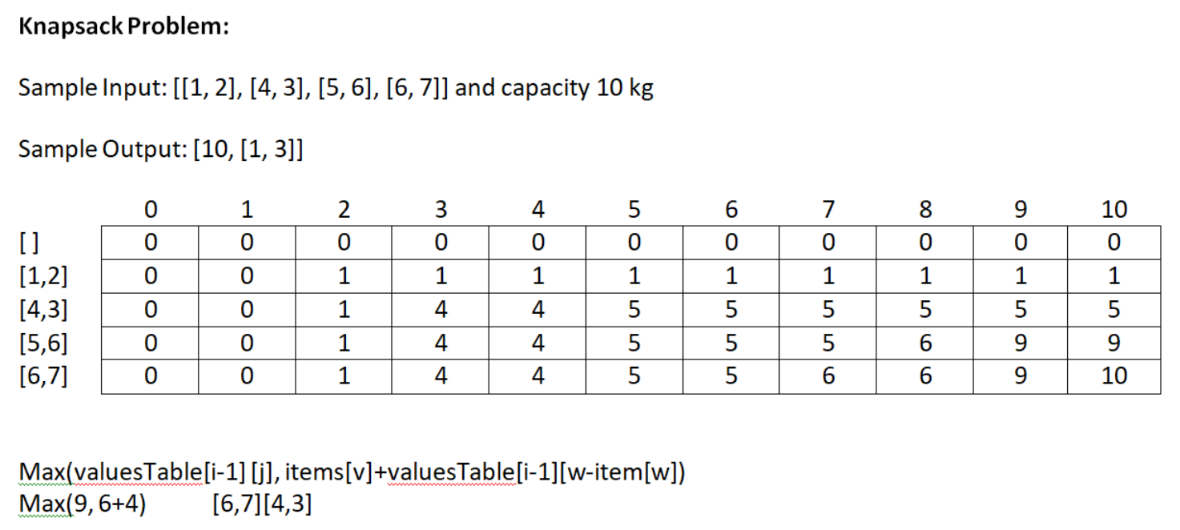

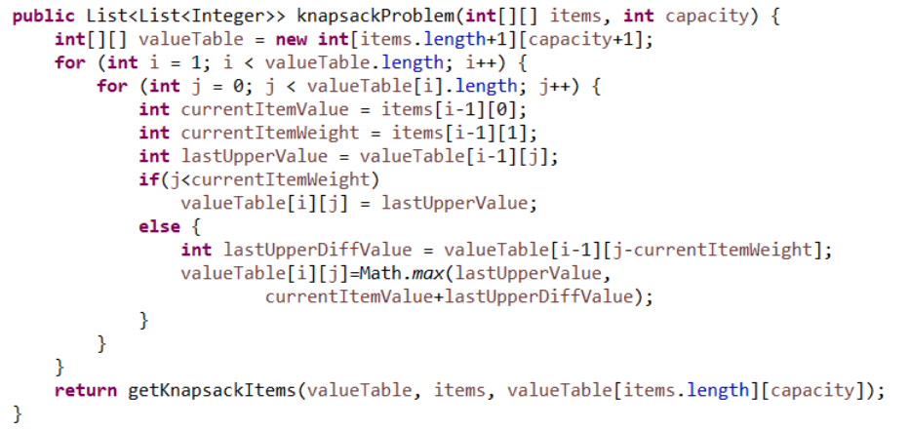

When the upper row value is same that means it took that upper row items. So it will go up until it finds any different value. When the upper row value is different that means it took current items.

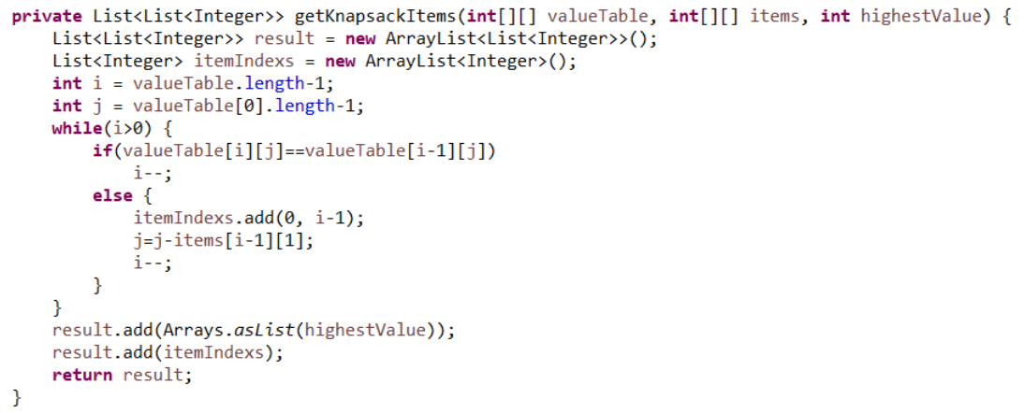

**Max Subset Sum No Adjacent**

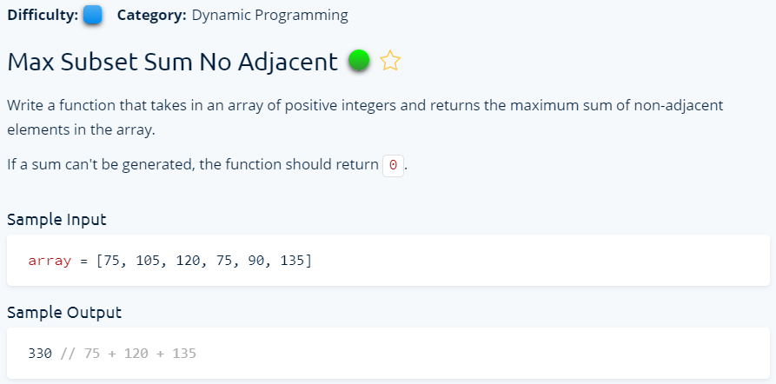

**Solution 1**

We have to find max non adjacent numbers sums from this array. As a dynamic problem, we can make table which will incrementally store the data. The first number has no adjacent problem. When it comes to second number, we can only take first one or second one because they are adjacent. The third number will be calculated based on the maximum value between maxSums previous number or its prev-prev number plus current number from the array. Because, the prev-prev number is the generated non adjacent number from current number of the array. O(n) time and O(n) space complexity.

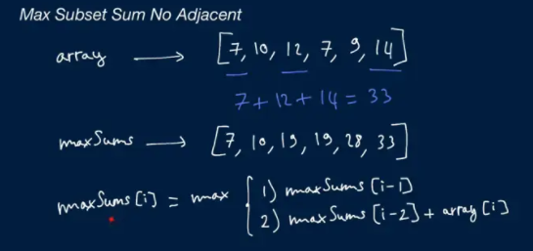

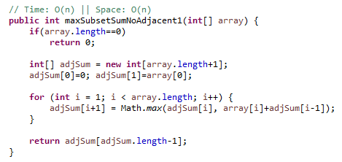

**Solution 2**

If you need to use only last two variables from an array, then instead of array you can just use three variables. This is how for this case the space complexity turned to O(1).

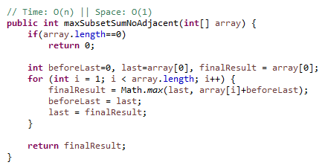

**LinkedList**

**Construction Linked List**

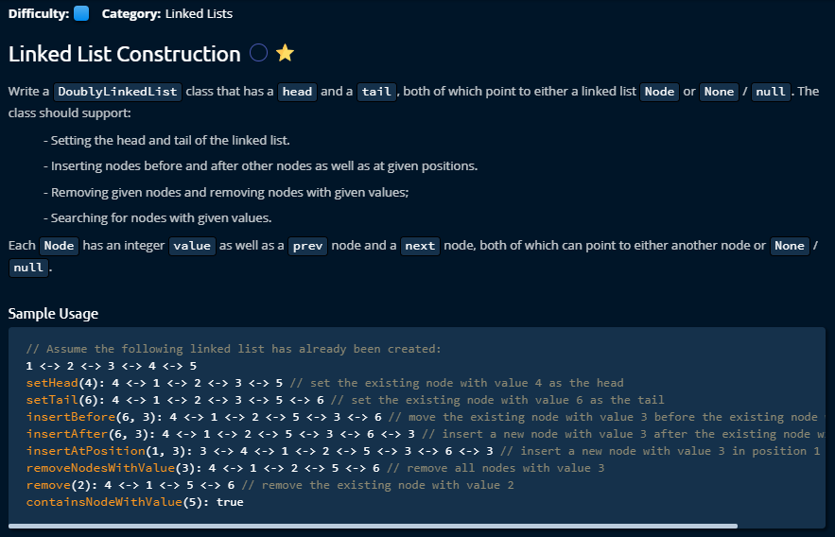

The given Linked list to test all the functionality is following. There are two types of Linked list, Single Linked List and Double Linked List. Here is a double link list given where each node has four different connections. To manage any operation like add a node or delete a node from the linked list from double linked list, we have to deal with all the four pointers that makes linked list so interesting. During any operation of linked list, we have to consider that the list must stay stable after any operation which means it should have stable connections with other nodes.

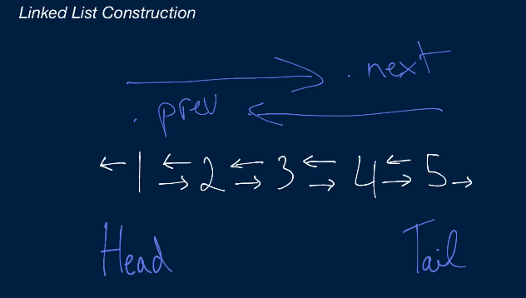

**Solution:**

Since we can reuse some method implementation, we can start from searching a node with a value. A class node will be given which contains node’s value and a link to next node and previous node.

**ContainsNodeWithValue (int value)**

For searching a node from the given linked list, the first things that we have to do is, set the current pointer to the head of the given list. Then we can travel all the nodes by node.next pointer movement. During the travel if the node is null, that means we reached to the end of the list.

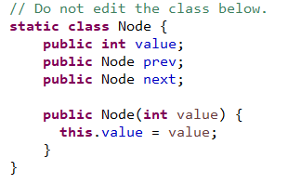 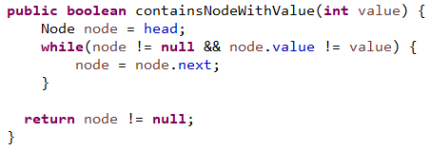

**Remove (Node node)**

To remove node, first we consider the corner cases that if the given node to delete is head or tail, then we have to move the head or tail to one node after or before. After that we can remove all of the connections from that node to other nodes.

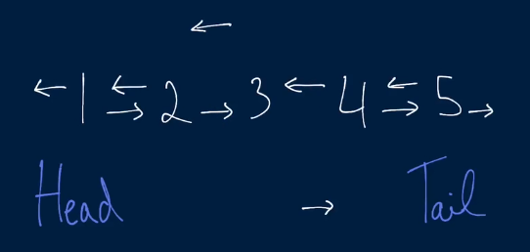 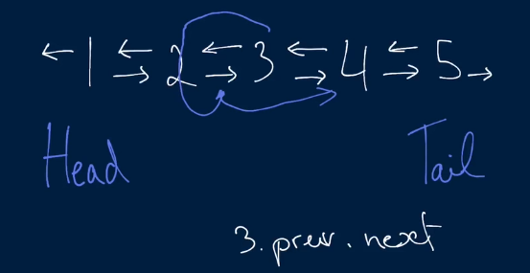

To remove the connection, first we need to think about the connections which are coming from other two nodes to the candidate node. Using Node.prev.next and Node.next.prev we can set up next and previous node’s connections to each other. Then we can set another two connections (two connections from candidate node) to null. That’s it.

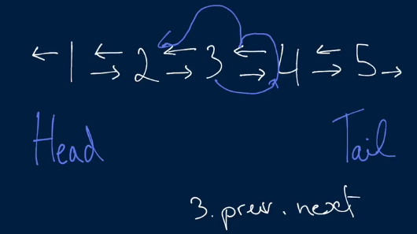 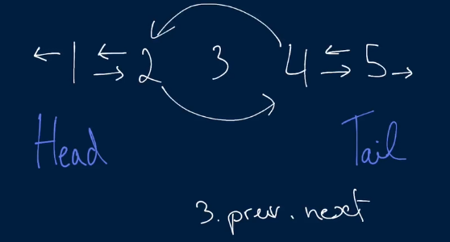

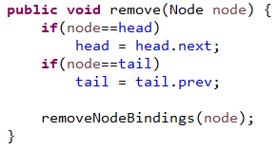 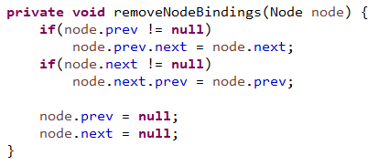

**RemoveNodesWithValue(int value)**

To remove node with particular value, first we have to search it from the list. To search, we need to set Head to the current node and using Node.next we can travel all over the nodes. By comparing by value when we find it, we can remove it using Remove method.

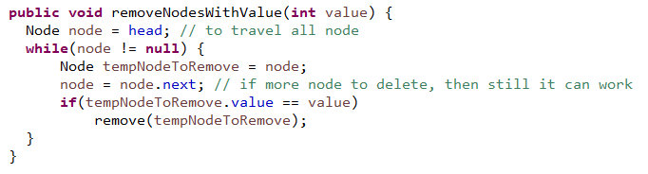

**insertAtPosition(int position, Node nodeToInsert)**

For inserting to a position of the linked list, first we need to find the node at where we to insert this node. If the position is 1, we can set this candidate to head. Otherwise, we have to travel over the node and by keeping track the number of nodes by a variable. When we find that node’s position in the list, we insert it by just using the method InsertBefore of that node. If we don’t find it, the last node will be null, so need to insert this candidate Node to tail of this node.

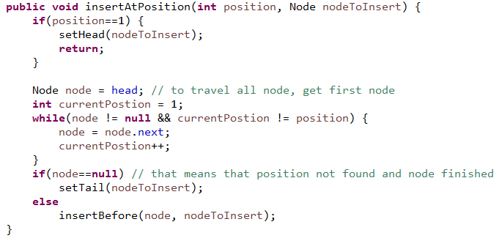

**insertAfter(Node node, Node nodeToInsert)**

Anode has to be inserted where first we need to remove that node from the given list. First of all, we need to think about the corner case that if there is only one node came in the given list and if the node is same as the candidate node, then we do nothing and return because it makes no sense to remove and insert same node.

Other wise after removing the node, we need to take care all the four pointers again for the new node. As we have the information, first we insert prev and next node for the candidate node. Then we need to think about if the next node is exists, if yes then the link from previous node to the candidate should be set. And finally we can set the given node’s next pointer to the candidate node. That is it.

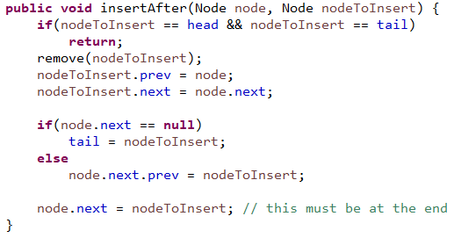

**insertBefore(Node node, Node nodeToInsert)**

InsertBefore is very similar to insertafter method, only the node’s pointer to take care is left oriented.

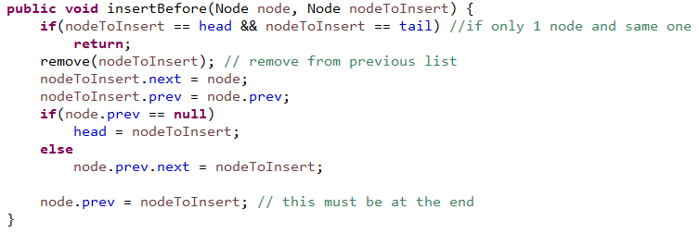

**setHead(Node node), setTail(Node node)**

To set Head and Tail, we need to use some of the existing method. Both of them are very similar. First we need to take care the corner cases as usual. For the case SetHead (node), if the head is null that means it is an empty list, then we only do set head and tail to the candidate node and return. Otherwise we just insert this candidate node before existing head. That’s it.

For the case of SetTail, we need to insert the candidate node after the tail node. That’s it.

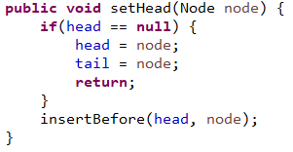 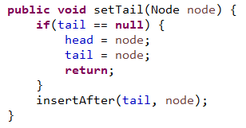

**Remove Kth Node From End**

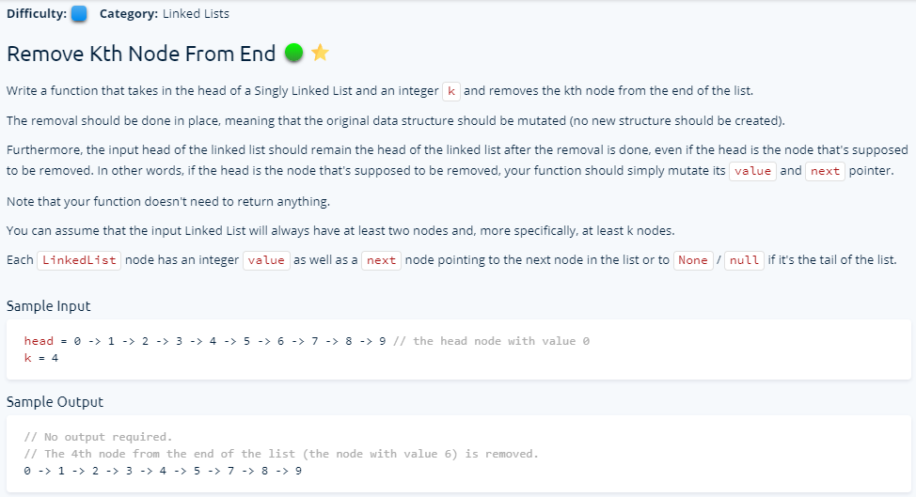

**Solution 1**

This is a one directional singly Linked List. We have to delete K element from the end of the linked list. The problem is that from the end we cannot come back as it was singly Linked list. So, I introduced two pointer methods. The second pointer will start when current pointer is already moved to the Kth position. That is how the second pointer will take the right position when current pointer reached to end or null. We just have to skip one number and make connection in the chain. The only problem remains when K is equal to size of linked list, then we have to delete the head node. We can detect it by comparing k and counter when they are same, and then put the next node head. That’s it for that condition.

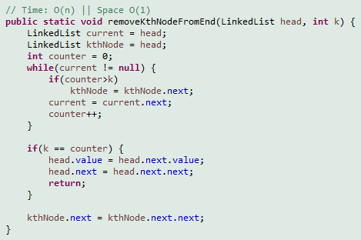

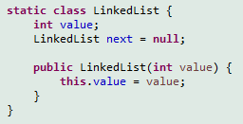

**Solution 2**

The other way of solving this problem is to move the first pointer until k and then move both first and second pointer together until end of the linked list. The same way as before we did, when the first pointer pointing to the null; that means 2nd pointer is at the place where we can delete next node. And the when first pointer is null by mobbing until k, that means the node to delete is same size as linked list, so we have move the head to one node forward.

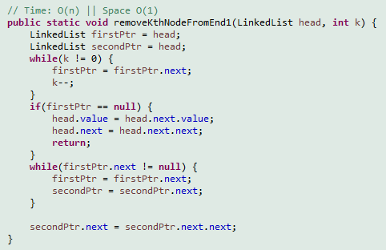

**Searching**

**Find Three Largest Numbers**

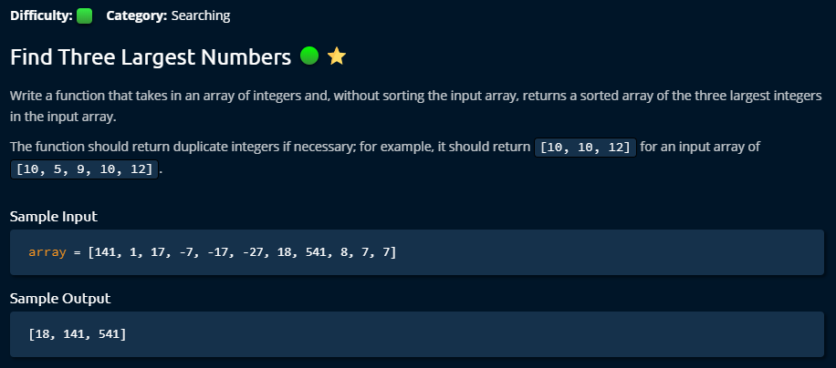

**Solution 1**

This solution came from me. I am happy that I was able to do it on 7th day. And the time and space complexity remain elegant from my solution.

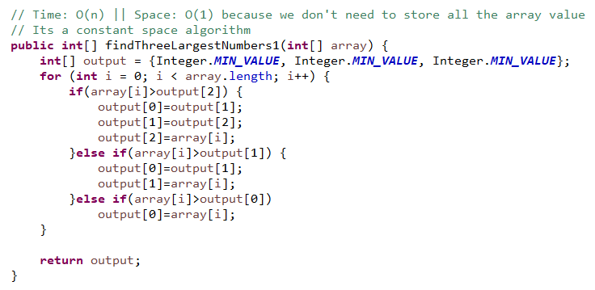

**Solution 2**

This is quite similar like my solution. The only difference is that it extracts a method to do dynamically the operations. And the time and space complexity remain same.

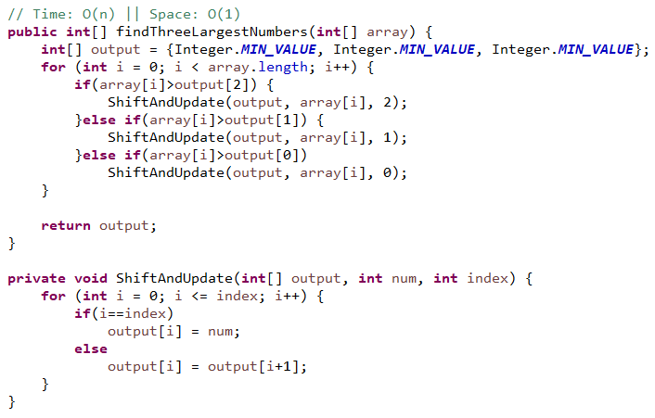

**Binary Search**

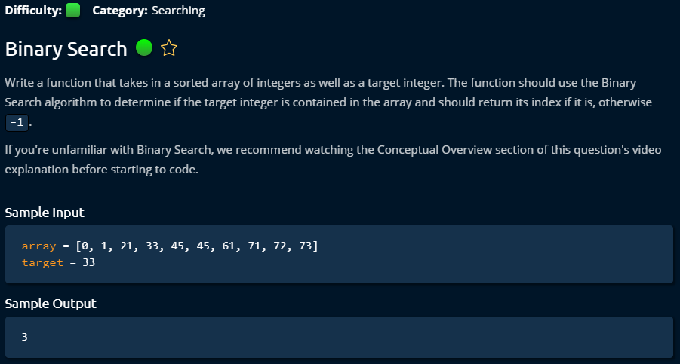

**Solution 1**

To do binary search, input array must be sorted. My general solution which costs O(n) in worst case when data not exists.

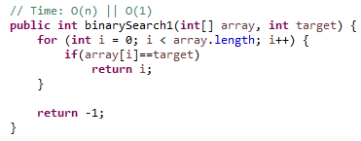

**Solution 2**

This is an elegant solution which reduces a significant amount of workload by eliminating half of data in each iteration. It starts with two pointers in left and right side of the array. Then it calculated middle index, and if the middle index is more than the target value, then left index is changed to middle +1. That’s how it reducing half of it every time.

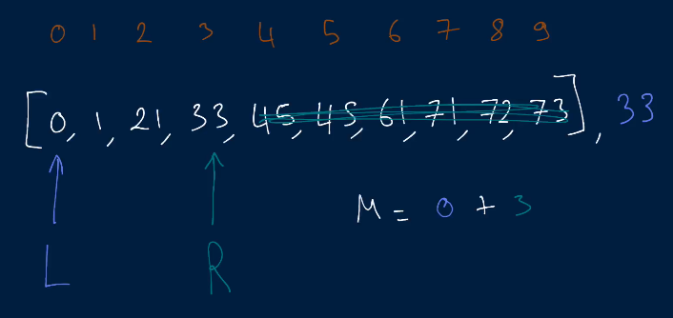

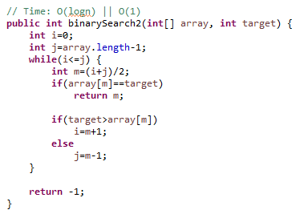

**Solution 3**

The same while loop job done in Solution 2 is done here by a recursive method calls. It shows recursive method job can be done in while loop. I like while loop more because to do recursive call we have use call stack which is not memory friendly (it can make problem when you have limited memory in server) and hard to track bugs, but while loop don’t need that.

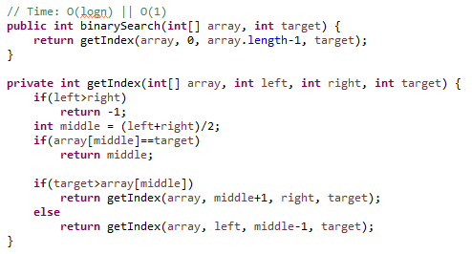

**Search in Sorted Matrix**

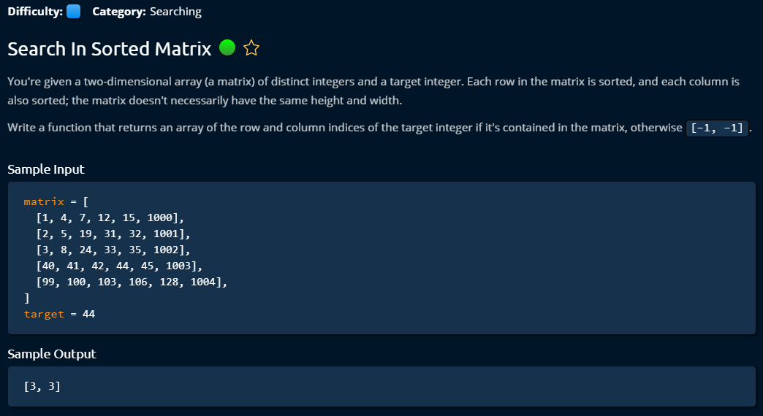

**Solution 1**

It was my solution. I used same idea of binary search in each row, when it is not found then moved to next row.

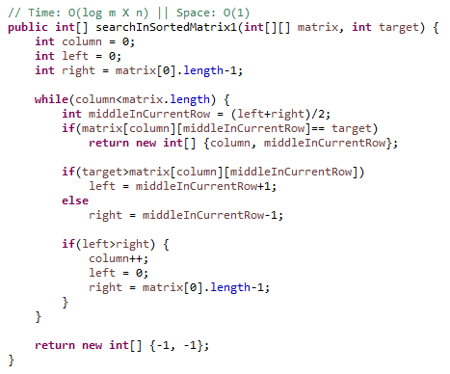

**Solution 2**

This is a genius solution from Clemen. It can be used many places. It starts with first row last index. If target is bigger than current index, then we move down by increasing row, otherwise we move left by reducing column. That’s we have to just visit maximum one row and one column to find out if target is there.

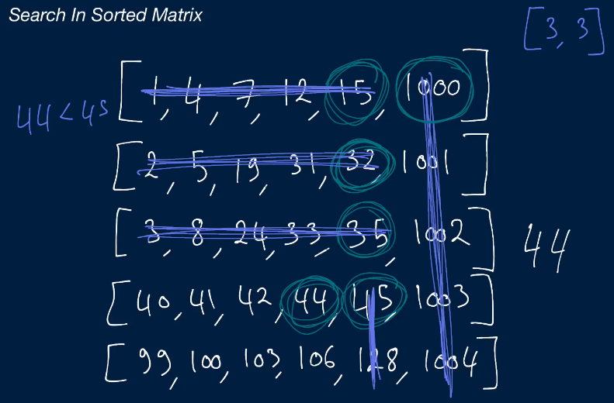

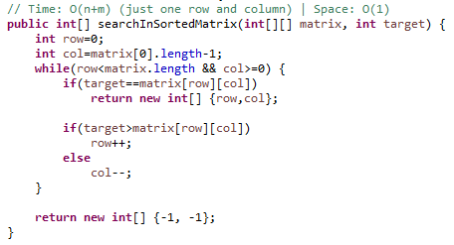

**Binary Search Trees**

**Construction**

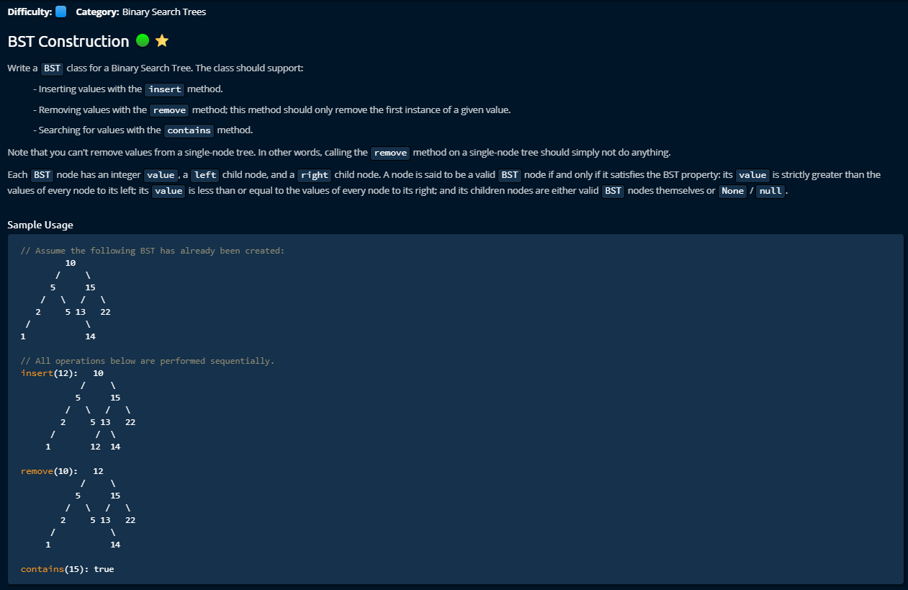

**Solution**

This was very complex to manage. I lose interest to make its document. I will make its document later when I am finished with everything else.

**Find Closest Value in BST**

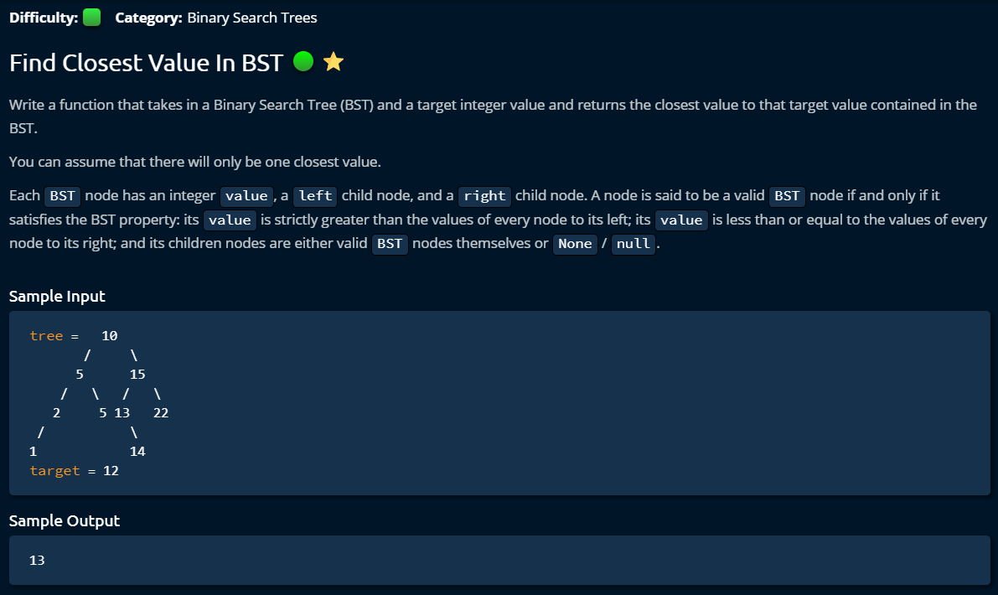

**Solution 1**

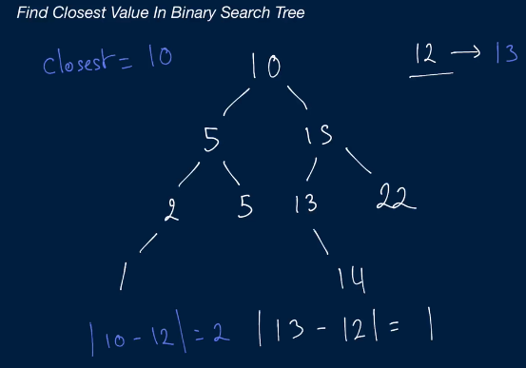

We store the node’s value when we find any node difference from the target less than previous one. That is how we remember closest node value from the target.

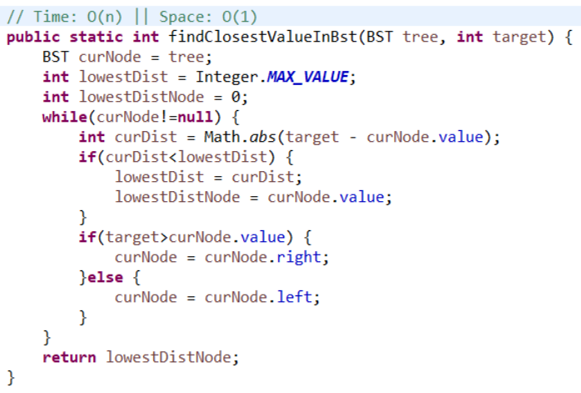

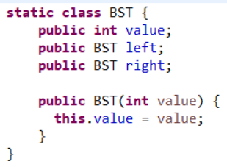

**Solution 2**

This is a recursive solution of this problem. We provide tree.value for the first time which is going be used to remember the closest node’s value. Then in the recursive method every time we compare if we found any closest node than earlier one.

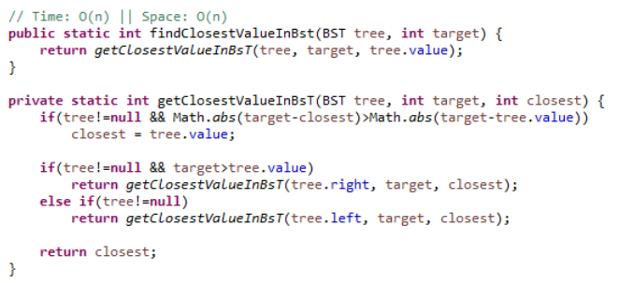

**Validate Binary Search Tree**

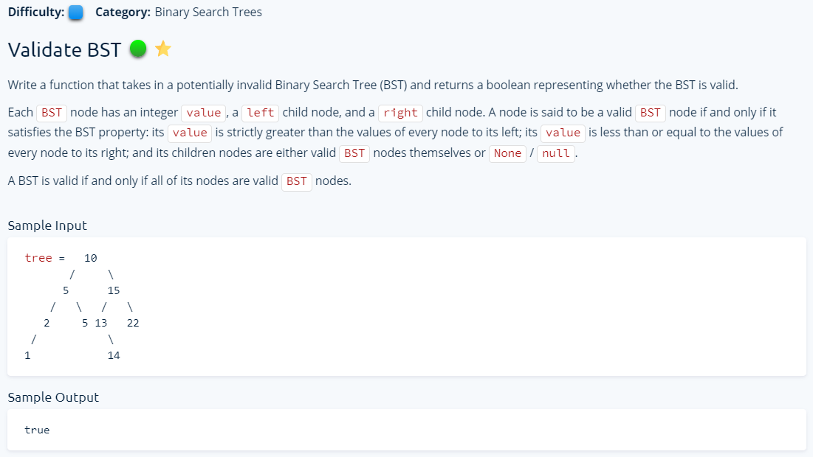

**Solution 1**

This is my solution. The solution has two parts. We provide left sub tree and right sub tree with root value, so that we can compare both of the condition of binary search tree that each left node is smaller than root node and each right node is bigger than root node. At the same time, left sub tree is smaller than root value and right sub tree is bigger than root. I used queue to do the operation for each sub tree.

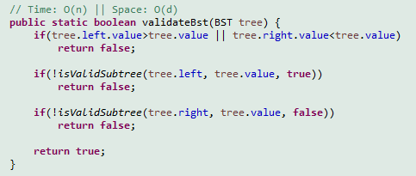

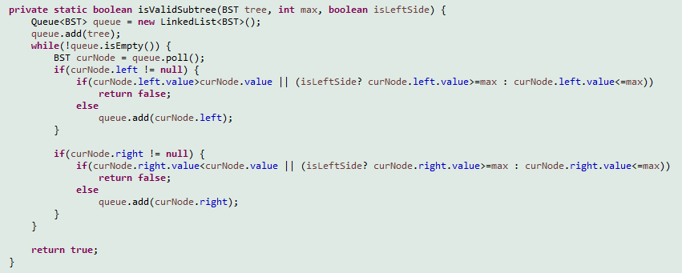

**Solution 2**

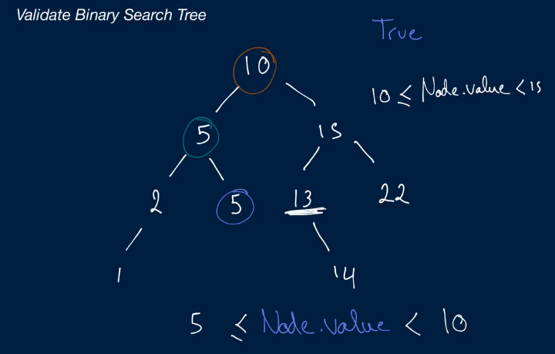

This is the recursive solution which seems simple but it is hard to understand the steps how it is going through the operations. I wrote all the steps in the following picture. The idea is that we provide max and min value with every tree node recursively where max or min is the parent of considered node. And by default we provide max and min the highest integer value for negative or positive.

When we provide left side node, we provide min value as previous min value and max value as current value of the node. When we provide right side node to the recursive method, we provide min value as current value of the node and max value as previous max value. This is because when it is going to left node, then that new node must be below its parent node which is defined by max value. And min value should same as parent node’s min value. Similarly, when it is going to right node, the min value should be same is parent node value of new node. And the max value should be max value of parent node.

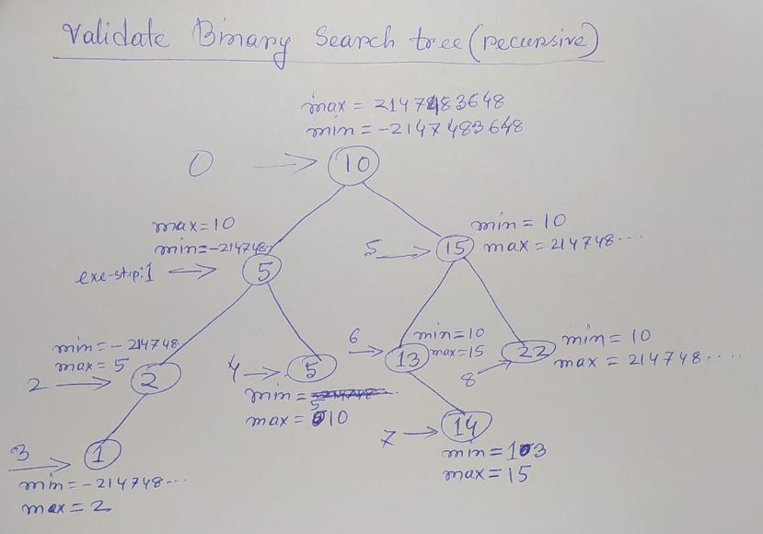

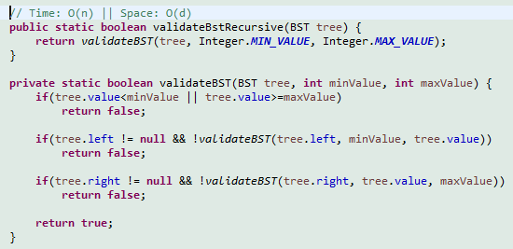

**BST Traversal**

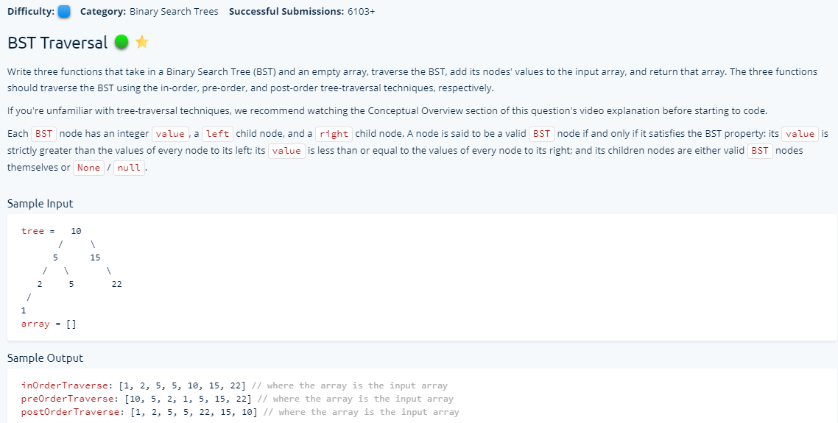

**Solution 1 (Stack based) (DFS based)**

**In-order-traverse**

This is a simple and understandable method of in-order-traverse for tree based on stack. Using stack we can do all sort of tree traverse. At first we go as left as possible by while loop and put nodes in the stack. Then we pick one node from stack and add it to the array. Then we try if this node has any right node. If yes it will until the left depth of that node, or it will pick one more node from stack. It requires O (n) time and O (n) space.

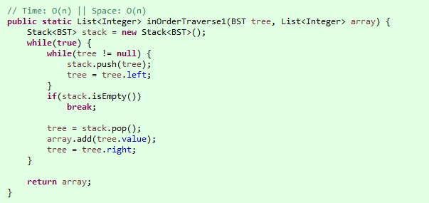

**Pre-order-traverse**

This is also a simple DFS stack based development. We start inserting node’s value to the result from the beginning of node inserting into stack. To keep the node traverse left centered we need to add first right node in the stack because in stack it always pick up from last inserted node. It requires O (n) time and O (n) space.

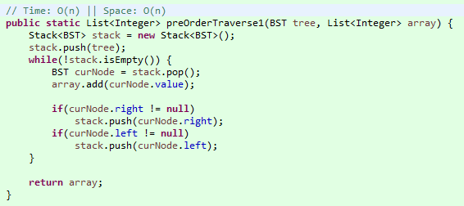

**Post-order-traverse**

We need two stacks to do the post order traverse. First we need to traverse these nodes by right centered which is pretty normal by stack. Finally, we need to reverse the first stack’s data by using 2nd stack. Because of using double stack it costs O (n^2) but the time remain O (n).

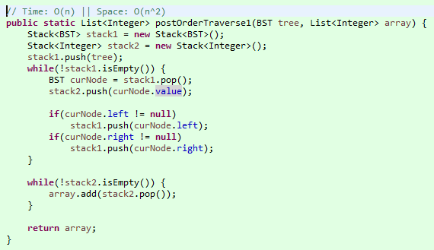

**Solution 2 (Recursion based)**

Recursive technique is made for tree based problem solution. This is a perfect fit this three different order of tree traversing techniques. We only have to change the order of node value pick up or print. **Most probably these three types of traversing name were based on this value pick up way from recursive method.** For example, in In-Order traversal the locations of node value pick up is in the middle of two recursive call. Similarly, Pre-Order and Post-Order is similarly node value pick up at the beginning and end respectively.

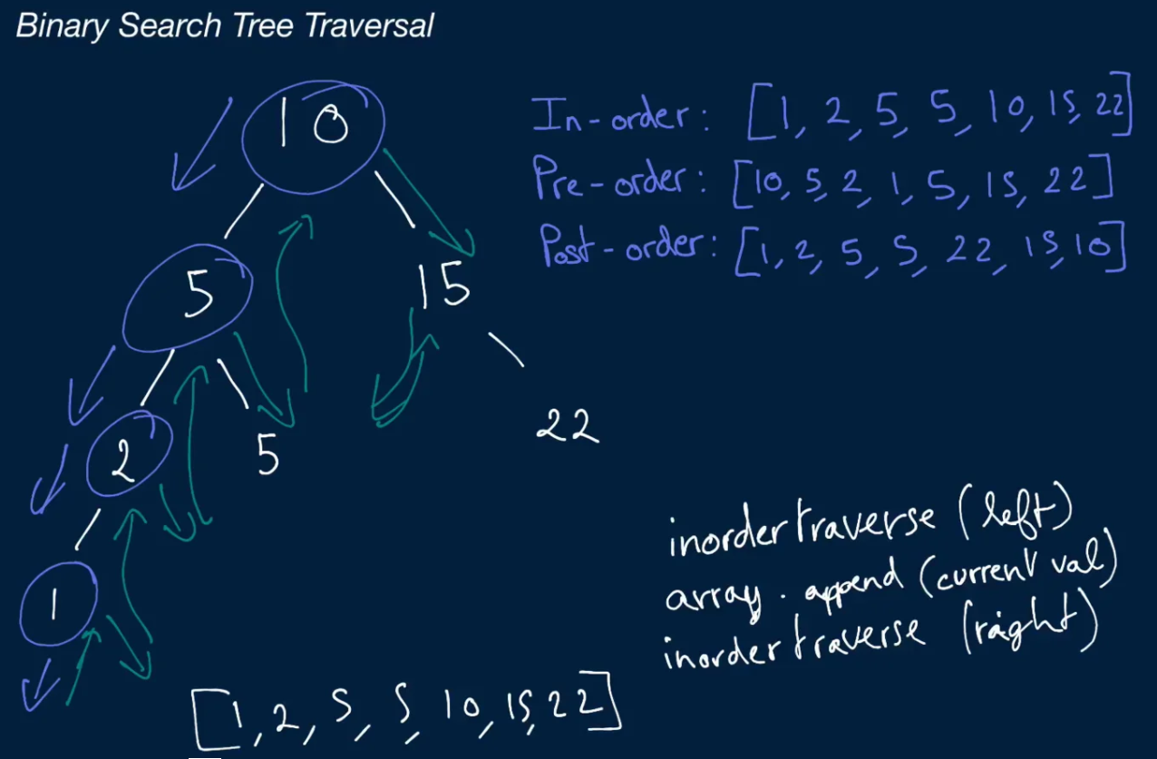

**In Order Traversal**

It does the job as: **left-root-right**

We have two way of recursive method writing. In one case, we provided the base case at the beginning, so that the first recursive method can go left deeper and at the base case it will pick up the node’s value. In our example, that was node with value 1. And then it tries if it can find any node on the right side. Then it does the same operation again and again until it visits all nodes.

At the second case, it will do only recursive call with left node when that node is not null. Similar like previous case we add the data in the array (pick up) in the middle of the recursive call.

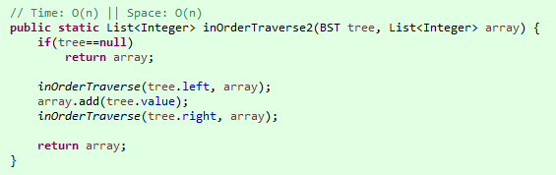

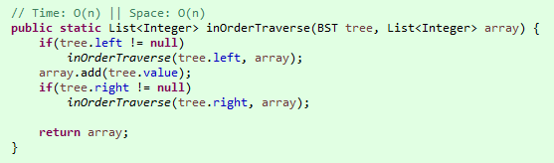

**Pre Order Traversal**

It does the job as: **root-left-right**

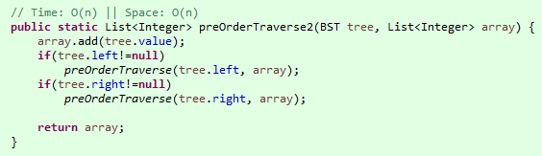

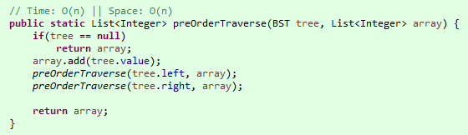

**Post Order Traversal**

It does the job as: **left-right-root**

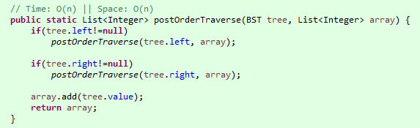

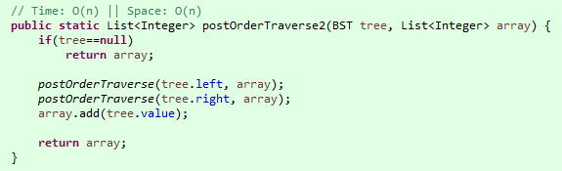

**Min Height BST**

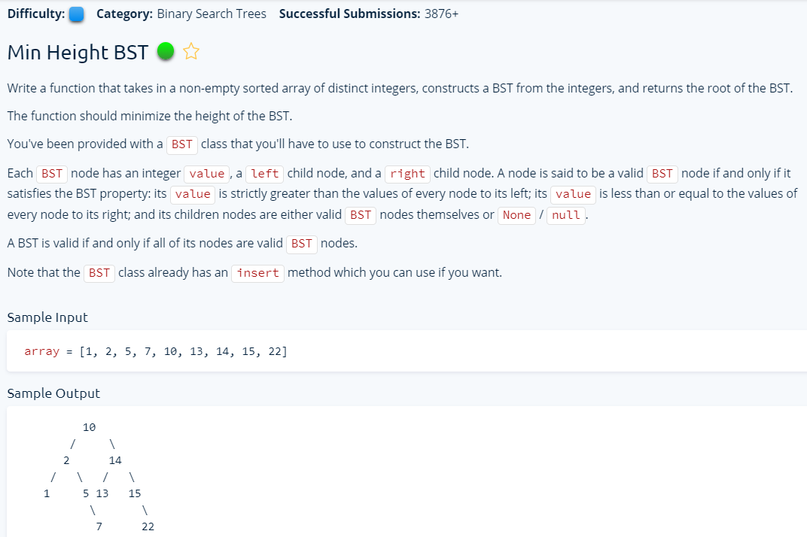

**Solution 1**

I tried to implement the problem using iterative procedure but somehow logically it did not fit perfectly for a few tests. But the recursive solution works like this we provide startIndex and endIndex for each half of the array recursively so that it can work smaller parts. Every time we identify the middle elements of each smaller half element and we insert into the BST. But we use given insert method which costs O (logn). So for N array elements, it costs O (nlogn). I make a drawing how or which order recursive method executes.

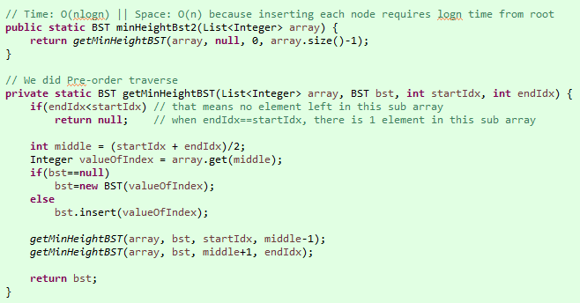

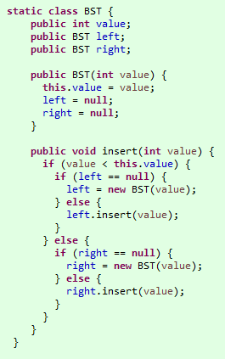

**Solution 2**

We can solve this problem without using given insert method. Because if see properly, we can find what insert method does, first it checks if given value is smaller than root value, if yes then it checks if left of root is null, if yes then it creates a new BST for left node and insert there. But if the left node was not null, it just recursively call that method with given value which works until it finds leaf node where there is null. So, it finds right position to insert.

The recursive method is the best option to do this problem. As we use recursive, it normally executes first method until it reaches to the base condition. At the base case, it will touch second method. That means in each iteration, it remembers all of the states with all variables in the program stack. So, as it is going from top to left, we do not need find the optimal location every time. The current iteration states are the right place to insert new elements. And to keep our pointer moving, we have to update bst root every time to the updated node (left or right). The only think we need to do is decide left or right where we need to put it. That means it will reduce that extra O (logn) costs. When left and right part is done for base case, it will go back to the next upper node from the stack and checks the right side (second recursive method). We used pre order traverse mechanism since we add every time first before left or right decision.

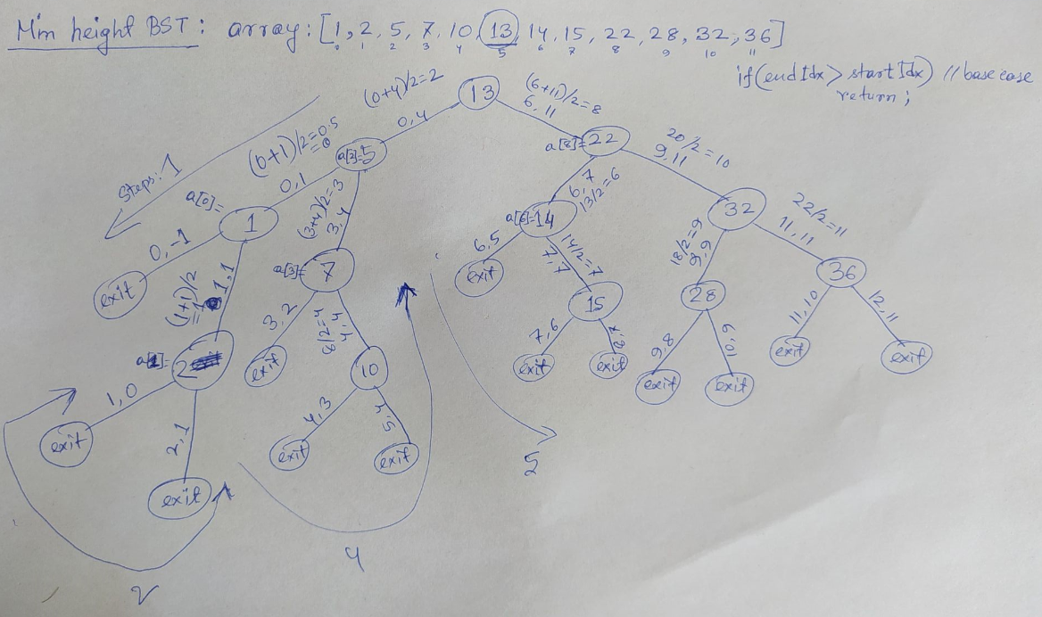

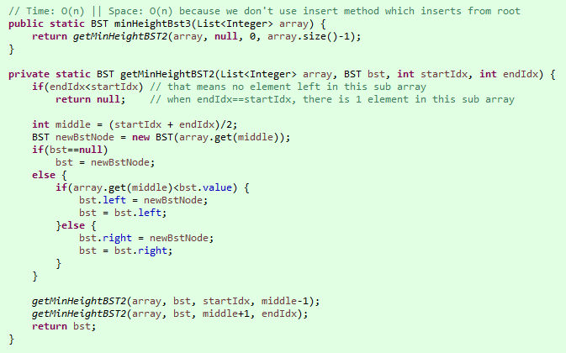

**Solution 3**

We can simply the process by writing the code more elegantly in the following way. We can put the return of each recursive call into root’s left or right node directly as we know the first method is dealing with left half and the second part is dealing with right half and their small parts. It will remember all the iteration states (middle, bst) into the stack. So, when it comes back to top, it will be able to handle them perfectly. So, as for the last solution, we do not have to use extra insert method.

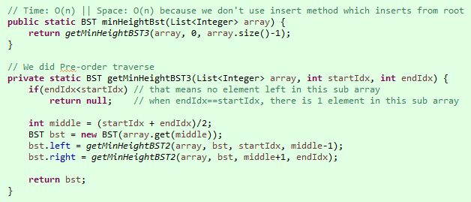

**Tries**

**Suffix Trie Construction**

Tries is basically used to construct string structure (with characters) which can be useful to make an extended type of search with comparatively less time complexity. First we need to generate Suffix trie with given String. Then we can do search on that.

The benefit we will get by constructing this trie is when we want to search the existence of a particular part of the string from the big string, it must search it from the beginning of the big string, but as every subset are stored on the trie, it will be able to find every element from the root if that string exists. So, it will reduce a big amount of search cost. But it requires suffix trie construction cost which O (n^2). Still it gives time complexity benefit over regular naïve techniques.

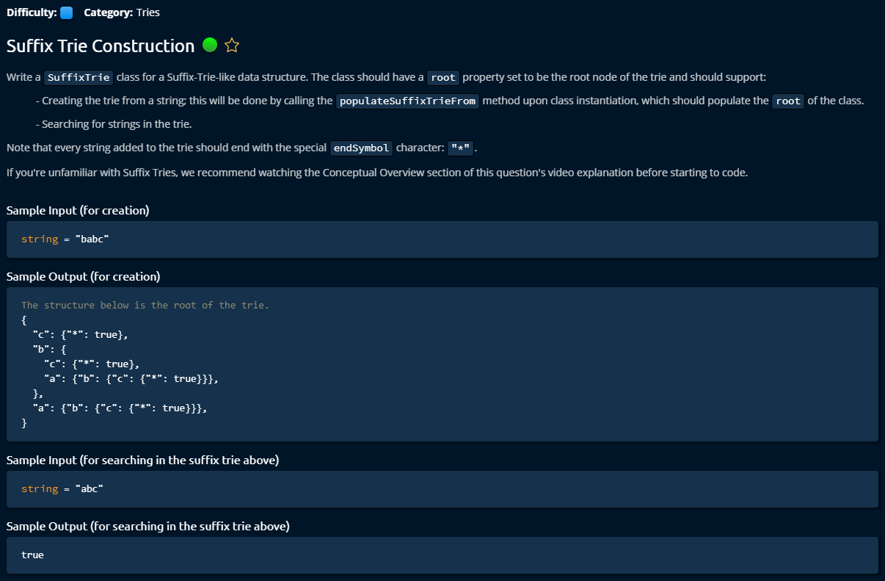

**Solution**

To construct a trie, we have to consider a string with every possible combination. For example, a string “babc”, we have “babc”, “abc”, “bc” and “c”. The root is empty and every combination should be accessible from root. And * at the end represents the end of a string. The benefit it will give that, we do not have to travel every letter to find any particular part of a string exists. And the negative sight is, to construct the trie, it will cost O (n^2).

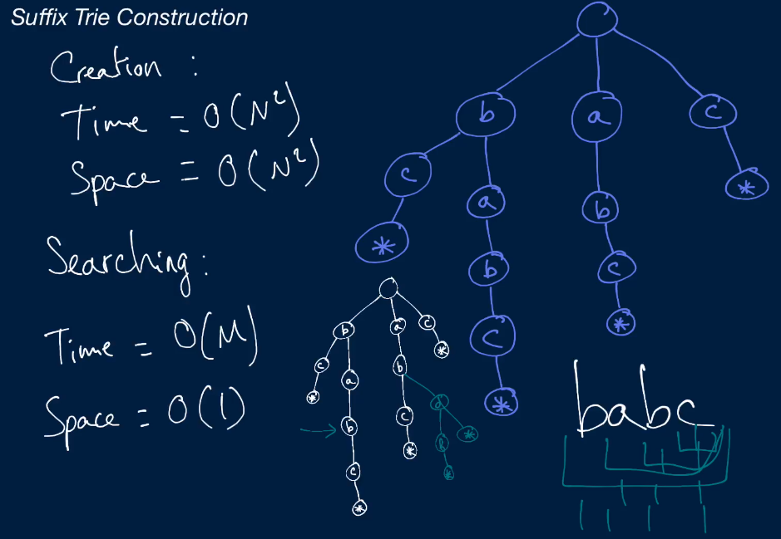

To store the node’s connection we used map of character and node. We store one character and a node in every level. To construct the tree, we need two loops because with the first loop, we provide every time one string with one less letter from the given string. And in the second loop, we start with root and it asks if it has a connected child node with current letter. We add a new node as a child node if it does not exists; otherwise we just move the current node root to the child node as a next node.

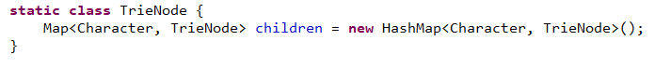

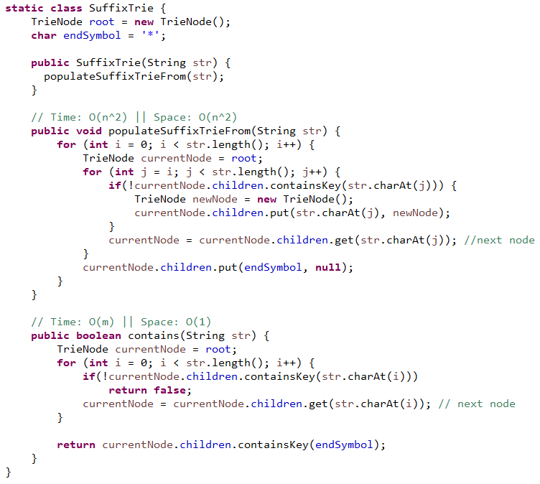

**Multi String Search**

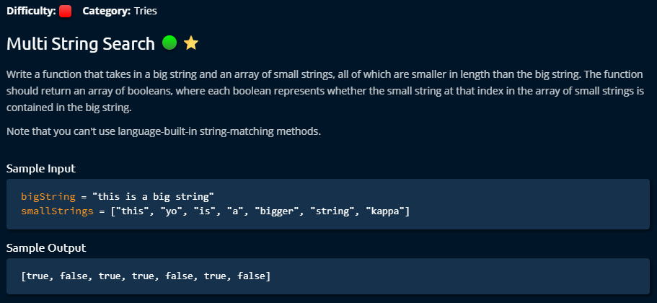

**Solution 1**

This is the simplest non trie solution. But they mentioned that we cannot use any build in string methods to solve the problem. String contain method can find any string which subset of any string.

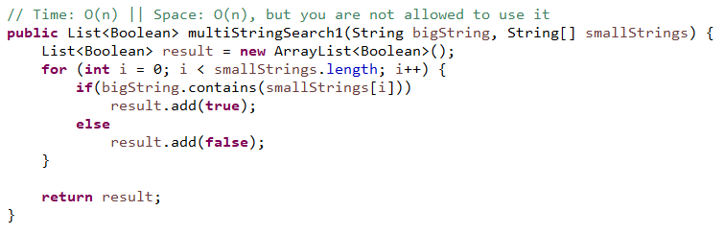

**Solution 2**

This one was acceptable solution but it is comparatively expensive solution. We take every string from the smallStrings and check into the whole bigString that if this string series exists. If we found it, we look for the next string from given smallStrings. That means for every string in smallStrings, in worse case we might have to find whole letters in bigString. That means it could cost for every string in the smallStrings, we have n length of bigString to visit. When we find it somewhere earlier before end of bigString, then it would cost logb. But overall it would cost O (nslogb) time and O (n) space.

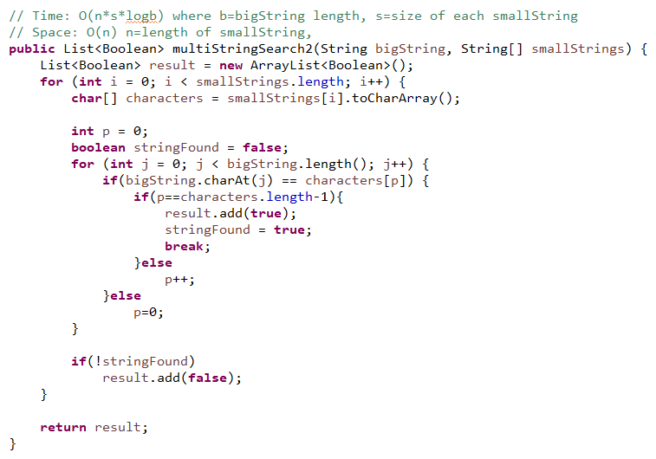

**Solution 3**

This problem can be solved by trie data structure. To construct a trie using that bigString, it would already cost O (b^2) where b is the length of bigString. For searching any sub string in bigString, it will be way faster because from the root node it will be able to find any sort of sub string. Finally, we get the cost 0(b^2 + ns) which is smaller than O(bns), notice it was multiply with b. In our case, we do not have to visit every letter in bigString for every word found smallStrings.

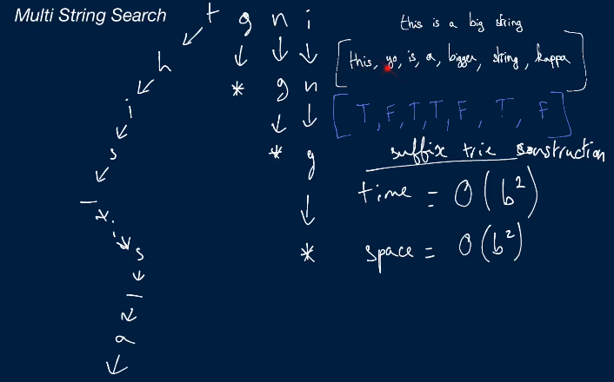

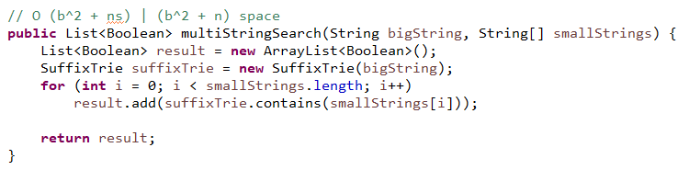



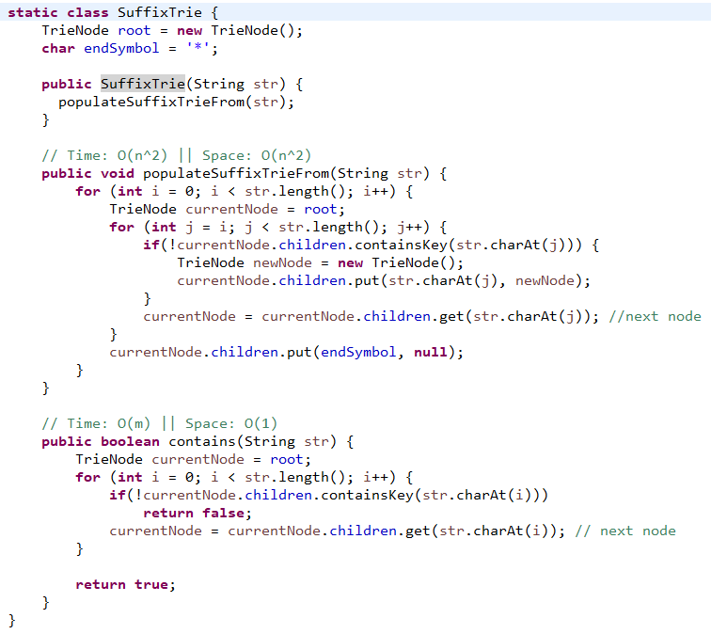

**Strings**

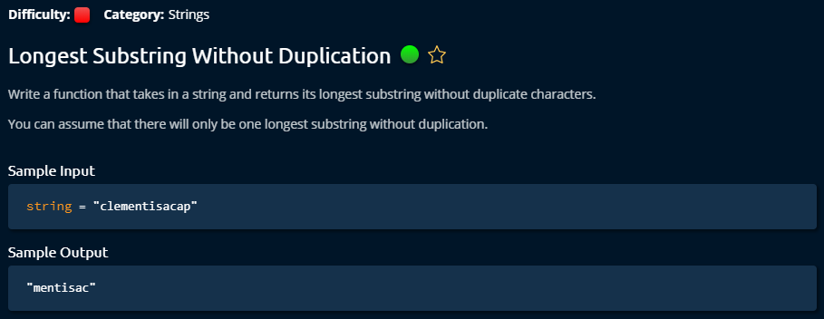

**Solution 1**

The solution was haspmap approach. The idea is to keep char store into map and when we find any repeated letter into map, we just store all others as it a string (only if it was the biggest string found) without duplication. And with the new unseen letters from now on, we start to build new non duplicate string. The hardest part is to decide the starting point of new string. It is always the last place in the given string of the repeated letter. It was hard because we used to store it by hashmap, but we need to keep track of given string location. For every string, we make a fresh hashmap. We can work with big string by loop without splitting it; that would also cause less memory use. Even if this code is time and space efficient, it was hard to manage this solution because lack of theoretical depth review.

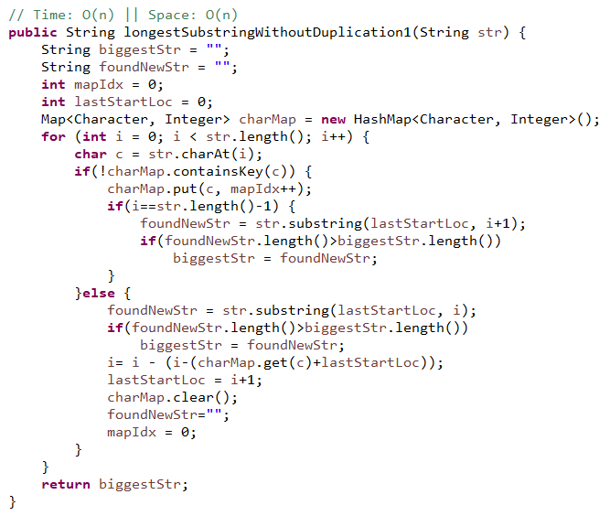

**Solution 2**

It was two pointer approach with hashmap and was comparative easy to manage. We only increase R for every non repeated letter into the hashmap and when we found repeated one, we know the length of new string by R-L. And L always stays at starting position of non repeated string. For every string, we make a fresh hashmap. When we find a string, we set back L and R to the starting point of new non repeated string.

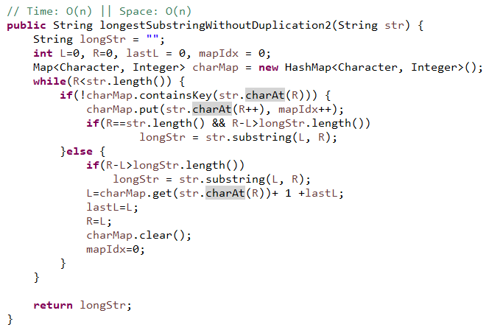

**Solution 3**

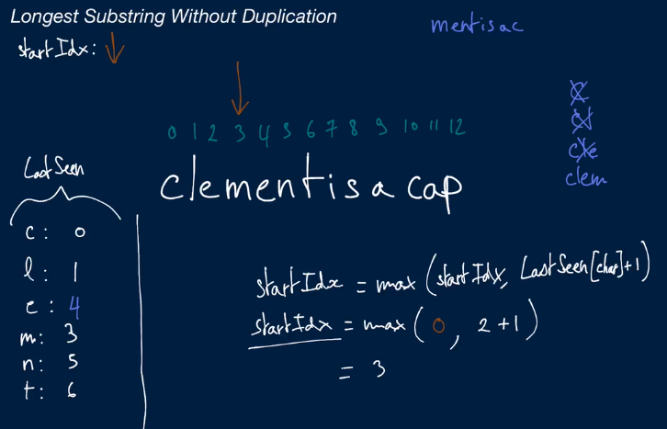

This is smartest approach found by Clemen. With a single hashmap we store all the characters into the hash map. By this approach, we store new character into hashmap every time. When we find one repeated letter, we overwrite it on hashmap’s location. So, it has little bit space complexity benefit over other solutions. And if it find repeated letter, then we calculate starting index for new string. And for every number in an iteration, we check if we found any new big string, we just keep track of that. It is very simple to code. We start with 0 index, that’s why we have to use i+1 to identify string length.

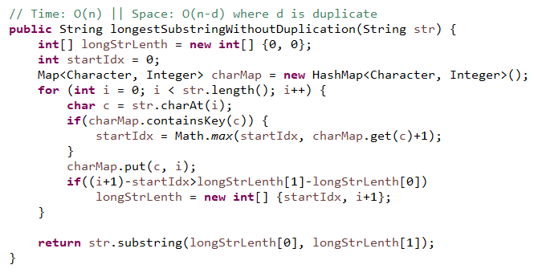

**Palindrome Check**

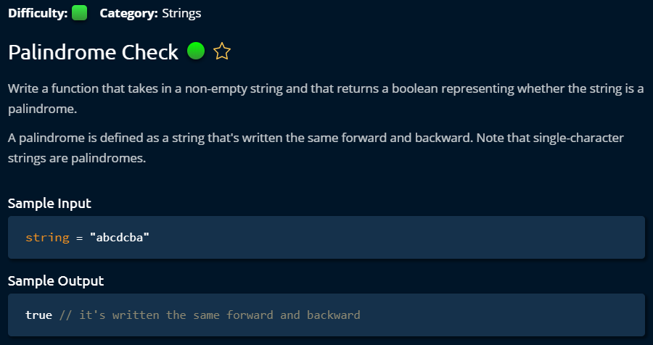

**Solution 1**

This is an interesting problem and we got 6 solutions. This is quite interesting. First solution was making another string in reverse order but it requires n^2 time complexity because every time it makes new string. And we need to store whole string.

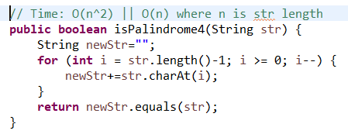

**Solution 2**

By using String builder, we can avoid generating string every time; rather we can append a letter to the string builder. It will reduce the time cost to O (n). But it still has space cost.

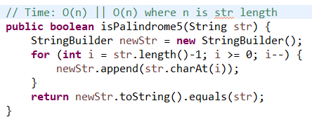

**Solution 3**

This is a recursive solution. The exit point is when there is one letter of 0 letter left. We compare first letter and last letter and give rest of the string to the recursive call.

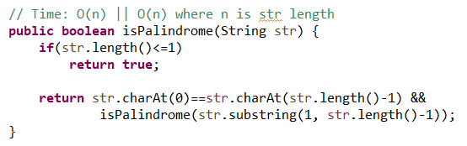

**Solution 4**

This is better solution from me but we can exclude the condition of length. This solution gives better performance. This is a solution with double pointer.

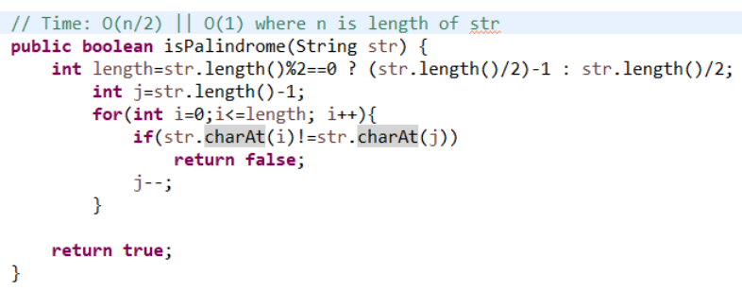

**Solution 5**

We removed the length portion which made it easy and a bit less memory.

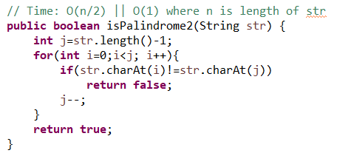

**Solution 6**

We can do the same things with while loop and double pointer.

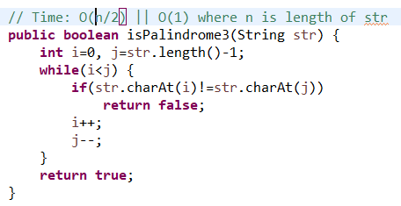

**Caesar Cipher Encryptor**

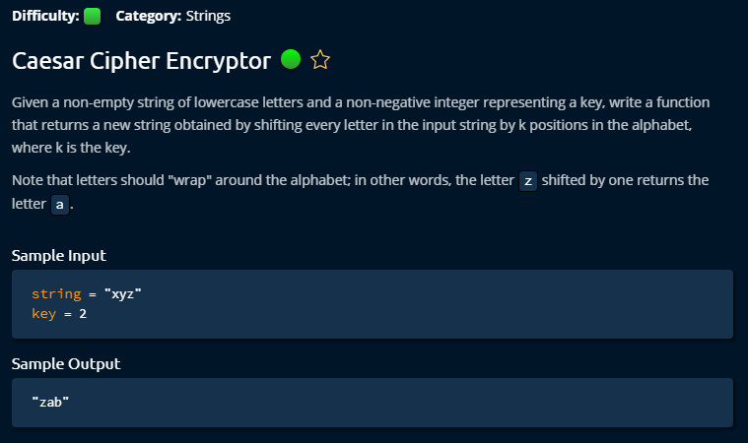

**Solution 1**

Here the idea is ascii number start with 96 and 97 mean a. The input key can be unlimited which is the challenge. We have to round up the big number to 26 letters. And last letter ascii value is 122. So, if a value with key exceeds 122, we have to round it up. The solution costs O(n^2+k) time because we are generating new strings every time when we add new character.

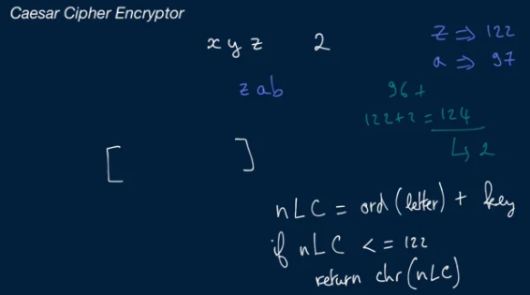

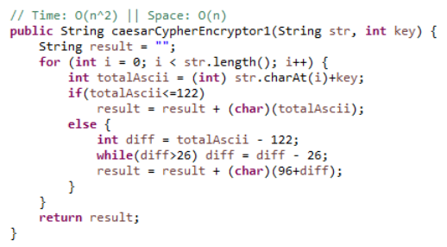

**Solution 2**

We can solve that new string generating problem by providing StringBuilder class. By appending letters on string it will reduce the costs to O (n+k) where k is English letters number.

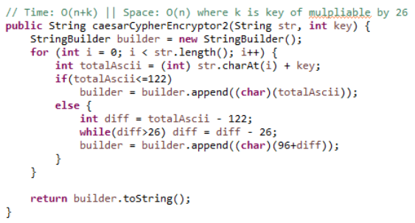

**Solution 3**

We can make the solution even better by doing mod to the key by 26 which would make it already round. So we do not need the extra while loop to round it up. This is a smart solution. So, it will reduce the time cost to O (n). And the space cost remains same because we need at O(n) space to store the encrypted string.

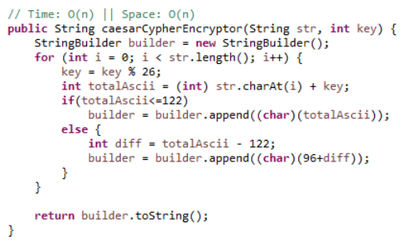

**Longest Palindromic Substring**

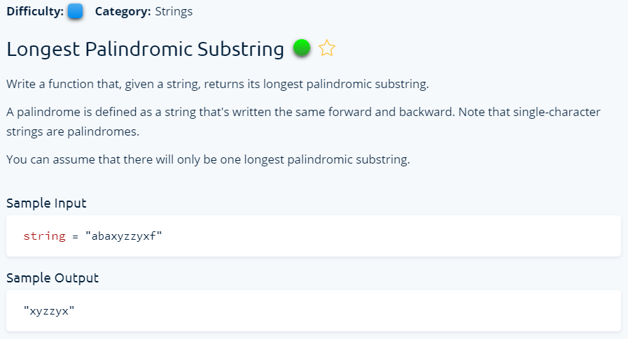

**Solution 1**

This is comparatively easy solution even if it did not come to my mind at the beginning. It makes all possible sub string of given string and then check for each sub string if they are palindrome. The cost is n^3 time complexity which can be reduced by different strategy.

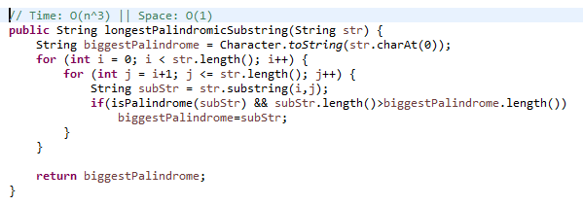

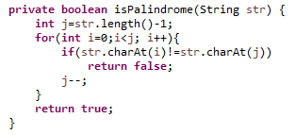

**Solution 2**

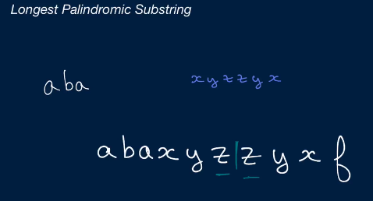

This is best solution for this problem with O (n^2). It tries to find where the center of a palindrome is. To find the center, it has two approach, first approach works like checking left and right letter of current letter if they are same, second approach is check the previous letter with current letter if they are same. If we find same letter from any of these approach then we try to expand left and right to see if there is more similar letters. It is an elegant solution.

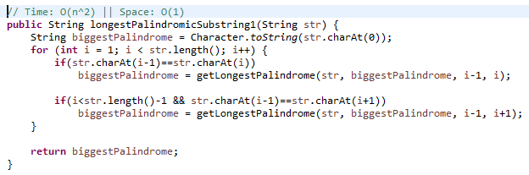

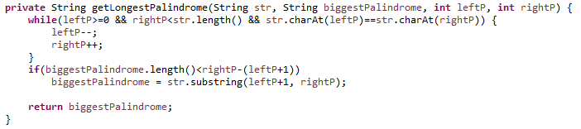

**Group Anagrams**

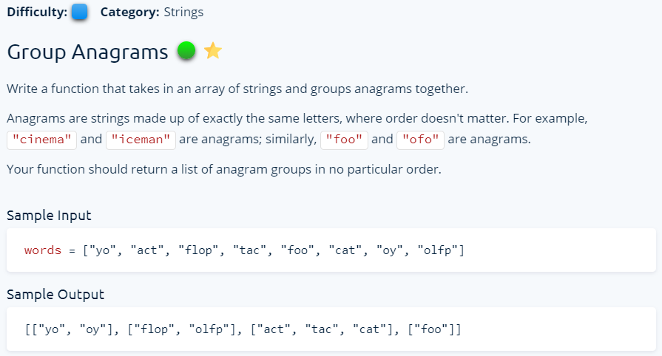

**Solution 1**

This solution deals by first sorting every word of the array and put in another sorted array. As the size of sorted array and original array is same, we traverse by sorted array and when found same string there, insert that index string in the list from given array. We have to maintain a seen list to avoid duplicate analysis. This process is rather time costly. For sorting it costs, w*nlogn and to figure out the words, it cost wn^2.

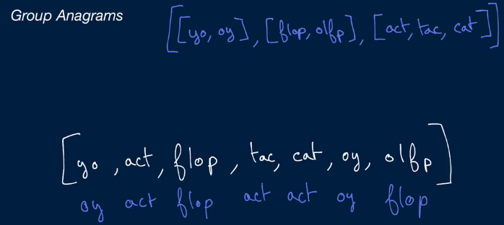

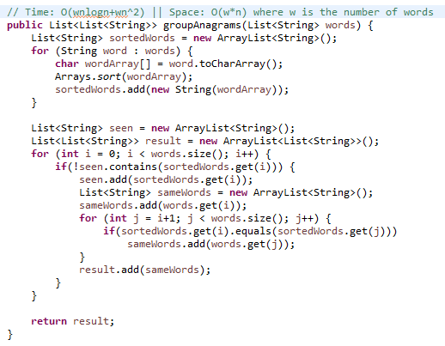

**Solution 2**

This is rather easy solution and comparatively time efficient algorithm by using Hashmap. We insert sorted word as a key of map. And compare each sorted word with it to find if there is any anagram. If we find any, then we add inside the existing list or we add as a new word in a new list.

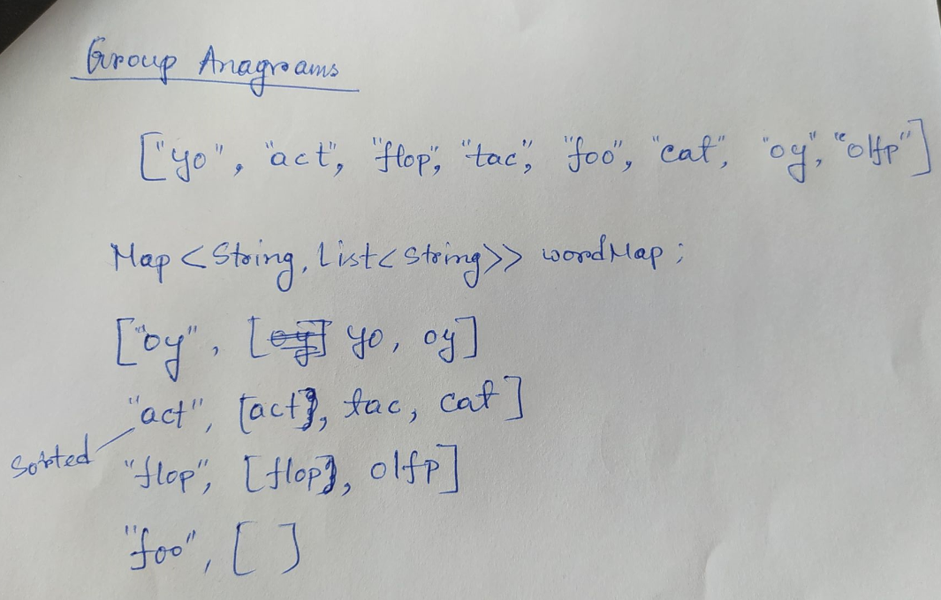

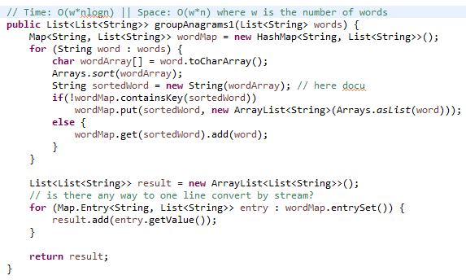

**Stacks**

**Balanced Brackets**

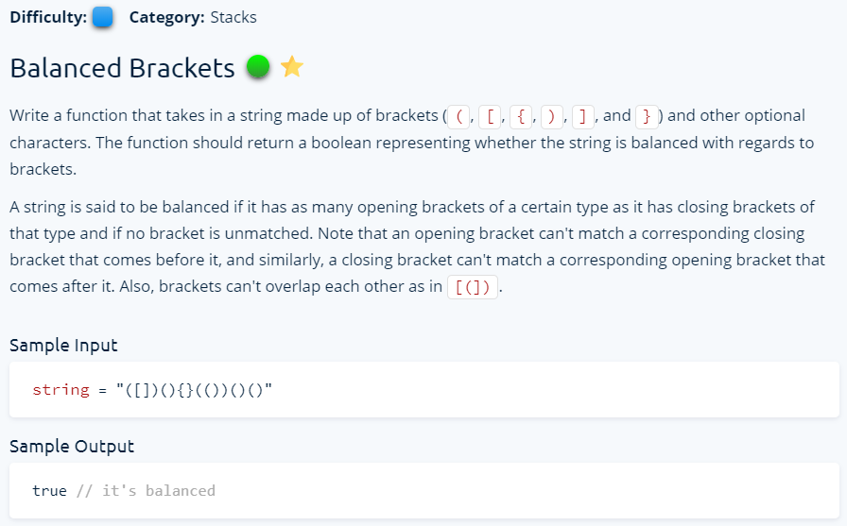

**Solution 1**

This is an interesting problem. This is a solution using linkedlist considering the best part of linkedlist that it is easy to insert and delete from any location in linkedlist. Furthermore, it has addFirst(), removeFirst() methods. When we find any starting parenthesis, we insert in the list and when we get any closed parenthesis and if it is same, we just remove it from the list. All of the solution has same time and space complexity.

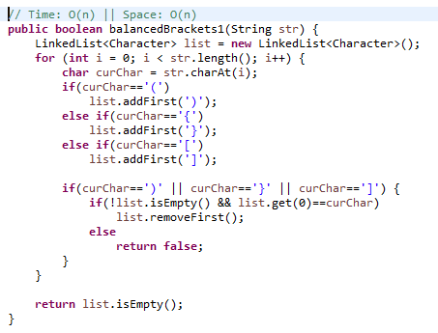

**Solution 2**

Since this problem is a perfect fit for Stack data structure, this is a solution based on build in stack provided by java. When we find any starting parenthesis, we insert in the stack and when we get any closed parenthesis, we just pop it from the stack. As a general technique stack always push it to the first position and also pick it from the first position. This is exactly what we needed for this problem to solve.

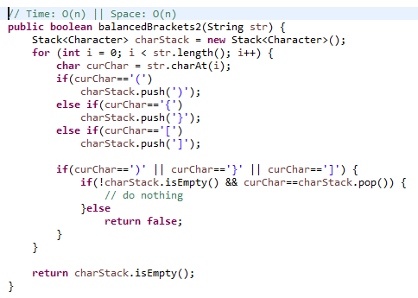

**Solution 3**

This solution is a bit other way of thinking. We put the entire open and closed parenthesis inside two strings so that we can check the current letter is from which sort. And we put parenthesis map inside a map, so that we can compare them easily. But at the end the costs are same.

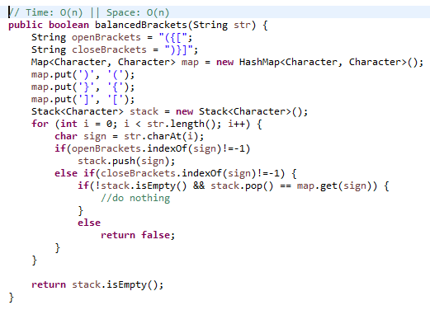

**Min Max Stack Construction**

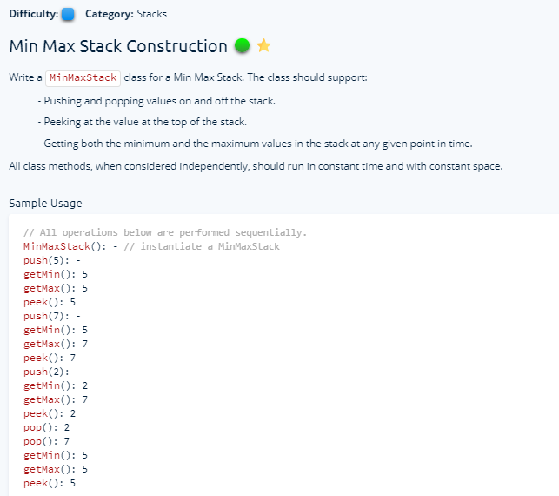

**Solution**

This is rather simple solution. Just considering a List<Integer> and do the operation like a stack: push(insert to first position), pop(get the first position and remove), peek(get the first position), we can also get Min or Max integer value by java stream easily. We can also use Linkedlist to do the same operation which would be a bit faster as getting setting is faster in linkedlist.

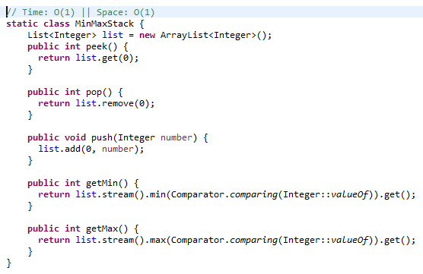

**O (N) Chart**

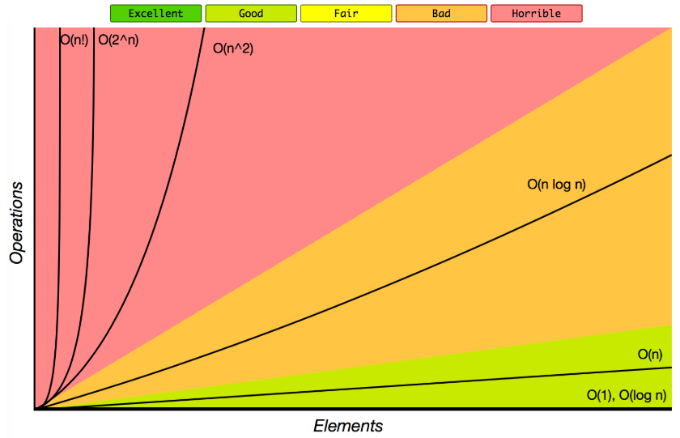

**Top 10 Algorithms for the Coding Interview,**

1. Depth First Search

2. Breadth-First Search

3. Matching Parenthesis

4. Making use of Hash Tables

5. Knowing how to manipulate multiple variables/Pointers at once (p1)

6. Reversing a linked list

7. Sorting fundamentals (time complexity, functioning, etc.)

8. Recursion

9. Custom Data structure (ex. suffix tree)

10. Binary Search (p1)

Here's the list if you want to search the topic's, still TechLead just nails it explaining each one on the video.

1. Solving the problem itself is not the goal, it is really the process that means the analysis of the problem, how well you can analyze it, and how well can you look at the alternatives considering pros and cons in terms of time and memory and bigO time analysis. You should be able to propose something like if you want optimize time complexity we might use this data structure and solve it this way, but if you want to optimize the memory we need to do it this other way.
2. Tree traversal: is used heavily in industry, how to traverse a tree: preorder traversal, in order traversal, post order traversal, breath first search and depth first search. One common problem is, given a hierarchy where there are views, sub views, sub-sub views: traverse every view and print every view, you should not do it recursively and iteratively, use breath first search to find the nearest node that match the criteria
3. Binary search tree: you need to traverse some tree structure looking for some node, that can be done in logarithmic time, you have to know the data structure to represent a tree. In the data structure course, they teach you it as just having a node with left node and right node, this is kind of naïve because that limit the fanout to two. If you want more larger fanouts, you can use an array, an array of children nodes. Recursions are the common way to traverse this tree structures.
4. Recursive function: is tricky to properly understand, most people do not know it elegantly. Commonly happens that when you need to write a recursive function, you need to pass parameters to pass the state, then recursive function gets bigger and bigger and you need to pass a bunch of variable into it. It is better to have helper function in recursive function where you call into the recursive program and the recursive program call straight into the helper function but passes in a set of initialization variables that keeps your code API clean. You have to think about what your base case is? If you can clarify under what condition it will end, that helps you to write cleaner recursive functions. Recursion is limited to stack space, because it has limits, it is not that optimal. But what professional programmer mostly does is, convert it to iterative function.
5. Iterative algorithm: Every recursive function can be converted to an iterative algorithm using stack and queues. Try implementing Fibonacci and Tree traversal iteratively. Some recursive function is pretty difficult to convert do it iteratively; it depends on how much state you are passing from one recursive to the next one.
6. Stacks and queues: Very common: number of parenthesis problem, you can do it using stack.
7. Object oriented programming: You know the code structure, making class for anything concise.
8. Data structures (Hashmaps, graphs, etc.)

Less but still important:

1. Pointers in the program how to control them efficiently
2. Sorting algorithms (Merge sort, quick sort, bubble sort)
3. Strings and how to navigate through them (Some types: palindrome, anagram)
4. Dynamic programming: Many times it is involved memorization or caching the values and reuse them.

**How to crack dream job in just 2 months? By Rachit jain (He guarantees)**

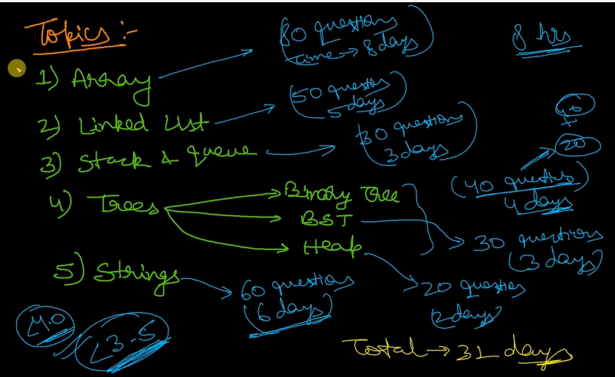

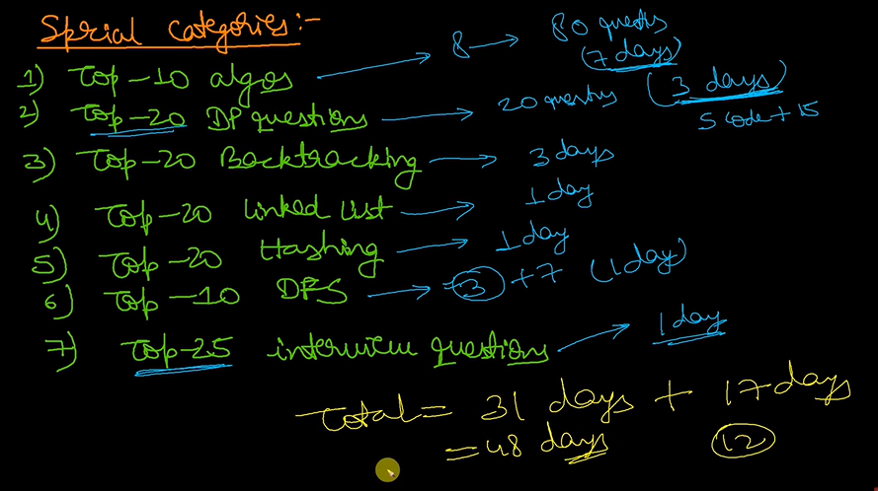

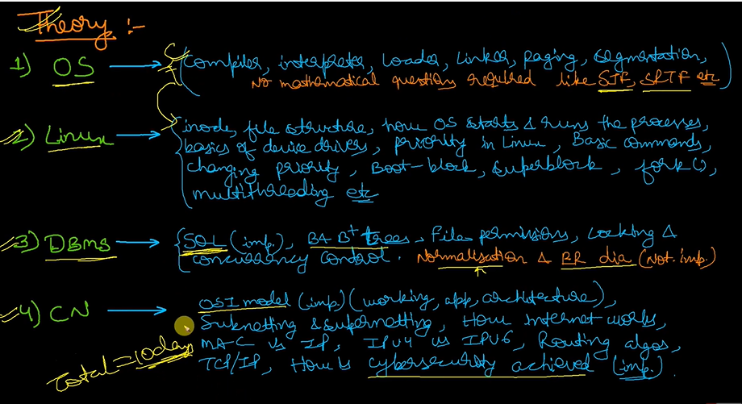

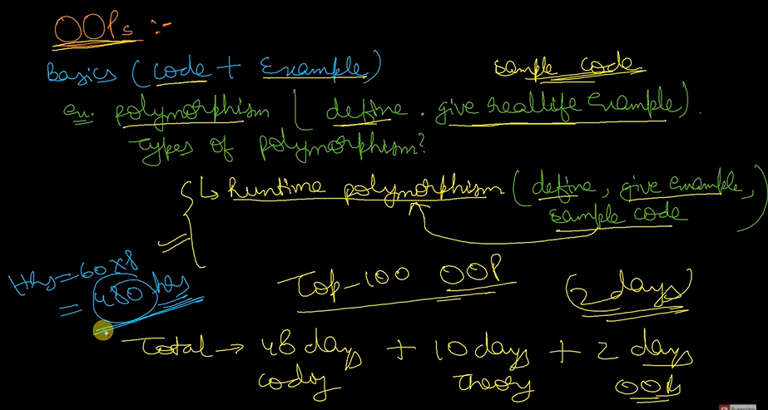

**Finishing task**

1. Try to find out and document how he wrote complex test cases for different (e.g. Tree, Graph, Linked List) types data structures.